WAVES
Wave | Wavelength $λ$ | Period  T | Frequency  f | Amplitude  A
Peak | Trough | $$T=\frac{change in time}{number ofcycles}$$ | $$f=\frac{number of cycles}{change in time}$$ | $$v=fλ$$

1. The highest point on a wave is the __________, while the lowest point is the __________.

2. The __________ of a wave is a measure of the amount of energy it carries.

3. The distance from one peak to the next peak is the __________.

4. The __________ is a measure of the number of waves that pass a point in a given amount of time.

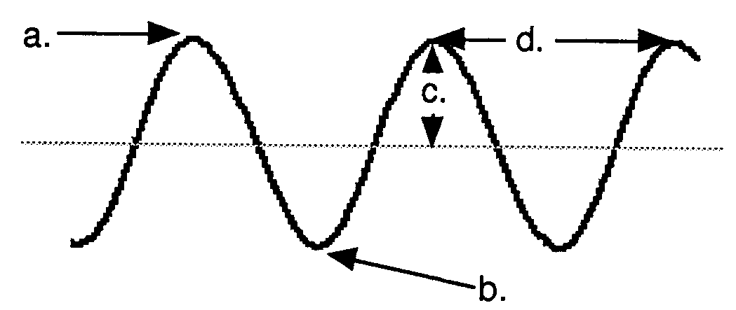
5. Draw the illustration to the right in your notebook and label each part.
a. ____________________

b. ____________________

c. ____________________

d. ____________________

6. Use the five illustrations of waves drawn below to answer the following questions:

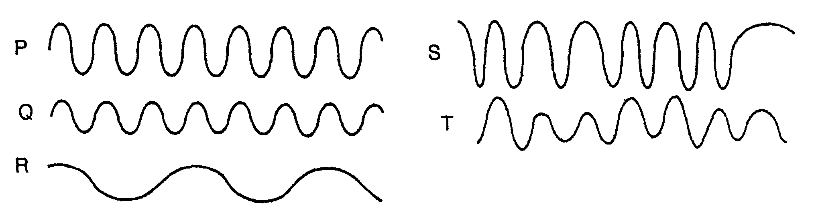

- Waves P and Q have the same __________, but wave P has twice the __________ of wave Q.

- Waves Q and R have the same __________, but wave R has twice the __________ of wave Q.

- Wave __________ shows a steady frequency but changing amplitude.

- Wave __________ shows steady amplitude but a changing frequency.

- Waves __________ and __________ have a low amplitude and a steady frequency.

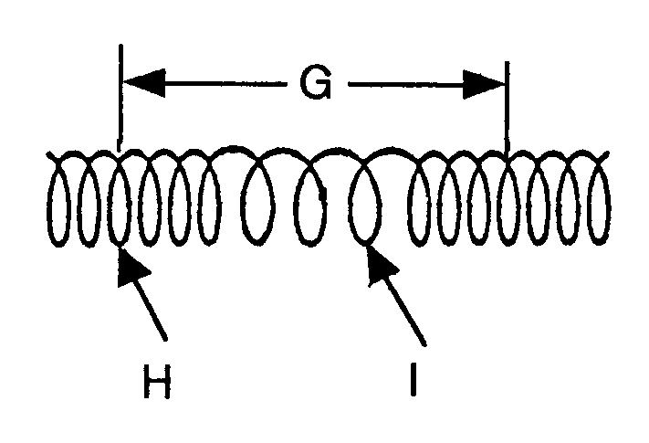
7. Draw the diagram to the right in your notebook. Label the parts of the wave.

- Is this wave transverse or longitudinal?

- Letter H represents a _______________ and
letter I represents a _______________.
- Letter G represents a ______________.

8. In what type of wave is the vibration perpendicular to the direction of travel of the wave? ____________________

9. What type of wave vibrates parallel to the direction of travel? ____________________

10. What type of wave is produced when you move one end of a horizontal spring up and down?
____________________

11. What type of wave has a wavelength? ____________________

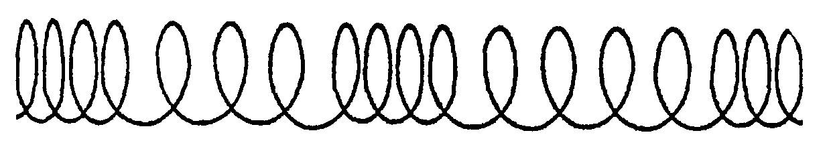
12. Obtain a ruler and determine the wavelength of the wave to the right.

Wavelength = __________

For Questions 13 through 18.The time from the beginning to the end of each diagram of waves is 1 second.
13. Diagram 1
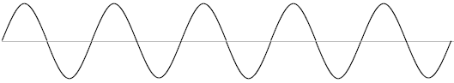
a) How many wavelengths are in the diagram above? _____
t = 1s
b) Wavelength ______ cm c) Amplitude _______ cm f) Period ___________ s
d) frequency ________ Hz e) speed of wave________cm/s
14. Diagram 2
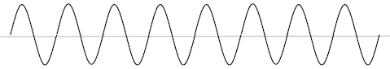
t = 1s
a) How many complete waves are in the diagram above? _____
b) Wavelength ______ cm c) Amplitude _______ cm f) Period ___________ s
d) frequency ______ Hz e) speed of wave________cm/s

15. Diagram 3
a) How many wavelengths are in the diagram above? _____
b) Wavelength ______ cm c) Amplitude _______ cm f) Period ___________ s
t = 1s
d) frequency ______ Hz e) speed of wave________cm/s
16. Diagram 4
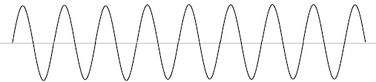
a) How many wavelengths are in the diagram above? _____
b) Wavelength ______ cm c) Amplitude _______ cm
t = 1s
d) frequency ______ Hz e) speed of wave________cm/s f) Period ___________ s
17. Diagram 5
a) How many complete wavelengths are in the diagram above? _____
b) Wavelength ______ cm c) Amplitude _______ cm f) Period ___________ s
t = 1s
d) frequency ______ Hz e) speed of wave________cm/s
18. Diagram 6
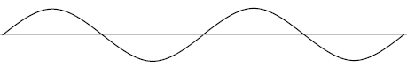
a) How many complete waves are in the diagram above? _____
t = 1s
b) Wavelength ______ cm c) Amplitude _______ cm f) Period ___________ s
d) frequency ______ Hz e) speed of wave________cm/s

