- A car was stopped at a stoplight for 10 seconds. The car takes 10 seconds to speed up to a velocity of 30 mph to the right. It then traveled for 20 seconds at 30 miles per hour. The car slows to a stop over a 10 second time period. The car remains stopped for 10 seconds before reversing direction and speeding up to 20 mph in 10 seconds. Draw this car’s journey:
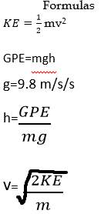
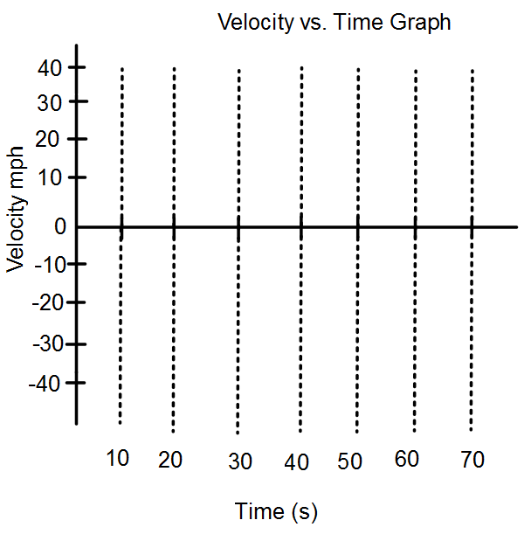

The following graph shows the velocity of a cart on a frictionless surface. The cart is initially pushed by a hand then later comes into contact with an elastic band.

- Identify the time periods for the following:
  - The hand is in contact with the cart _______s to _______s
  - The cart is in contact with the elastic band _______s to _______s
  - The cart is speeding up and moving to the left _______s to _______s
  - The cart is speeding up and moving to the right _______s to _______s
  - When the cart changes direction _______s to _______s
  - When the cart is slowing down _______s to _______s
  - When 2 energy transfers are taking place. ______s to _____s and _____s to _____s
- Give a description of all of the energy transfers (from object to object) taking place. Include the following terms (Energy Giver, Energy Receiver, Hand, Cart, Elastic Band)
- Give a description of all of the energy conversions (types of energy) taking place. (Chemical Potential Energy, Kinetic Energy, Elastic Potential Energy).
- What is the Kinetic Energy of the cart at the instant before it hits the elastic band?
- What is the Elastic Potential Energy of the cart at the instant the cart is changing direction? (the cart at this instant has no velocity)
- Does the cart have more kinetic energy at 5 seconds or 12 seconds? Explain your reasoning
- Draw a graph to represent the Elastic Potential Energy in the cart band system.

EP E

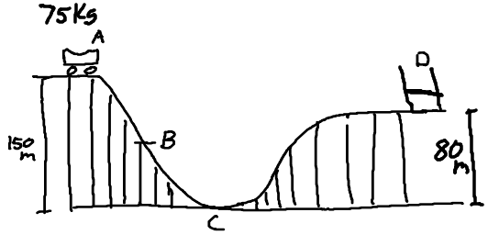

- At point A of the Coaster/Cart/Elastic Band System what is the GPE of the cart?
- Assuming this is a frictionless track what is the Kinetic Energy at point C?
- What is the velocity of the cart at point C?
- What is the Gravitational Potential Energy of the cart at point D?
- What is the Elastic Potential Energy of the Elastic Band at point D at the instant the cart is changing direction? (The cart at this instant has no velocity)
- If the cart has 55,125 J of GPE at point B at what height is the cart?
- What is the Kinetic Energy of the cart at point B?
- Complete the Energy Bar Graphs for the cart band System for the following points:
A
B
D
C

