Study Guide for Physics Final
- In the Inertia demonstration with the eggs and glasses use the idea of inertia to explain why the eggs fell into the glasses of water.
- How does mass affect the inertia of an object? Does speed affect the inertia of an object?
- In space, in the absence of air resistance and gravity, use Newton’s 1st law of motion to explain why spacecraft move at a constant speed and direction when no force is applied to it.
- Use the ideas of inertia and Newton’s 2nd Law of motion to explain why when traveling in car a ball will not hit the back of the windshield when thrown straight up.
- When Troy Tulowitzki hits a baseball with 100 Newtons of force and Carlos Gonzalez hits a baseball with 80 Newtons of force which baseball will experience greater acceleration?
- If every force has an opposite but equal force, why does the Earth move with less acceleration than the Moon?

- Is the mathematical relationship of force on acceleration directly proportional (acceleration increases: force increases) or inversely proportional (acceleration increases : force decreases)?
- Is the mathematical relationship between acceleration and mass directly proportional (mass increases: acceleration increases) or inversely proportional (mass increases : acceleration decreases)?

- At what time interval is a force being applied to the cart?
- What is the acceleration of the cart between 2 and 5 seconds?
- What is the acceleration of the cart between 0 and 2 seconds?
- Is the force being applied to the cart between 2 and 3 seconds in the opposite direction of the cart or in the direction of the cart?
- Is the force being applied to the cart between 3 and 5 seconds in the opposite direction of the cart or in the direction of the cart?
- If the cart has a mass of 0.5 kg, how much kinetic energy does the cart have at t=4s?(KE=1/2mv²)
- If a car is moving at a constant speed are the forces acting on the car in equilibrium? What about a car that is speeding up?

- The graph above shows the velocity of a cart with a fan exerting a force to speed the cart up. The cart and fan together have a mass of 2 kg. What is the net force on the cart? (F = ma) (a = change in velocity/change in time)
- What is the acceleration of the cart between 3 and 6 seconds?
- What is acceleration of the cart between 0 and 3 seconds?
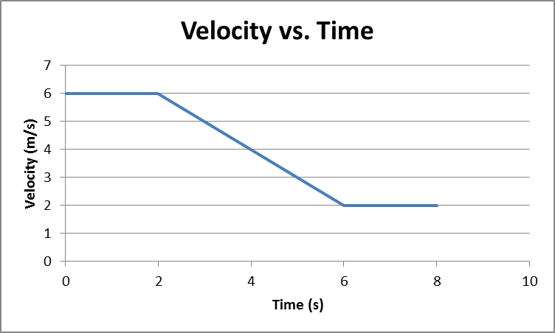

- The graph above shows the velocity of a cart with a fan exerting a force to speed the cart up. The cart and fan together have a mass of 2 kg. What is the net force on the cart? (F = ma) (a = change in velocity/change in time)
- What is the acceleration of the cart between 2 and 6 seconds?
- What is the acceleration of the cart between 6and 8 seconds?
- At what time interval is the force being applied to the cart?
- Is the direction of the force opposite the direction of the cart or in the same direction?
- What is the kinetic energy of the cart at 2 seconds? (KE = ½ mv²)

- The graph above shows a cart that has had two different forces applies to it. Which line represents the greater amount of force applied?
- When traveling in a train use the concept of inertia to explain why your body wants to continue to move forward when the train stops quickly.

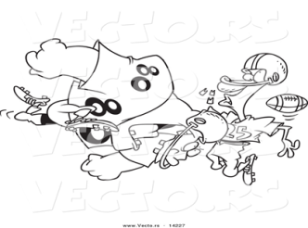
- According to Newton’s 3rd law of motion each football player is hitting each other with the same amount of force. Why does the smaller player experience greater acceleration? (Hint: Newton’s 2nd law of motion F =ma)

Use the Velocity vs. Time graph below to answer questions 21-36. The following graph shows the velocity of a cart on a frictionless surface. The cart is initially pushed by a hand then later comes into contact with an elastic band. There may be more than one correct answer.

- Where on the graph did the cart change direction?
- Where on the graph was cart moving at a constant velocity to the right? To the left?
- Where on the graph was the cart slowing down?
- Where on the graph was the cart speeding up and moving in the negative direction?
- Where on the graph was an energy transfer is taking place?
- Identify where on the graph the hand was in contact with the cart.
- Identify where the cart was in contact with the elastic band.
- If the mass of the cart is 2 kg; what would the Kinetic Energy of the cart be at the point where the hand releases the cart?
- Where on the graph was the elastic band stretched the furthest?
- What was the Elastic Potential Energy of the Band/Cart system at point F of the graph if the cart’s mass is 3 kg?
- At points C and F of the graph is the energy equal, greater at C or greater at F?
- Identify the where on the graph the forces acting on the cart were unbalanced.
- Identify the where on the graph the net force acting in the cart was zero. (the forces are balanced)
- How much force was applied to the cart during the 2 second to 5 second time span? The cart’s mass is 3 kg.
- How much force was applied to the cart during the 7 second to 13 second time span? The cart’s mass is 3 kg.
- Draw an Elastic Potential Energy graph that best represents the Elastic Potential Energy of the Cart/Band.

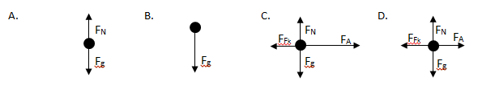
- Which of the following force diagrams represent objects that are in equilibrium?

- Draw free body diagrams for each of the following force pairs
- Two cars in in a car crash | - A person pushes on a wall
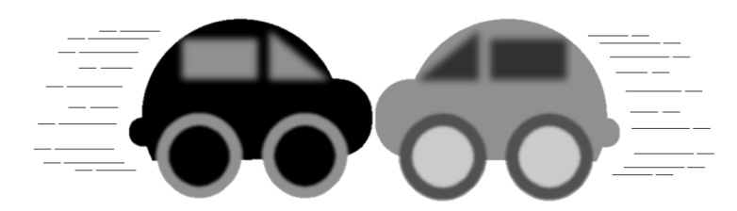
- For each of the situations below, identify the force pairs:
  - Snowball hits a girl in the back
  - A baseball player catches a ball
  - A swimmer pushes off of the wall of a pool
  - A soccer player kicks a ball
  - What force pair is responsible for pushing a car forward?

