PSI Physics - Kinematics
Multiple Choice Questions
- An object moves at a constant speed of 6 m/s. This means that the object:
A. Increases its speed by 6 m/s every second
B. Decreases its speed by 6 m/s every second
C. Doesn’t move
D. Has a positive acceleration
E. Moves 6 meters every second

- A toy car moves 8 m in 4 s at the constant velocity. What is the car’s velocity?
A. 1 m/s B. 2 m/s C. 3 m/s D. 4 m/s E. 5 m/s

- A train moves at a constant velocity of 50 km/h. How far will it move in 0.5 h?
A. 10 km B. 20 km C. 25 km D. 45 km E. 50 km

- A boat can move at a constant velocity of 8 km/h in still water. How long will it take for the boat to move 24 km?
A. 2 h B. 3 h C. 4 h D. 6 h E. 8 h
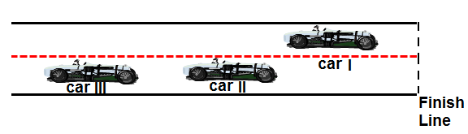

- A snapshot of three racing cars is shown on the diagram. All three cars start the race at the same time, at the same place and move along a straight track. As they approach the finish line, which car has the lowest average speed?
A. Car I
B. Car II
C. Car III
D. All three cars have the same average speed
E. More information is required

- A bicyclist moves at a constant speed of 4 m/s. How long it will take for the bicyclist to move 36 m?
A. 3 s B. 6 s B. 12 s D. 9 s E. 18 s

The graph represents the relationship between velocity and time for an object moving in a straight line. Use this graph to answer questions 7 and 8.
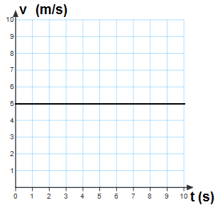

- Which of the following statements is true?
A. The object speeds up
B. The object slows down
C. The object moves with a constant velocity
D. The object stays at rest
E. The object is in free fall

- What is the velocity of the object at 5 s?
A. 1 m/s B. 2 m/s C. 3 m/s D. 4 m/s E. 5 m/s

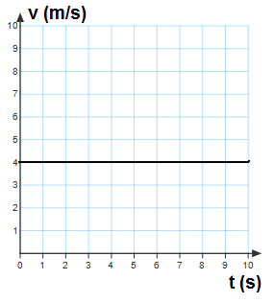

- The graph represents the relationship between velocity and time for an object moving in a straight line. What is the traveled distance of the object at 9 s?
A. 10 m B. 24 m C. 36 m D. 48 m E. 56 m

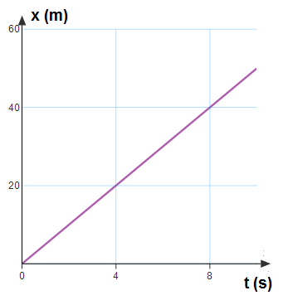
The following graph represents the position as a function of time for a moving object. Use this graph to answer questions 10 and 11.

- Which of the following is true?
A. The object increases its velocity
B. The object decreases its velocity
C. The object’s velocity stays unchanged
D. The object stays at rest
E. More information is required

- What is the velocity of the object?
A. 4 m/s B. 20 m/s C. 8 m/s D. 40 m/s E. 5 m/s

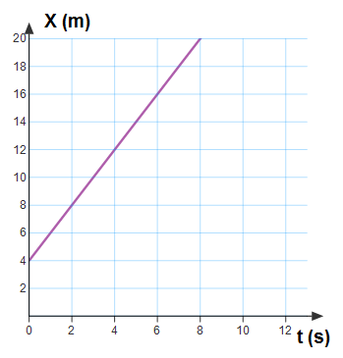
The following graph represents the position as a function of time of a moving object. Use this graph to answer questions 12 and 13.

- What is the initial position of the object?
A. 2 m B. 4 m C. 6 m D. 8 m E. 10 m

- What is the velocity of the object?
A. 2 m/s B. 4 m/s C. 6 m/s D. 8 m/s E. 10 m/s

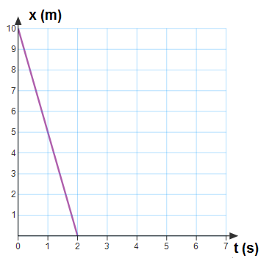
The following graph represents the position as a function of time of a moving object. Use this graph for questions 14 and 15.

- What is the initial position of the object?
A. 2 m B. 4 m C. 6 m D. 8 m E. 10 m

- What is the velocity of the object?
A. 5 m/s B. -5 m/s C. 10 m/s D. -10 m/s E. 0 m/s

- Which of the following is a vector quantity?
A. Speed B. Time C. Traveled distance D. Velocity E. Area
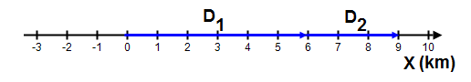

- Starting from the origin, a person walks 6 km east during first day, and 3 km east the next day. What is the net displacement of the person from the initial point in two days?
A. 6 km, west B. 3 km, east C. 10 km, east D. 5 km, west E. 9 km, east

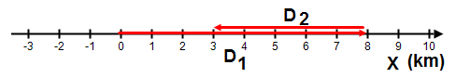

The diagram above illustrates a person who, starting from the origin, walks 8 km east during first day, and 5 km west the next day. Use it to answer questions 18 and 19.

- What is the net displacement of the person from the initial point in two days?
A. 6 km, east B. 3 km, east C. 10 km, west D. 5 km, west E. 9 km, east

- What is the traveled distance of the person from the initial point in two days?
A. 13 km B. 3 km C. 10 km D. 5 km E. 9 km

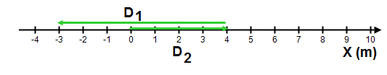

The diagram above illustrates a car that, starting from the origin, travels 4 km east and then 7 km west. Use it to answer questions 20 and 21.

- What is the net displacement of the car from the initial point?
A. 3 km, west B. 3 km, east C. 4 km, east D. 7 km, west E. 7 km east

- Starting from the origin, a car travels 4 km east and then 7 km west. What is the traveled distance of the car from the initial point?
A. 3 km B. 3 km C. 4 km D. 7 km E. 11 km

- An object moves with a constant acceleration of 5 m/s². Which of the following statements is true?
A. The object’s velocity stays the same
B. The object moves 5 m each second
C. The object’s acceleration increases by 5 m/s² each second
D. The object’s acceleration decreases by 5 m/s² each second
E. the object’s velocity increases by 5 m/s each second

- A truck travels east with an increasing velocity. Which of the following is the correct direction of the car’s acceleration?
A. B. C.

D. E.

- A motorbike travels east and begins to slow down before a traffic light. Which of the following is the correct direction of the motorbike’s acceleration?
A. B. C.

D. E.

- A race car moving west begins to slow down after crossing a finish line. Which of the following is the correct direction of the car’s acceleration?
A. B. C.

D. E.

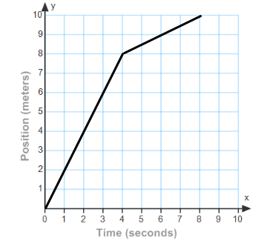
The position vs. time graph of a moving object is shown to the right. Use this graph to answer questions 26 through 30.
- What is the average speed from 0 s to 4 s?
A. 0.5 m/s B. 1 m/s C. 2 m/s
D. 3 m/s E. 4 m/s

- What is the average speed from 4 s to 8 s?
A. 0.5 m/s B. 1 m/s C. 2 m/s D. 3 m/s E. 4 m/s

- What is the object’s position at 6 s?
A. 2 m B. 1 m C. 3 m
D. 7 m E. 9 m

- What is the average acceleration from 4 s to 8 s?
A. 0 m/s² B. 1 m/s² C. 2 m/s² D. 3 m/s² E. 4 m/s²

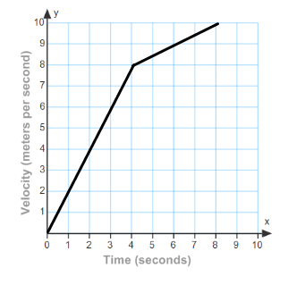
- Which of the following is the velocity vs. time graph?
A. B.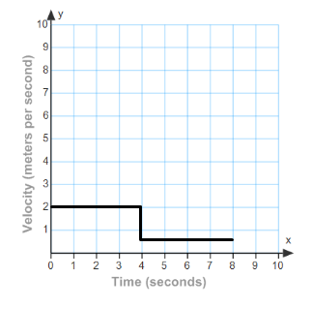 C.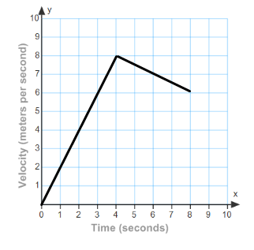 D.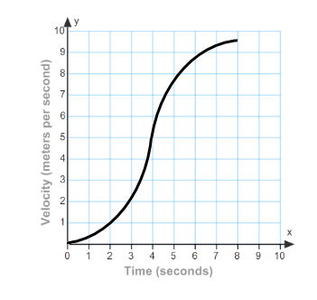 E. 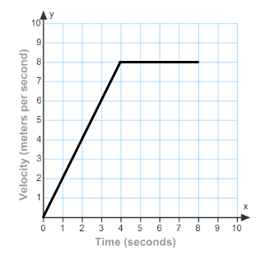

- A car and a delivery truck both start from rest and accelerate at the same rate. However, the car accelerates for twice the amount of time as the truck. What is the final speed of the car compared to the truck?
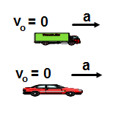
A. Half as much
B. The same
C. Twice as much
D. Four times as much
E. One quarter as much

- A car and a delivery truck both start from rest and accelerate at the same rate. However, the car accelerates for twice the amount of time as the truck. What is the traveled distance of the car compared to the truck?
A. Half as much
B. The same
C. Twice as much
D. Four times as much
E. One quarter as much

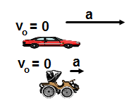
- A modern car can develop an acceleration four times greater than an antique car like “Lanchester 1800”. If they accelerate over the same distance, what would be the velocity of the modern car compared to the antique car?
A. Half as much
B. The same
C. Twice as much
D. Four times as much
E. One quarter as much

- An object is released from rest and falls in the absence of air resistance. Which of the following is true about its motion?
A. Its acceleration is zero
B. Its acceleration is constant
C. Its velocity is constant
D. Its acceleration is increasing
E. Its velocity is decreasing

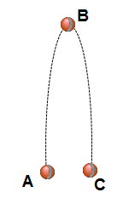

A ball is thrown straight up from point A, reaches
a maximum height at point B, and then falls back to point C,
as illustrated by the picture to the right. Use this for
questions 35, 36, and 37.

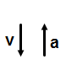
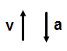
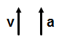
- Which of the following is true about the direction the ball’s velocity and acceleration between A and B?

A. B. C.

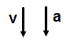
D. E.

- Which of the following is true about the direction the ball’s velocity and acceleration between B and C?
A. B. C.

D. E.

- Which of the following is true about the ball’s velocity and acceleration the highest point B?
A. Its velocity and acceleration are both zero
B. Its velocity is up and non-zero constant and acceleration is zero
C. Its velocity is down and non-zero constant and acceleration is zero
D. Its velocity is zero and acceleration is up and non-zero constant
E. Its velocity is zero and acceleration is down and non-zero constant

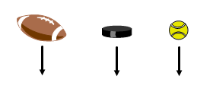
- A football, a hockey puck, and a tennis ball all fall down in the absence of air resistance. Which of the following is true about their acceleration?
A. The acceleration of the football is greater than the other two
B. The acceleration of the hockey puck is greater than the other two
C. The acceleration of the tennis ball is greater than the other two
D. They all fall down with the same constant acceleration
E. More information is required
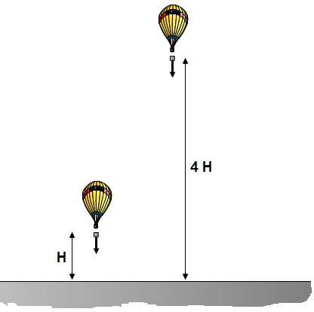

- A package is dropped from an air balloon two times. In the first trial the distance between the balloon and the surface is H and in the second trial 4H. Compare the time it takes for the package to reach the surface in the second trial to that in the first trial?
A. The time in the second trial is four times greater
B. The time in the second trial is two times greater
C. The time the same in both trials because it doesn’t depend on height
D. The time in the second trial is four times less
E. The time in the second trial is two times less

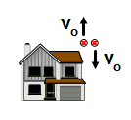
- Two baseballs are thrown from the roof of a house with the same initial speed, one is thrown up, and the other is down. Compare the speeds of the baseballs just before they hit the ground.
A. The one thrown up moves faster because the initial velocity is up
B. The one thrown down moves faster because the initial velocity is down
C. They both move with the same speed
D. The one thrown up moves faster because it has greater acceleration
E. The one thrown down moves faster because it has greater acceleration

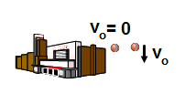
- A tennis ball is dropped from the top of a tall building. A second tennis ball is thrown down from the same building. Make a statement about the acceleration of each tennis ball.
A. The first ball falls with a greater acceleration
B. The second ball falls with a greater acceleration
C. They both fall with the same acceleration because they stated from the same height
D. The both fall with the same acceleration because they are in a free fall
E. More information is required

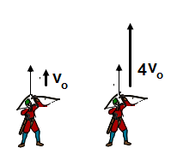

- An archer practicing with an arrow bow shoots an arrow straight up two times. The first time the initial speed is v₀ and second time he increases the initial sped to 4v₀. How would you compare the maximum height in the second trial to that in the first trial?
A. Two times greater
B. Four times greater
C. Eight times greater
D. Sixteen times greater
E. The same

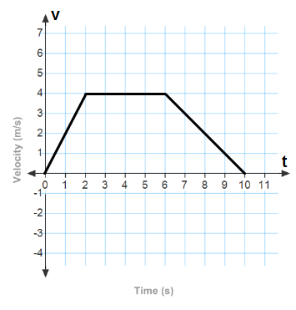

The velocity as a function of time of a moving object is presented by the graph to the right. Use this graph for questions 43 through 48.

- What is the acceleration of the object between 0 s and 2 s?
A. 0 m/s² B. 1 m/s² C. 2 m/s²
D. 3 m/s² E. 4m/s²

- What is the acceleration of the object between 2 s and 6 s?
A. 0 m/s² B. 1 m/s² C. 2 m/s²
D. 3 m/s² E. 4m/s²

- What is the magnitude of acceleration of the object between 6 s and 10 s?
A. 0 m/s² B. 1 m/s² C. 2 m/s² D. 3 m/s² E. 4m/s²

- How far from the origin does the object move in first 2 s?
A. 4 m B. 16 m C. 20 m D. 28 m E. 36 m

- How far from the origin does the object move in first 6 s?
A. 4 m B. 16 m C. 20 m D. 28 m E. 36 m

- How far from the origin does the object move in first 10 s?
A. 4 m B. 16 m C. 20 m D. 28 m E. 36 m

The diagram above presents the position and elapsed time of a motorbike that starts from rest and accelerates at a constant rate. Use it to answer questions 49 and 50.

- What is the average velocity of the motorbike during first 5 s?
A. 0 m/s B. 5 m/s C. 10 m/s D. 15 m/s E. 20 m/s

- What is the acceleration of the motorbike?
A. 0 m/s² B. 2 m/s² C. 4 m/s² D. 6 m/s² E. 8 m/s²

Answers
- E
- B
- C
- B
- C
- D
- C
- E
- C
- C
- E
- B
- A
- E
- B
- D
- E
- B
- A
- A
- E
- E
- A
- D
- A
- C
- A
- E
- A
- B
- C
- D
- C
- B
- B
- D
- E
- D
- B
- C
- D
- D
- C
- A
- B
- A
- C
- D
- C
- C

