INTRODUCTION TO FORCES, TORQUES & LEVERS
Directions: Read the following article and answer questions (eg, Q1) in your notebook.
PART 1: Linear and Rotational Motion
Rigid bodies (objects that cannot bend or stretch) can undergo two different types of motion: linear (in a straight line); and rotational (rotating in a circle). For each type of motion, an object has three optional paths for movement because it occupies three dimensions of space.
Example 1: Ship Motion
A ship (see figure below) can move up/down along the z-axis (line #1), left/right along its y-axis (line #2) or forward/backward along its x-axis (line #3). These three motions are LINEAR because they happen in a straight line, in the same direction as each axis.
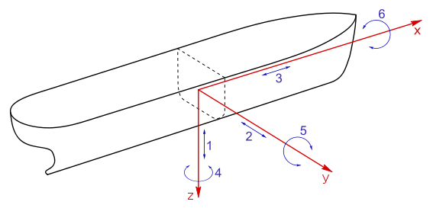
Q1: In your notebook, sketch a picture of a ship. Then, sketch and label arrows representing its three linear paths of motion.

A ship could also undergo three types of ROTATIONAL motion—rotating around each of its three axes. For example, it can rotate left/right around its z-axis (curved line #4), making the ship’s front end pivot left and right. It can also rotate up/down around its y-axis (curved line #5), making the ship’s front end pivot up and down (like a teeter-totter). And, the ship can rotate (twist) around its x-axis (curved line #6), making the ship’s front end twist.
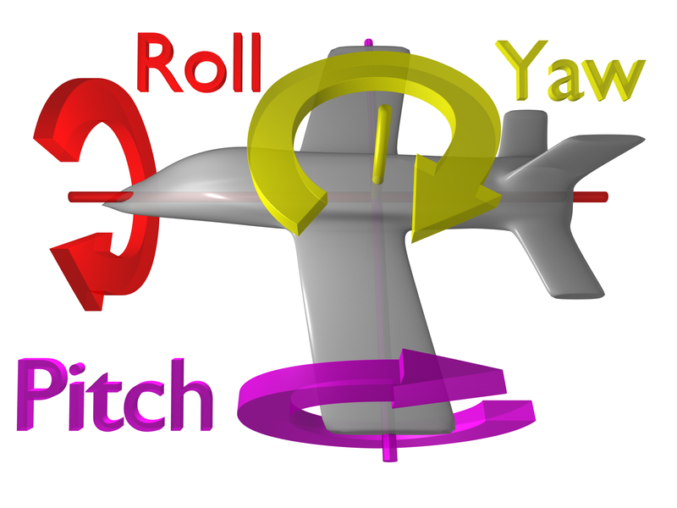
Q2: On the ship diagram in your notebook, sketch and label arrows showing the ship’s three paths of rotational motion.
Example 2: Airplane
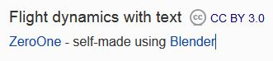
Ships are not the only rigid objects that can experience both linear and rotational motion—in fact, any rigid object can do this.
Q3: In your notebook, sketch the plane (right). Next, draw arrows and write labels representing the three paths of LINEAR motion and three paths of ROTATIONAL motion.
Q4: What is the difference between linear and rotational motion? Explain.

PART 2: FORCES AND TORQUES: MAKING OBJECTS ROTATE
How can we use forces to make objects rotate? During our last lab with the carts and motion detectors, we found that applying a force to an object can change its motion.
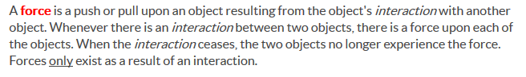

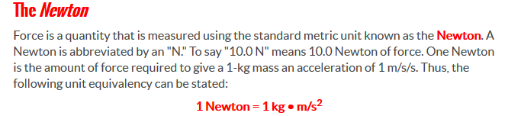

Q5: What is a force?
Q6: What units do we use to measure forces?
Sketch the diagrams below in your notebook. Use the diagrams to answer the following questions:
Q7: What does the dot represent?
Q8: What does the arrow represent?
Q9: What is similar and different about the two situations below?
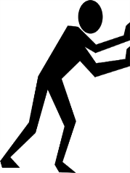
A B

Q10: When a FORCE is applied to the CENTER of an object (rotational axis), will it move in a line or will it “rotate” and fall over? Why do you think this will happen?
Q11: When a FORCE is applied to an object at a DISTANCE FROM ITS CENTER (rotational axis), will it move in a line or will it “rotate” and fall over? Why do you think this will happen?

Sketch diagrams A-C in your notebook. Use the image below to answer the following questions:
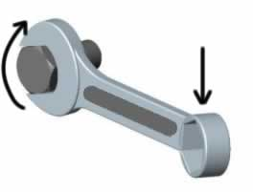
Q12: Which diagrams(s) show forces being applied to the wrench that will cause the wrench to rotate? Explain your reasoning.
F
A B C
F
F

Q13: Based on your answer to Q12, how would you describe the DIRECTION of the force that will make an object rotate—is it PARALLEL to the rigid object or PERPENDICULAR? Explain.
Q14: When you push on a door to make it open, is it easier to open if you push near the door hinge (its axis of rotation) or if you push on a handle that is far away from the hinge? (Try this if you can’t remember!)
Q15: Based on your answer to Q14, will it be easier to turn the bolt in Diagram B or Diagram C? Why?
Watch the following video, then answer the questions below:
Khan Academy Video “Introduction to Torque” (ONLY watch the first 3 minutes) https://www.khanacademy.org/science/physics/torque-angular-momentum/torque-tutorial/v/introduction-to-torque
Q16: What is a TORQUE?
Q17: What units do we use for measuring the size of a torque?
Q17: What two variables affect the size of a torque?
Q18: How is a TORQUE different from a FORCE?
PART 3: CONTROLING THE MOTION OF A FINGER
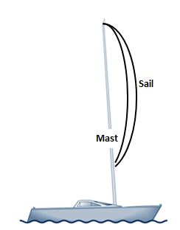
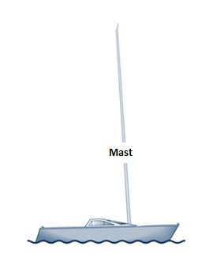
Imagine you have a sail boat (see images below). The sail is attached to a tall, thin post which is called a mast.
Images adapted from: www.hydesails.co.uk/extra-half-knot.html

Q20: Sketch a sailboat in your notebook.
Q21: When the sail is attached, the mast is susceptible to lots of swaying, especially when the wind is blowing. Where could you attach ropes to stabilize the mast? (Sketch your stabilizing ropes on your sailboat sketch).
Q22: What is the minimal number of ropes that you should use? Explain your reasoning.
Q23: In sailing terms, these ropes are called “pulls” or “stays”. Why do you think they have these nicknames?
Although a sail boat does not seem, at first glance, to be similar to a finger, it actually functions due to similar forces. In a finger, pulling (tension) forces are used to control the motion of a finger.
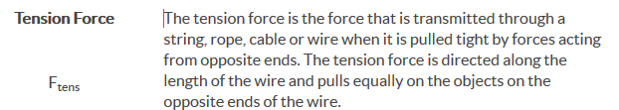

Q24: What is a “tension force”? Define in your own words and sketch a picture.
Q25: Does a tension force push or pull? Explain.

PART 4: FLEXION & EXTENSION
When we think about moving finger bones around a joint, two of the primary types of motion include “flexion” and “extension” (see image below).
Images from: Li K, Chen IM, Yeo SH, Lim CK. Development of finger-motion capturing device based on optical linear encoder. J Rehabil Res Dev. 2011;48(1):69-82.

Q26: In your notebook, define and sketch images to show the meaning of “extension” and “flexion”.

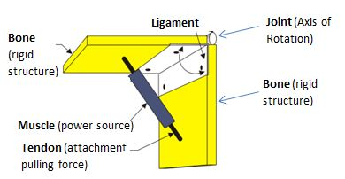
The diagram below shows the basic structure of a hinge joint, similar to that found at one of the distal knuckles of your phalanx (finger).
Q27: Sketch this diagram in your notebook.
Q28: Based on the diagram, do you think this specific muscle/tendon pairing will cause flexion or extension movement? Explain.
Q29: Based on the hinge joint diagram:
- What role do tendons play in controlling motion of a bone?
- What role do muscles play in controlling motion of a bone?
- What role do ligaments play in controlling motion of a bone?
Q30: Based on this diagram, would these bones be able to experience extension movement? Why or why not?
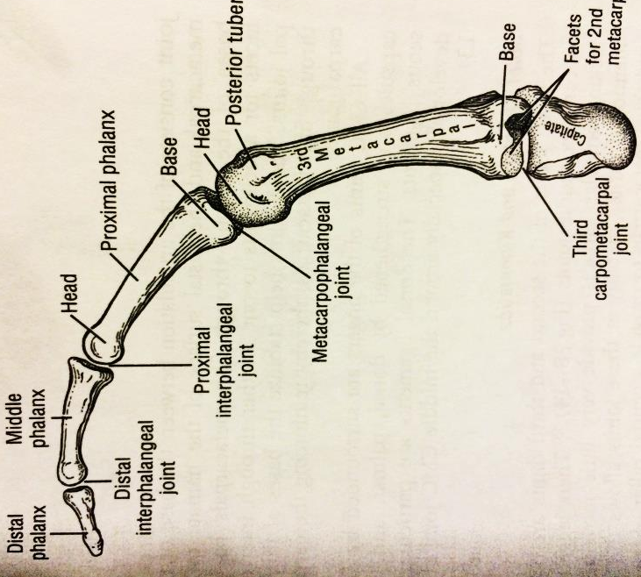
On the right is a diagram of the bones of a human finger.
Q31: Sketch a diagram in your notebook that shows the distal, middle and proximal phalanx bones.
Think about the joint image above that shows how tendons connect your bones and muscles to allow for bone rotation around a joint.
Q32: On your finger sketch, sketch and label in RED where you would attach tendons/muscles to your phalanx bones to allow for flexion movement of your finger.
Q33: Next, sketch and label in BLUE where you would attach tendons/muscles to your phalanx bones to allow for extension movement of your finger.
Q34: Based on your sketches, do the tendons and muscles in your hand cause bone rotation around joints through pulling (tension), pushing (compression) or both?

