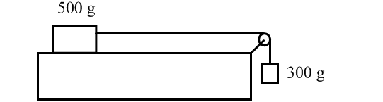
M₁ = 800 g
M₂ = 400 g

An 800 g block lies on a horizontal tabletop. The friction between the table and the block is negligible. The block is connected by a massless string to the second block with a mass of 400 g. The string passes over a light frictionless pulley as shown above. The system is released from rest.

A. Draw a clearly labeled free body diagram for m₁. Include all forces and next to the free body diagram draw the direction of the block’s expected acceleration, a₁.

B. Draw a clearly labeled free body diagram for m₂. Include all forces and next to the free body diagram draw the direction of the block’s expected acceleration, a₂.

C. Use Newton’s Second Law to write an equation for the tension (T) in the string based on your free body diagram for m₁.

F_{t} = m₁a

D. Use Newton’s Second Law to write an equation for the tension (T) in the string based on your free body diagram for m₂.

F_{t} = m₂ g + m₂(-a)

E. Find the acceleration (a) of the system (hint: use both of the equations from parts C and D, Tension Force is the same for both masses)

m₁a = m₂ g + m₂(-a)

a = m₂g/(m₂ + m₁)

a = 3.27 m/s²

F. Find the tension force in the string.

F_{t} = m₁a

F_{t} = 2.61 N

