Purpose:
Motion Sensor
Take a moment to think about all of the ways things move. Think about how fast you’ll need to walk in order to get to school on time. Or think about how hard you’ll need to kick a soccer so it moves to a player across the field.
In the first few chapters of this course you will be exploring how objects move and interact with other objects. To collect information about motion, you will be measuring velocity using a Motion Sensor. In this activity, you will learn to use the motion sensor and the data collection device that works with it.

Key Question:
How can you represent and analyze the motion of an object speeding up, slowing down, and moving at a constant velocity?

Initial Ideas:
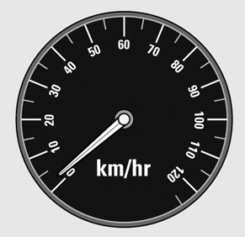
Imagine taking a short trip in your car. When you first start, you push on the gas pedal and the car starts moving and then picks up speed. Once you reach the speed limit, you drive at a constant speed for a while. Then, you come up to a stop sign and you use the brakes to slow the car down and make it stop.

Complete the following question individually in your lab notebook:
- Draw two different ways of showing the motion of the car during its drive. Label when the car was: speeding up, moving at a constant speed, and slowing down.

Share your ideas with your group members.
On a presentation board, record your group’s thoughts about the Initial Ideas.

Reading: Tools of the Trade

The LabQuest2
The LabQuest2 is able to show motion data using graphs and tables. The LabQuest2 has options for graphing “position” and “velocity.” In this course we will begin by learning about velocity. For this activity, we will use velocity and speed to mean the same thing.

General Settings:
- Plug the motion sensor into the LabQuest2
- Once you plug in the motion sensor, a home screen will appear:
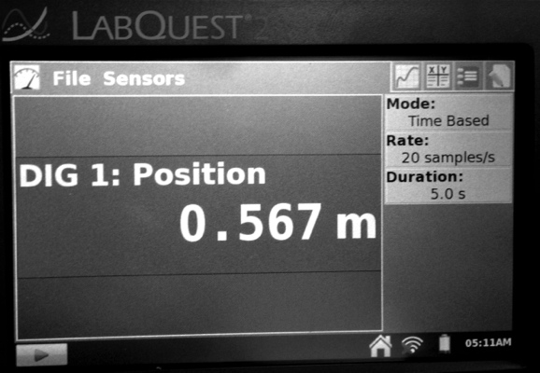
This home screen provides important information about how the data is being collected:
- Rate: how frequently data is being collected
- Duration: amount of time data is collected
You can modify how data is collected by selecting rate or duration from this home screen.

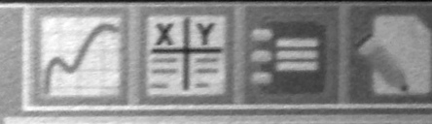
To Open a Velocity-Time Graph:
- From the opening screen, click the logger pro icon that is on the upper right corner of the display.
- Two graphs to appear: position-time and velocity-time.
- For the first several labs, we will only be analyzing a velocity-time graph, so we will need to remove the position-time graph.
- Remove the position-time graph by selecting the Graph tab and then selecting Show Graph.
- 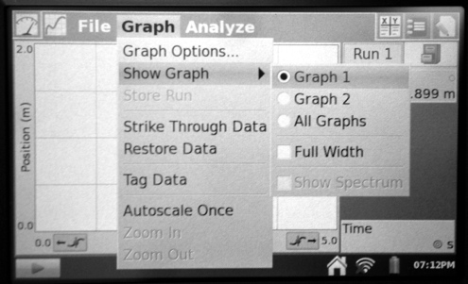Select Graph 2.

Collecting and Interpreting Evidence:
Experiment #1: How can graphs show motion?
Materials:
- Motion sensor
- Data collection device
- Meter stick
- Masking tape
- White board

Step 1: Turn on the data collection device. Connect the motion sensor. Take 5-10 minutes to explore the motion sensor and data collection device. Each group member MUST have a turn using and becoming familiar with the data collection device. Specifically practice using the motion sensor and data collection device to:
- collect motion data
- use different settings on the motion sensor
- change the settings on the data collection device

Step 2: Based upon your exploration with the motion sensor and data collection device, answer the following questions:
- What settings were you able to change on the data collection device? What is the purpose of changing each setting?
- How can you change the motion sensor to collect data for different types of objects?

In this lab, you will collect data about a person’s velocity. We can use a velocity-time graph to collect this data. For now, we will ignore the negative values on the graph by always walking away from the motion sensor. In the next activity, you will learn about the differences between speed and velocity and what negative values mean.

Step 3: Using the data collection device, open a blank velocity-time graph. Check that the Duration (amount of time data is collected) is set to 5 seconds.

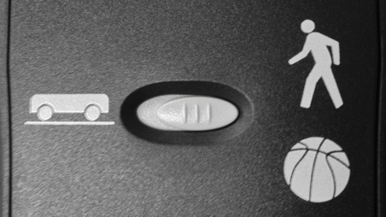
Step 4: Place the motion sensor on the edge of the table and make sure there is a clear path across the floor for 3 meters. Using the meter stick, place masking tape on the floor at 1, 2, and 3 meters away from the motion sensor. Set the motion sensor to collect “long range” (person) data. Hold the dull side of the white board toward the motion sensor for clearer data collection.

3 meters 2 meters 1 meter

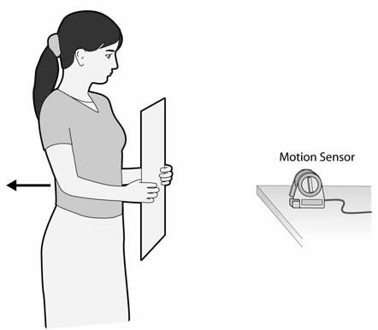
Step 5: Have one member of your group stand 1 meter from the motion sensor. Begin collecting data by pressing PLAY on your data collection device. The person should:
- Stand still for 2 seconds
- Walk away from the sensor to the 3 meter mark
- Stand still again for 2 seconds

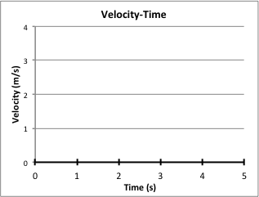
- Draw a graph of your data (on a graph like the one shown on the right).
- What do you think the graph is showing about the person’s velocity?

Step 6: Below are six velocity-time graphs. Try to recreate the graphs by moving in front of the motion sensor and collecting velocity-time graphs with the data collection device.
a. 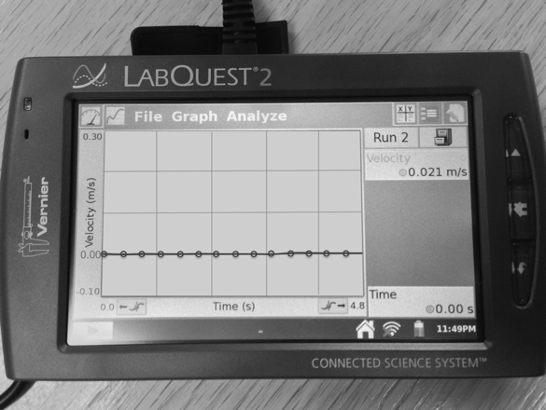 | b. 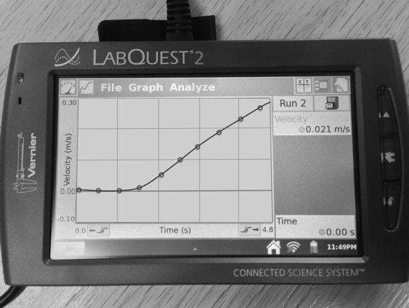
c. 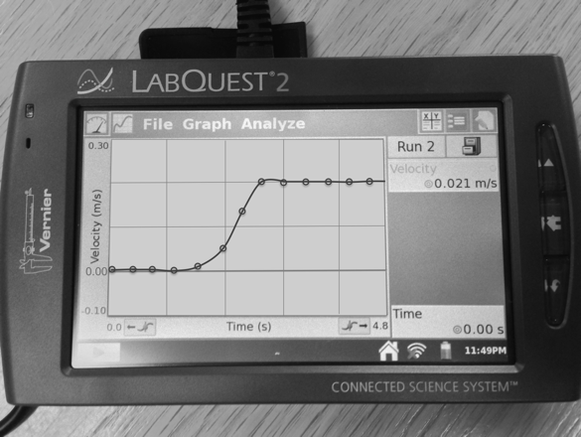 | d. 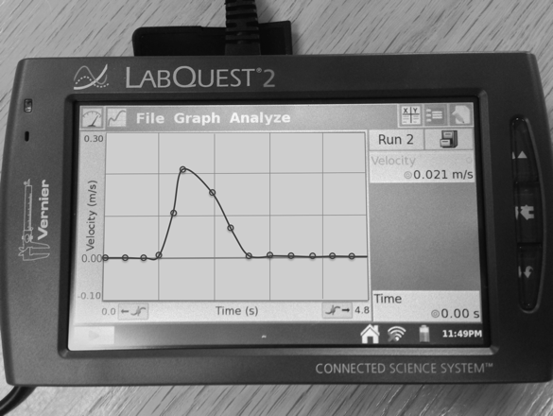
e. 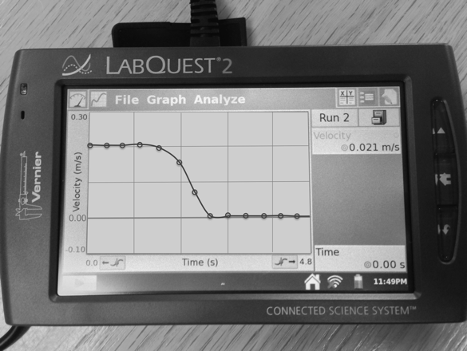 | f. 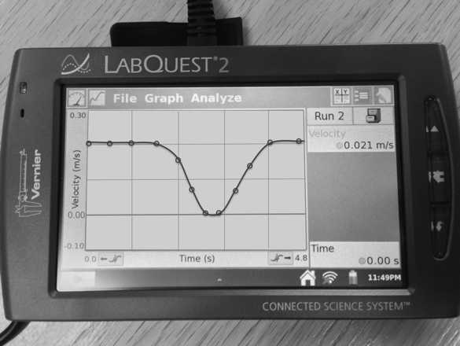
Step 7: Draw each graph in your lab notebook and describe what you did to recreate the graph. Describe how fast you were moving, whether your velocity was changing, and whether you were moving toward or away from the motion detector.
Step 8: Discuss what you have learned about graphing velocity.
- In 2-3 sentences, summarize how to show motion on a velocity-time graph. Write your explanation like you are trying to teach someone who hasn’t done it before.

Collecting and Interpreting Evidence:
Experiment #2: How do graphs show speeding up, slowing down, and constant velocity of an object?
Materials:
- Motion sensor
- Data collection device
- Low-Friction cart
- Track

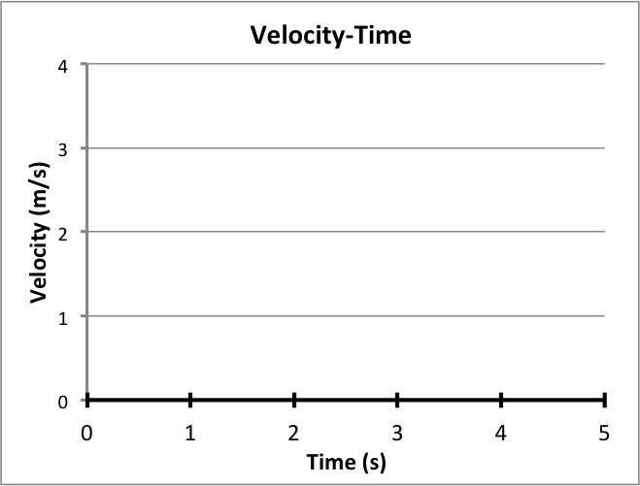
Step 1: In the previous experiment, you walked in front of the motion sensor to show your velocity on a velocity-time graph. In this experiment, your goal is to graph the velocity of a cart moving on a track.
- Draw a blank velocity-time graph (like the one on the right). Predict what the graph will look like for the cart speeding up, moving at a constant velocity, and then slowing down.

- When using the motion sensor for the cart, it needs to be on the “short range” (cart) setting.
- In the next step, the cart should be moving away from the motion sensor.
Step 2: Using the motion sensor, test your prediction from the previous question.
- Using a colored pencil, draw a graph of your data on the same axes as the previous question. Label your first graph as “prediction” and your data as “observation.”
- Compare your “prediction” and “observation” graphs. How are they different? What are some reasons for the differences?

Step 3: Below are four velocity-time graphs. Draw each graph in your lab notebook and predict how you will make the cart move to collect each of the graphs below. Record your ideas in your lab notebook.

a. | b.
c. | d. 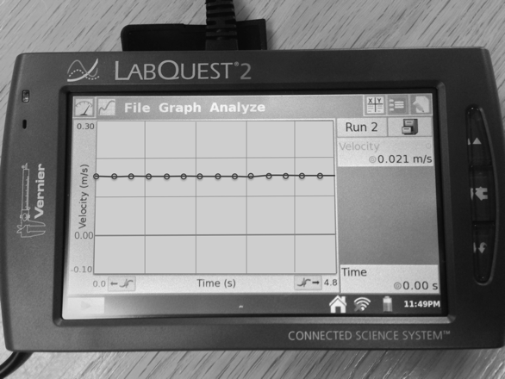

Step 4: Using the motion sensor, data collection device, cart, and track, try to recreate the four graphs from the previous step.
- Describe what you did to recreate each graph.
- Label when the graphs show the cart stopped, speeding up, slowing down, and when it has constant velocity.
- Think back to the previous experiment when you collected velocity-time graphs of a person moving. What method do you prefer for producing motion graphs: having people move in front of the sensor, or using the cart moving along the track? Describe why.
E.1 Summarizing Questions Name: _______________________________
How can you represent and analyze the motion of an object speeding up, slowing down, and moving at a constant velocity?
- On the axes on the right, use two different colors to draw two velocity time graphs:
Graph 1: for an object that is stopped, speeds up, moves at a constant velocity, and then slows down. Label each part of the graph.
Graph 2: for an object that is already moving when data collection starts, then it speeds up, and then it travels at a constant velocity.

- 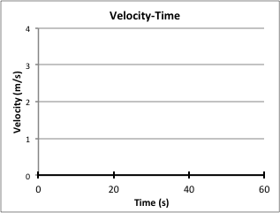On the right is a velocity-time graph for one minute (60 s) of a student’s walk to school.
  - Circle and label when the student is moving at the greatest velocity and when the student is stopped.
  - How long (for what amount of time, in seconds) did the student take to slow down to a stop? How do you know (from the graph)?

  - Describe the student’s motion.

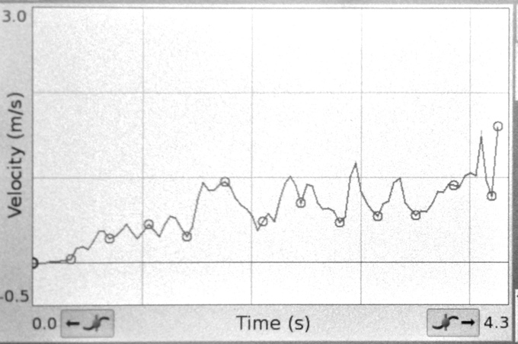
- A group of students collected the graph data shown on the right. Describe how you think the students collected the data (walking or with a cart) and what the graph shows about the object’s motion.

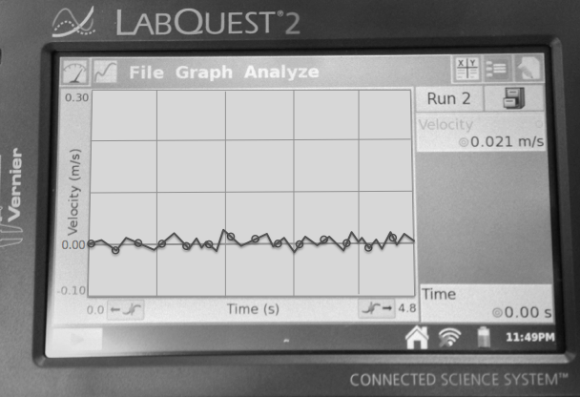
- A group of students watched the cart move along the track and then slow down when it was given a quick tap. The graph on the right shows the velocity-time data they collected.
  - How do you recommend they interpret this data?

  - What are possible ways to improve their data collection in the next trial?

- Using the Velocity-Time graph of the cart on a track give a scientific explanation (using a claim, evidence, and reasoning) that describes the motion of the cart.

E.1 Scientists’ Ideas Reading
Instructions: As you read the Scientists’ Ideas, think about how they relate to the evidence you collected in the activity.
E.1a | Graphs Tell a Story Idea: Graphs are used in science as a way of visually showing (or representing) data. A graph can tell a story about the motion of an object.
As you saw in this activity, graphs can be used to describe the story of an object’s motion. You used velocity-time graphs to show the velocity of a car, a person, and a cart on a track.
E.1b | E.1b - Parts of a Graph Idea: Graphs have two axes: the X-axis and the Y-axis. Graphs need to include a title and labels with units for each axis.
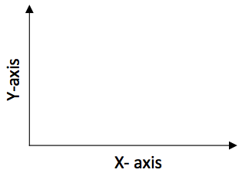You may have heard of graph axes in your math class. The axes are two lines: the horizontal axis (side-to-side) and the vertical axis (up-and-down). Axes is plural word for axis, meaning that when talking about both the X-axis and Y-axis, scientists say axes.
Title
All graphs need to include a title and labels for the X-axis and Y-axis (including units). The graphs you made in this activity represented “velocity” on the Y-axis and “time” on the X-axis. Usually when graphing a variable and time, time will be on the X-axis of the graph.
E.1c | Velocity-Time Graph Idea: In velocity-time graphs, the X-axis represents time and the Y-axis represents velocity. Velocity-time graphs show when an object is stopped, speeding up, slowing down, or moving at a constant velocity.

Velocity-Time Graph | Velocity-Time Graph
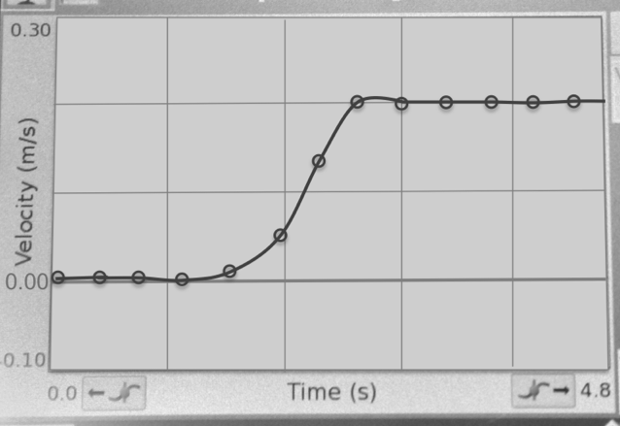  Stopped  Constant  Velocity  Speeding  Up | 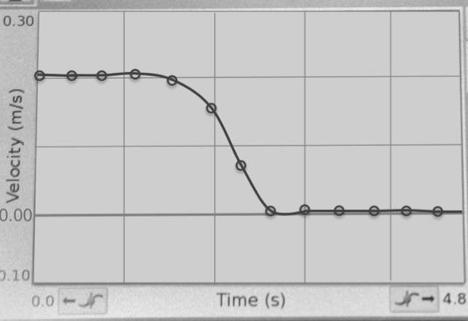  Stopped  Slowing  Down  Constant  Velocity
E.1d | Type of Graphs Idea: Different stories require different types of graphs. Two common graphs are the bar graph and the line graph.
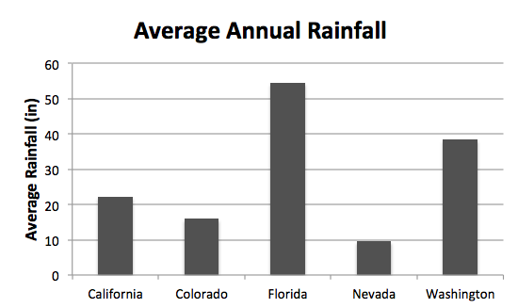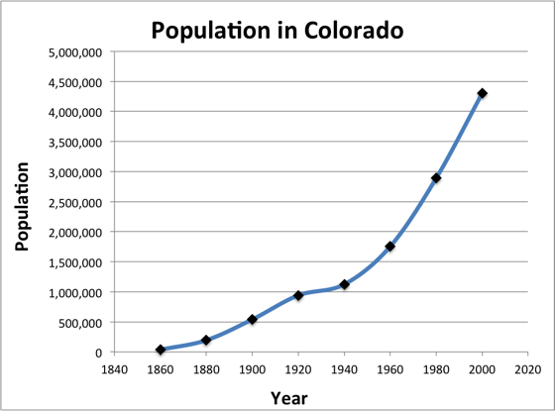There are many different types of graphs. Scientists carefully select the type of graph they use based upon the data they are trying to present. For example, bar graphs are useful when comparing data for different groups. When representing data over time, scientists often use a line graph. This is why line graphs are used to represent how the velocity changes over time. Examples of each of these graphs are shown below.
Bar Graph
Line Graph

Respond to the following questions individually in your lab notebook:
- Describe how graphs are used to tell a story of an object’s motion.
- When making a graph, what must always be present on the graph (regardless of the type of graph)?
- What type of graph did we use in this activity to show velocity and time? Why?
- Describe why a scientist might decide to present temperature data with a bar graph.
- The graph on the right shows a cart that was already in motion at a constant speed and then was pushed (by a hand) to slow it down to a stop. How long (for what amount of time, in seconds) did the cart take to slow down to a stop? How do you know (from the graph)?

- Label the velocity of the object on each of the graphs below. (Include when the object is moving at a constant velocity, speeding up, slowing down or stopped.) What evidence did you collect that supports your answer?
Velocity-Time Graph | Velocity-Time Graph
a. 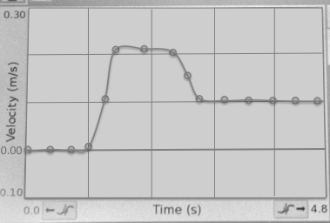 | b. 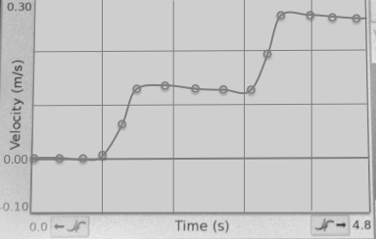
Velocity-Time Graph | Velocity-Time Graph
c. 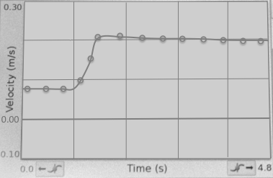 | d. 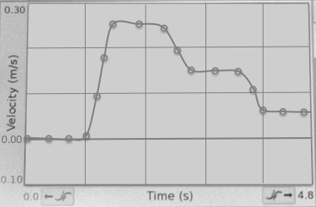
- A car was stopped at a stoplight for 30 seconds. The car quickly sped up to the speed limit (35 miles per hour). It then traveled for 20 seconds at 35 miles per hour and then came up to a school zone. The car slowed its velocity to 20 miles per hour for 20 seconds while traveling in the school zone. Draw this car’s journey:
