Dynamics Multiple Choice Homework
PSI Physics Name____________________________________

- In the absence of a net force, a moving object will
  - slow down and eventually stop
  - stop immediately
  - turn right
  - move with constant velocity
  - turn left

- When a cat sleeps on a table, the net force on it is
  - zero
  - directed upward
  - directed downward
  - directed in the horizontal direction
  - more information is required

- When the engines on a rocket ship in deep space, far from any other objects, are turned off, it will
  - slow down and eventually stop
  - stop immediately
  - turn right
  - move with constant velocity
  - turn left

- In order for a rocket ship in deep space, far from any other objects, to move in a straight line with constant speed it must exert a net force that is
  - proportional to its mass
  - proportional to its weight
  - proportional to its velocity
  - zero
  - proportional to its displacement

- If a book on the dashboard of your car suddenly flies towards you, the forward velocity of the car must have
  - decreased
  - increased
  - changed direction to the right
  - become zero
  - changed direction to the left

- Which Newton’s law can explain the following statement that we often see on the highway display: “Buckle up –it’s the State Law”?
  - First Newton’s Law
  - Second Newton’s Law
  - Third Newton’s Law
  - Gravitational Law
  - None from the above

- A spacecraft travels at a constant velocity in empty space far away from any center of gravity. Which of the following about the force applied on the spacecraft is true?
A. The applied force is equal to its weight
B. The applied force is slightly greater than its weight
C. The applied force is slightly less that its weight
D. The applied force must perpendicular to its velocity
E. No applied force is required to maintain a constant velocity

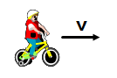
- A boy rides a bicycle at a constant velocity. Which of the following about the net force is true?
A. There is a net force acting in the velocity direction
B. There is a net force acting opposite to the velocity direction
C. The net force is zero
D. There is a net force acting perpendicularly to the velocity direction
E. None from the above

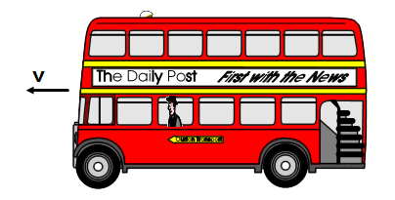
- A passenger standing in a moving bus, facing forward suddenly falls forward. This can be an indication which of the following?
A. The bus speeds up
B. The bus slows down
C. The bus doesn’t change its velocity
D. The bus turns to the right
E. The bus turns to the left

- A passenger standing in a moving bus, facing forward suddenly falls backward. This can be an indication which of the following?
A. The bus speeds up
B. The bus slows down
C. The bus doesn’t change its velocity
D. The bus turns to the right
E. The bus turns to the left

- A passenger standing in a moving bus, facing forward suddenly falls to the right. This can be an indication which of the following?
A. The bus speeds up
B. The bus slows down
C. The bus doesn’t change its velocity
D. The bus turns to the right
E. The bus turns to the left
- The acceleration of an object is proportional to
  - the net force acting on it
  - its position
  - its velocity
  - its mass
  - its displacement

- The acceleration of an object is inversely proportional to
  - the net force acting on it
  - its position
  - its velocity
  - its mass
  - its displacement

- A net force F accelerates a mass m with an acceleration a. If the same net force is applied to mass 5m, then the acceleration will be
  - 5a
  - 25a
  - a/5
  - a/25
  - a/10

- A net force F acts on a mass m and produces an acceleration a. What acceleration results if a net force 3F acts on mass 6m?
  - a/2
  - 8a
  - 4a
  - 2a
  - a/4

- A loaded truck collides with a car causing huge damage to the car. Which of the following is true about the collision?
A. The force on the truck is greater than the force on the car
B. The force on the car is greater than the force on the truck
C. The force on the truck is the same in magnitude as the force on the car
D. During the collision the truck makes greater displacement than the car
E. During the collision the truck has greater acceleration than the car
- When a baseball is struck by a bat, the force of the bat on the ball is equal and opposite to the force of the ball on the bat. This is an example of
  - Newton's first law
  - Newton's second law
  - Newton's third law
  - Newton's law of gravitation
  - None from the above

- If you exert a force F on an object which has a much greater mass than you do, the force which the object exerts on you will
  - be of magnitude F and in the same direction
  - be of magnitude F and in the opposite direction
  - be of much less magnitude than F
  - be of much greater magnitude than F
  - be zero

- Newton’s third law refers to “action-reaction forces”. These forces always occur in pairs and
  - sometimes act on the same object
  - always act on the same object
  - may be at right angles
  - never act on the same object
  - always act at right angles

- Action-reaction forces are
  - equal in magnitude and point in the same direction
  - equal in magnitude and point in opposite directions
  - unequal in magnitude but point in the same direction
  - unequal in magnitude and point in opposite directions
  - cancel each other
- A car traveling at 40 m/s strikes a mosquito. Which of the following is the true statement?
  - The force on the mosquito is greater than the force on the car
  - The force on the mosquito is equal to the force on the car
  - The force on the mosquito is smaller than the force on the car
  - The damage to the mosquito is equal to the damage to the car
  - None from the above

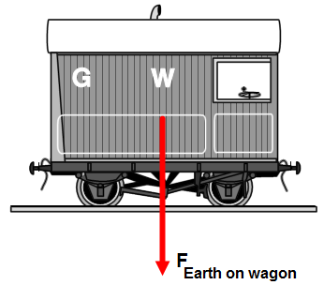
- The Earth pulls down on a railroad wagon with a force of 200 kN. Which of the following is the “reaction force”?
A. The wagon pulls up the Earth with 200 kN
B. The wagon pushes down the railroad with 200 kN
C. The railroad pushes up the wagon with 200 kN
D. The buoyant force pushes up the wagon with 200 kN
E. The wagon pushes down the Earth with 200 kN

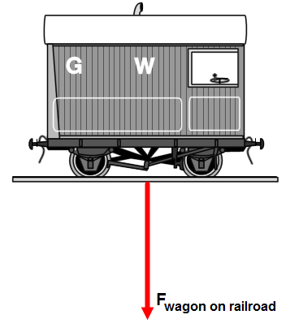

- A railroad wagon pushes down on a railroad with a force of 200 kN. Which of the following is the “reaction force”?
A. The wagon pulls up the Earth with 200 kN
B. The wagon pushes down the railroad with 200 kN
C. The railroad pushes up the wagon with 200 kN
D. The buoyant force pushes up the wagon with 200 kN
E. The wagon pushes down the Earth with 200 kN

- Earth pulls downward on a pen, of mass m, which is sitting on a table; the magnitude of the force is mg. If that is called the action force, what is the reaction force?
  - The table pushing up on the pen with a force equal to mg
  - The pen pushing down on the table with a force equal to mg
  - The table pushing down on the floor with a force equal to mg
  - The pen pulling upward on Earth with a force equal to mg
  - The pen pulling up on the table with a force equal to mg

- A traffic light is suspended from a cable. Earth pulls downward on the traffic light with a force of 1500 N. If this is the "action force," what is the "reaction force"?
  - The cable pulling upward on the traffic light with a 1500 N force
  - The traffic light pulling downward on the cable with a 1500 N force
  - The traffic light pulling upward on Earth with a 1500 N force
  - Earth pulling downward on the cable with a 1500 N force
  - The cable pulling up on Earth with a 1500 N force

- A soccer player kicks a soccer ball with a force of 1300 N. The soccer ball hits the player with a force of
  - less than 1300 N
  - exactly 1300 N
  - more than 1300 N
  - 0 N
  - none from the above

- Mass and weight
  - Both have the same measuring units
  - Both have different measuring units
  - Both represent force of gravity
  - Both represent measure of inertia
  - None from the above

- The acceleration due to gravity is higher on Jupiter than on Earth. The mass and weight of a rock on Jupiter compared to that on Earth would be
  - same, more
  - same, less
  - more, more
  - more, less
  - same, same

- Which of the following is an example of a force which acts at a distance (without contact)?
  - Tension
  - Gravity
  - Static friction
  - Kinetic friction
  - Normal force

- A ball is thrown straight up. At the top of its path, the magnitude of the net force acting on it is
  - less than zero
  - between zero and mg
  - equal to mg
  - greater than mg
  - none from the above

- A hammer and a pebble are dropped simultaneously from the same height. Neglect air resistance.
  - the hammer accelerates faster because it is heavier
  - the hammer accelerates slower because it has more inertia
  - the pebble accelerates faster because it has a smaller mass
  - they both accelerate at the same rate because they have the same weight to mass ratio
  - the pebble accelerates slower because it has a smaller mass

- An elevator of mass M is pulled upwards at constant velocity by a cable. What is the tension in the cable (neglecting the mass of the cable)?
  - less than zero
  - between zero and Mg
  - equal to Mg
  - greater than Mg
  - zero

- An elevator of mass M is pulled upwards by a cable; the elevator has a positive, but decreasing, velocity. What is the tension in the cable (neglecting the mass of the cable)?
  - less than zero
  - between zero and Mg
  - equal to Mg
  - greater than Mg
  - zero

- An elevator of mass M is pulled upwards by a cable; the elevator has a positive, increasing, velocity. What is the tension in the cable (neglecting the mass of the cable)?
  - less than zero
  - between zero and Mg
  - equal to Mg
  - greater than Mg
  - zero

- **Which force is directly responsible for your ability to walk, and to stop?
  - weight
  - kinetic friction
  - static friction
  - normal force
  - applied force

- **Why is it so much more difficult to get a heavy table to start moving, than it is to keep it moving?
  - the normal force is greater for objects at rest
  - μ_{s} < μ_{k}
  - μ_{s} = μ_{k}
  - μ_{s} > μ_{k}
  - μ_{s} = 0

- **A horizontal force is exerted on an object so that it accelerates at a constant rate across a rough horizontal surface (friction cannot be neglected). The applied force is then doubled; what happens to the object’s acceleration?
  - It increases to more than double its original value
  - increases to exactly double its original value
  - It increases to less than double its original value
  - It increases somewhat
  - It drops to zero

- **A box is being pushed by a constant force along a horizontal surface. If the object’s velocity is constant, we can infer that there is _______ acting on the box
  - a frictional force
  - a net downward force
  - no frictional force
  - a net force upward
  - a net force in the acceleration direction

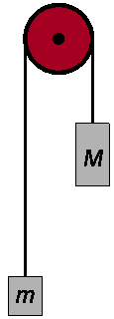
- **In the Atwood machine, shown on the diagram, two masses M and m are suspended from the pulley, what is the magnitude of the acceleration of the system? (Ignore friction and the mass of the pulley. M > m)

  - $\frac{\left(M-m\right)g}{M+m}$

  - $\frac{\left(M-m\right)g}{M-m}$

  - $\frac{\left(M+m\right)g}{M+m}$

  - $\frac{\left(M-m\right)g}{2M}$

  - $\frac{\left(M-m\right)g}{2m}$

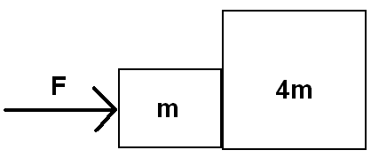
- **In the figure to the right, two boxes of masses m and 4m are in contact with each other on a frictionless surface. What is the acceleration of the more massive box?
  - F/m
  - F/(2m)
  - F/(4m)
  - F/(5m)
  - F/(6m)

- **In the figure to the right, two boxes of masses m and 4m are in contact with each other on a frictionless surface. What is the force causing the acceleration of the more massive box?
  - 4F
  - 3F/2
  - 5F/4
  - 4F/5
  - F/6

- **In the figure to the right, two boxes of masses m and 3m are connected by a string while a force F is pulling on the more massive box; what is the acceleration of the less massive box?
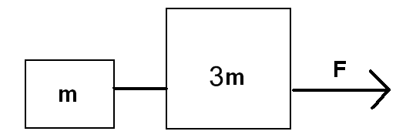
  - F/m
  - F/(2m)
  - F/(4m)
  - F/(5m)
  - F/(6m)

- **In the figure to the right, two boxes of masses m and 3m are connected by a string while a force F is pulling on the more massive box; what is the tension force in the string between the boxes?
  - F/m
  - F/2
  - F/4
  - F/5
  - F/6

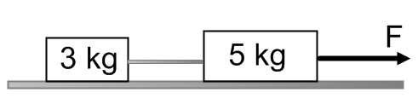
- **A system of two blocks is accelerated by an applied force of magnitude F on the frictionless horizontal surface. The tension in the string between the blocks is:
A. 3F
B. 5F
C. 3/8 F
D. 1/3 F
E. 1/5 F

- Two blocks are attached by a compressed spring and are initially held at rest on a frictionless surface. The blocks are then released simultaneously. If block I has four times the mass of block II, which of the following quantities is the same for both blocks as the spring pushes the two blocks away from each other?
(A) Speed
(B) Velocity
(C) Acceleration
(D) Displacement
(E) Force on each block

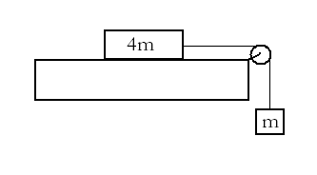
- A block of mass 4m can move without friction on a horizontal table. This block is attached to another block of mass m by a string that passes over a frictionless pulley. If the masses of the string and the pulley are negligible, what is the magnitude of the acceleration of the descending block?
A. g/5
B. g/4
C. g/3
D. 2g/3
E. g

- A locomotive is pulling an empty freight car with a constant acceleration on a horizontal surface. The mass of the locomotive is five times the mass of the car. Which statement is true about the force applied by the car on the locomotive?
- 5 times greater than the force of the locomotive on the car
- 5 times less than the force of the locomotive on the car
- Zero since they move with a constant acceleration
- Equal to the force of the locomotive on the car
- More information is required

- **A block with initial velocity of 3 m/s slides 9 m across a rough horizontal surface before coming to rest. What is the coefficient of kinetic friction?
A. 0.10
B. 0.50
C. 0.30
D. 0.05
E. 0.01

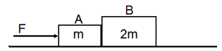

- **In the diagram shown above, two blocks A and B with masses m and 2m are in contact on a horizontal frictionless surface. A force F is applied to block A. What is the acceleration of the system two blocks?
A. F/m
B. F/2m
C. F/3m
D. F/4m
E. F/5m

- **In the diagram shown above, two blocks A and B with masses m and 2m are in contact on a horizontal frictionless surface. A force F is applied to block A. What is the force exerted by block A on block B?
A. F/2
B. F/3
C. 3F/2
D. 2F/3
E. F/5

Answers
- D
- A
- D
- D
- B
- A
- E
- C
- B
- A
- E
- A
- D
- C
- A
- C
- C
- B
- D
- B
- B
- A
- C
- D
- C
- B
- B
- A
- B
- C
- D
- C
- B
- D
- C
- D
- A
- A
- A
- D
- D
- C
- C
- C
- E
- A
- D
- D
- C
- D

