Learning Target: You will analyze energy conversions using elastic objects in order to make and support a claim about energy in systems.
Purpose:
In previous activities, you made inferences about energy transfers between rigid objects (objects like carts that don’t bend or stretch). You observed velocity increases and inferred that kinetic energy also increased. Unlike the carts, elastic objects (such as a rubber band or a trampoline) can be stretched or deformed in some way. How do these stretchy objects change in energy when they are in contact with other objects? How are energy transfers for elastic objects different than for rigid objects?
What energy conversions take place when stretchy objects are involved?

Initial Ideas:
Think about a child that is playing with a small toy slingshot. The child is launching little marshmallows across a field by pulling back the slingshot and then releasing the marshmallow.

Complete the following questions individually in your lab notebook:
- When the slingshot is pulled back, what energy transfers are taking place? Explain your thinking.
- When the marshmallow is released, what energy transfers are taking place? Explain your thinking.
- During both the pulling back of the slingshot and the releasing of the marshmallow, how is energy changing forms?

Share your ideas with your group members.
On a presentation board, record your group’s thoughts about the Initial Ideas.

Review from activities 1, 2, and 3.

Read the Tools of the Trade about how you will be collecting velocity-vs-time data in this experiment.
 | You will be collecting data with the cart moving toward the motion sensor. Remember that we refer to this as motion in the negative direction. Review what a velocity-time graph looks like when the cart is moving toward the motion detector and is speeding up, moving at a constant speed, and then slowing down. | 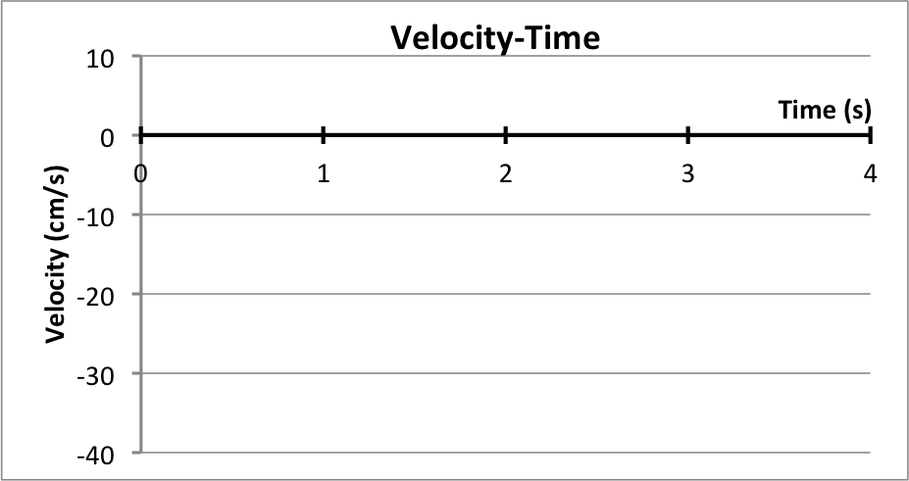  Slowing Down  Speeding Up  Constant

- For the graph shown in the Tools of the Trade reading, describe how the cart’s kinetic energy changes over time. Use Evidence. Check your group’s ideas with another group before moving on in the experiment.

Collecting and Interpreting Evidence: Experiment #1:
Can energy be “stored” and used later?
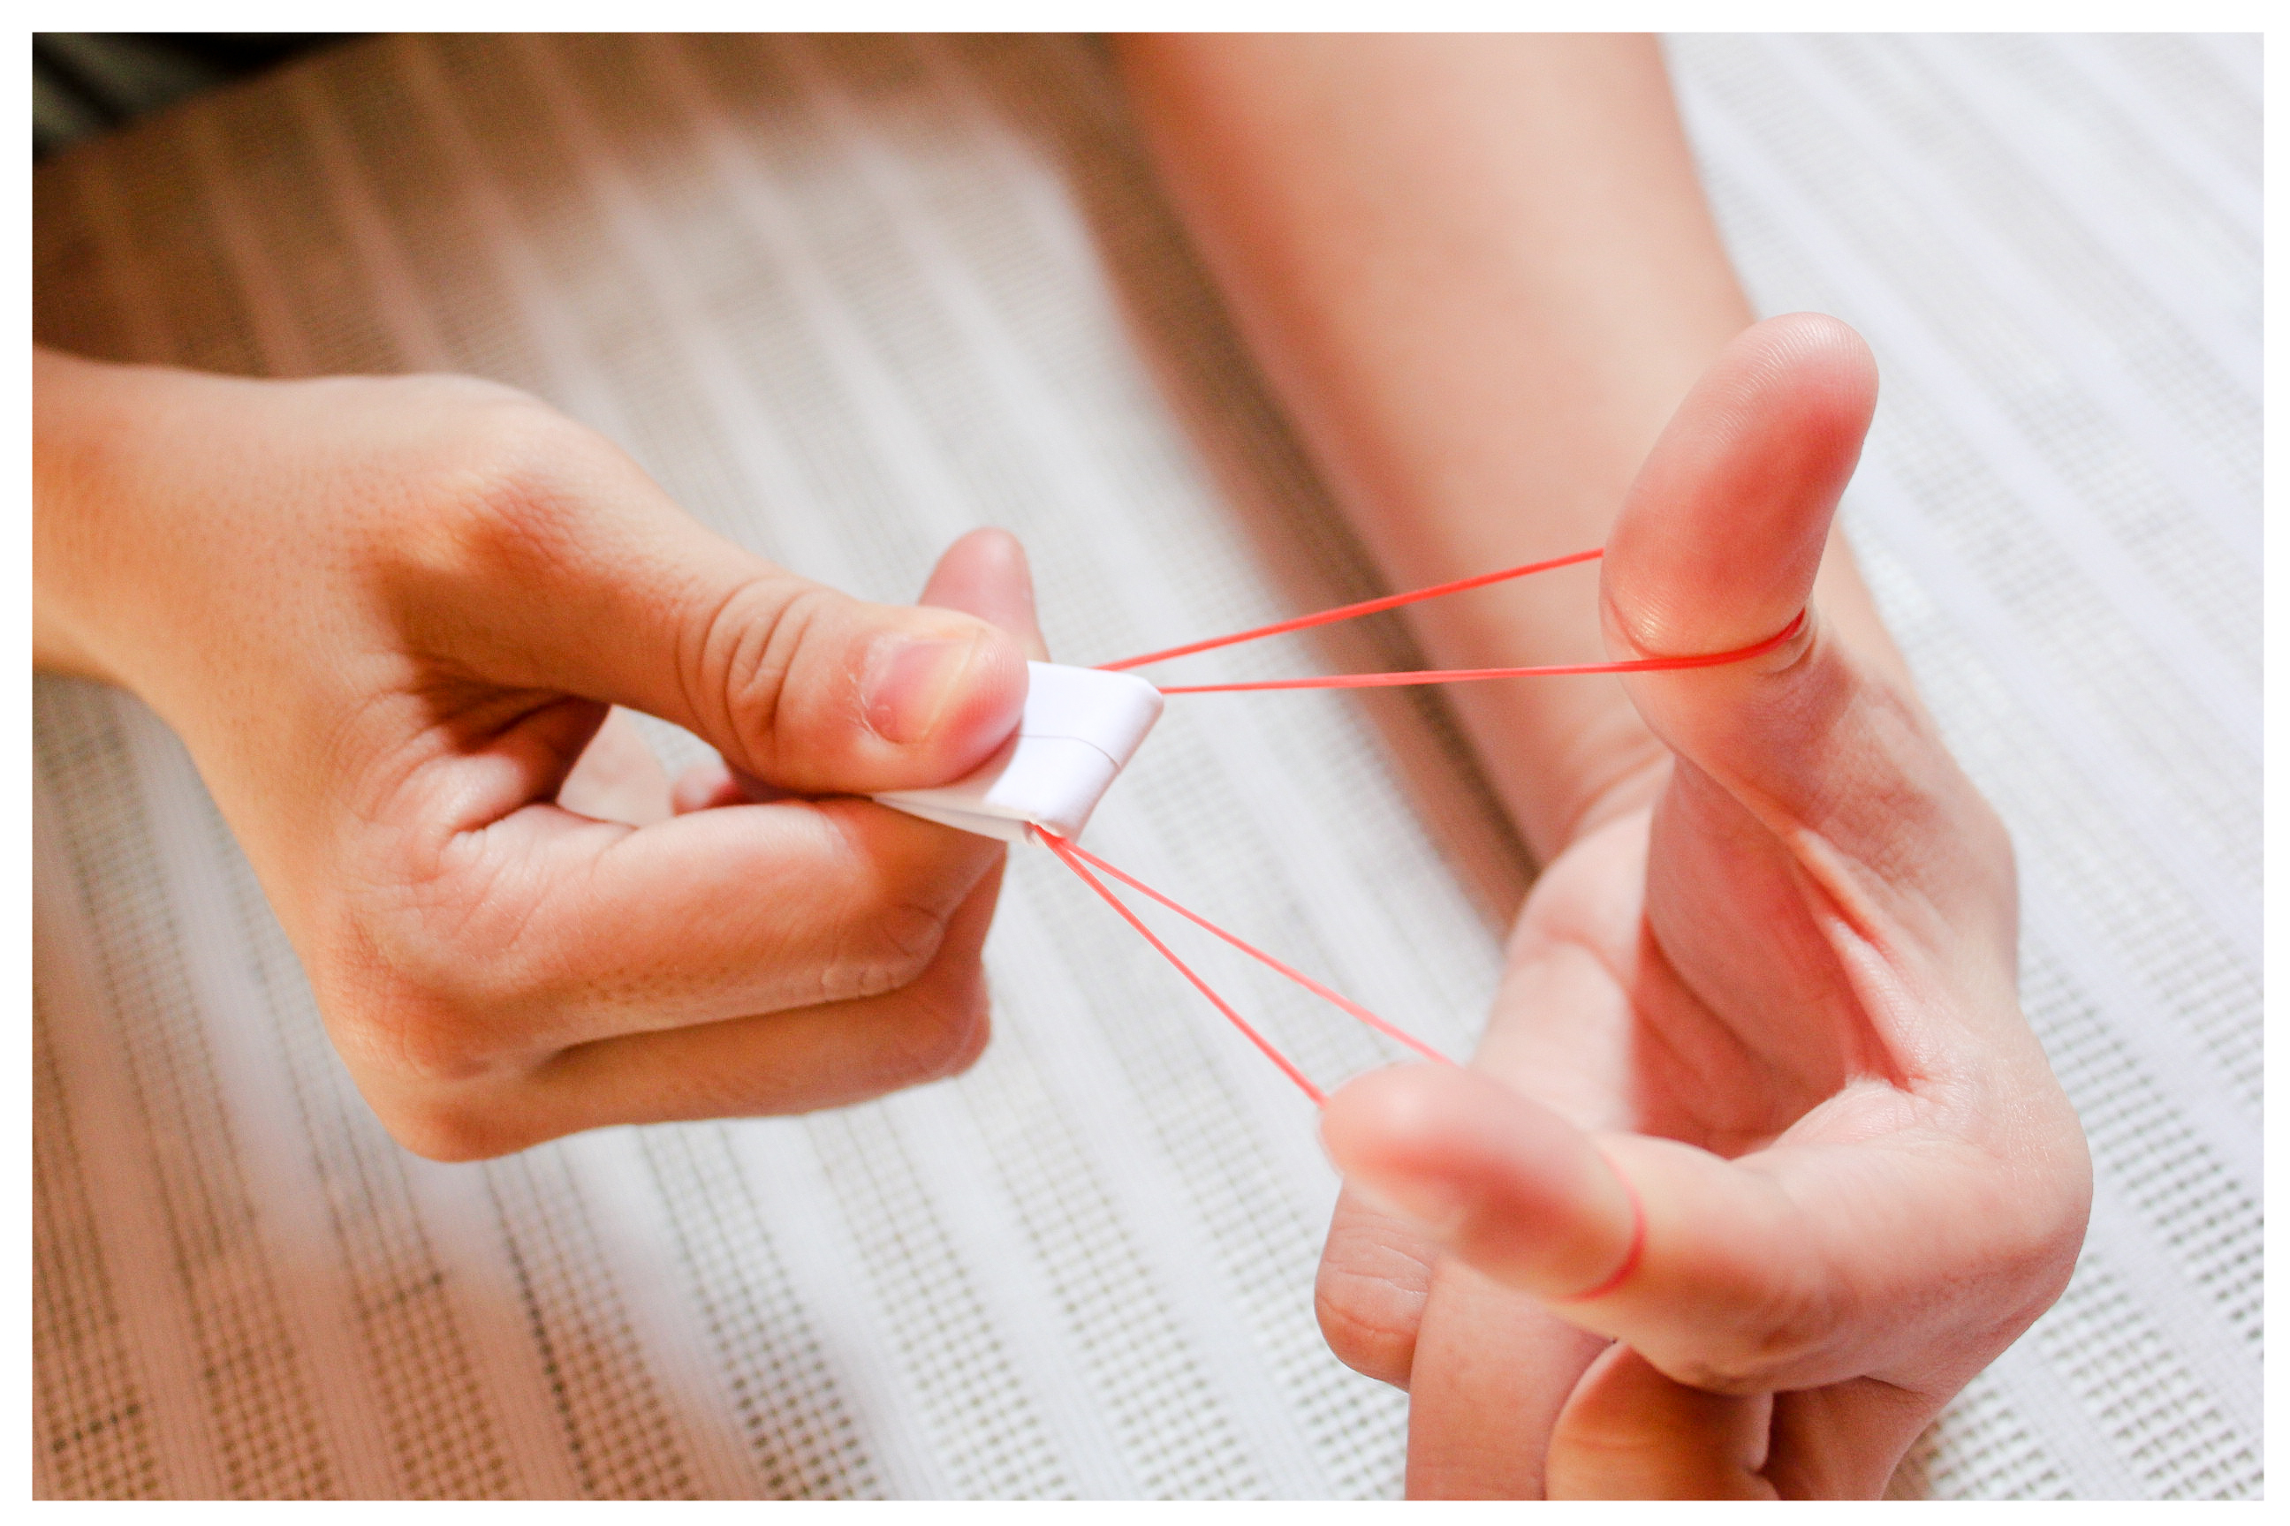
Materials:
Elastic launcher (rubber band) piece of paper

Step 1: Set up the experiment by folding a small piece of paper and using your fingers to brace the rubber band.

Step 2: Place the paper across the rubber band and use it to pull the elastic band back.
- Do you think the elastic band has energy when it is stretched back? What is your reasoning?
- Do you think the paper has energy at this time? What is your reasoning?

Step 3: Release the band and paper (pick up any pieces launched and do not launch at other people).
- Where did the paper get its kinetic energy?

Step 4: In your lab notebook, complete the statements below about how an elastic object is changing energy (increasing, decreasing, not changing).
When an elastic object is being stretched, the amount of energy “stored” in the elastic is _______________________________.
When an elastic object is being released, the amount of energy “stored” in the elastic is _______________________________.

- In your laboratory notebook, complete the energy diagram for when the elastic band releases and the paper is being launched.
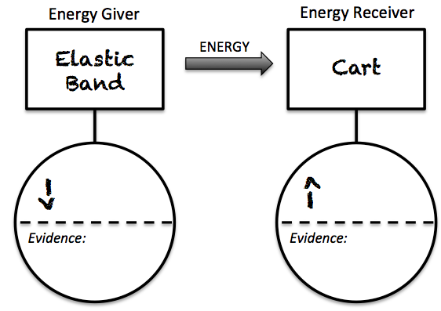
Paper

Step 5: The above set up was used to measure velocity of a cart. The cart is initially located at the right, stretching the band to “launch” the cart. The motion sensor was used to determine the maximum speed of a cart when it is launched when the band is stretched to different distances. Read the Tools of the Trade reading (below) about finding maximum speed from a velocity-vs-time graph.
 | To find the maximum speed from a velocity-vs-time graph, find the largest value of velocity. You may ignore the negative sign because it is only telling you direction. We are interested in speed, not velocity.  The graph on the right shows two carts. Cart A has a maximum speed of 20 cm/s and Cart B has a maximum speed of 30 cm/s. Cart B has a greater maximum speed than Cart A | Cart A  Cart B  Cart A Cart B
Stretch Distance (cm) | Maximum Speed (m/s)
1 cm
2 cm
3 cm
4 cm
5 cm
Step 6: Draw the experimental set up in your notebook. Label where the stretch distance was measured.

Step 7: Analyze the graphs that were created by releasing the cart from stretch distances of 1 cm, 2cm, 3cm, 4cm, and 5cm. Draw and complete the data table from the right into your notebook.

Step 8: Write and complete the following statements.
- The cart had the most kinetic energy after being released from the stretch distance of __________, The evidence to support this is _________________________________ ______________________________________________________________.
- The band had the greatest amount of energy at the stretch distance of ________________. The reasoning for this is _____________________________________________________________________________________.
 | This activity explored how the elastic band “stores” energy. This type of “stored” energy is called Elastic Potential Energy and as you found in this experiment, the amount of elastic potential energy is dependent upon the distance the elastic object is stretched. | 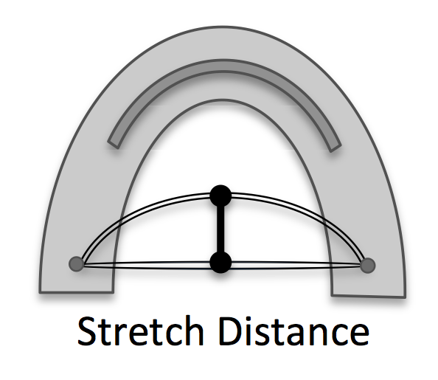
Collecting and Interpreting Evidence: Experiment #2:
What happens to energy after it enters a system?
Materials:
Elastic launcher Track
Low-friction cart Motion Sensor
Data collection device Slow motion video

Step 1: Place the elastic launcher at one end of the table. You may either clamp the launcher to the table, have a group member hold it, or secure it with books.

Step 2: Place the cart 20-30 cm away from the launcher. Start collecting velocity-vs-time data and then give the cart a gentle push toward the elastic band.
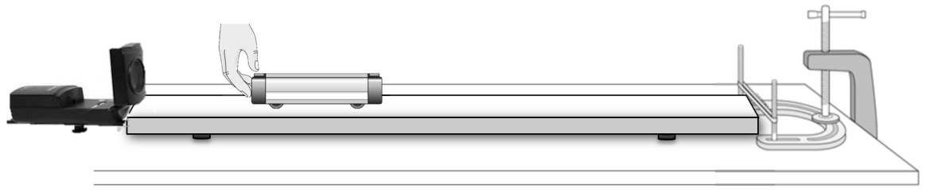
- Sketch the velocity-vs-time graph in your lab notebook. On the velocity-vs-time graph, label the following:
- The instant the cart first comes in contact with the elastic band
- The instant cart reverses direction
- The instant the cart leaves the band
- On the velocity-time graph that you just sketched in your lab notebook, label the following:
- When the kinetic energy of the cart is decreasing
- When the kinetic energy of the cart is increasing
- When the kinetic energy of the cart is zero
- During the time that the cart is slowing down, where is the cart’s kinetic energy going to? What energy conversions are taking place?
- During the time that the cart is speeding up, where is the cart’s kinetic energy coming from? What energy conversions are taking place?

Step 3: Watch the slow motion video of the cart when it collides with the band. Below are time-lapse pictures taken from the video.
- When was the kinetic energy of the cart the greatest? When was the kinetic energy of the cart the least? What evidence supports your inference?
- When was the elastic potential energy of the band the greatest? When was the elastic potential energy of the band the least? What evidence supports your inference?
Energy of the Cart + Energy of the Band = Total Energy in the Cart and Band
- Do you think the energy of the cart plus the band (total energy) in Snapshot #1 is the much more, much less, or about the same as the total energy in Snapshot #2? What is your reasoning?
In the previous questions, you thought about the “total energy” in the cart and the band combined. By deciding to look only at the cart and the band (without including the hand and the track), you have defined the cart and the band as the system. Scientists often choose the objects they want to focus on and call that the system. Everything else is considered the surroundings.
- If you chose the system to be the cart and elastic band, at what point did energy enter the system? Where did it come from?
- As the cart moves along the track and slows down due to friction, what happens to the amount of energy in the system?
Step 4: Imagine that you could remove friction entirely from the track and cart. Complete the statement below.
The amount of energy that enters the system is _____________________ the amount of energy that remains in the system.
Collecting and Interpreting Evidence: Experiment #3:
energy Change in the System
Materials:
Elastic launcher Track
Low-friction cart Motion Sensor Data collection device

Step 1: Use the time-lapse picture below to answer questions about the cart, band, and surroundings.
- Prediction Claim: Do you think the kinetic energy in the cart in Snapshot #1 is greater than, less than, or about the same as the energy in the cart in Snapshot #5?
- Gather Evidence: Write a detailed procedure for how you could determine whether the kinetic energy is the same in Snapshot #1 and Snapshot #5.

Step 2: Carry out your procedure (or if your data from the previous experiment was detailed enough, you may just begin to use your data).
- Conclusion Claim: Based on your experiment, is the kinetic energy of the cart in Snapshot #1 greater than, less than, or about the same as the energy of the cart in Snapshot #5?
- Evidence: What was the speed of the cart the moment it first came into contact with the band?
- Evidence: What was the speed of the cart the moment it was released from the band?
- Reasoning: Explain how the evidence of your experiment (speed) supports your claim about the energy of the cart. If there was energy loss, explain what could be the cause.

Summarizing Questions Name: _______________________________
What energy conversions take place when stretchy objects are involved?
Learning Target: You will analyze energy conversions using elastic objects in order to make and support a claim about energy in systems.
- What evidence supports the claim that elastic objects can “store” energy?

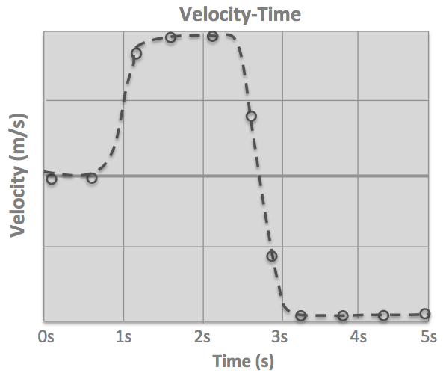
- The graph on the right shows the velocity of a cart that was pushed toward an elastic band and then reversed direction when coming in contact with the band.
  - Circle and label the entire time the hand was in contact with the cart.
  - Circle and label the entire time the cart was in contact with the band.
  - Place an X on the graph at the moment when the band was stretched the most. What is your rationalle?
  - The graph below shows the kinetic energy for the cart. On the graph on the right, sketch the elastic potential energy of the band.
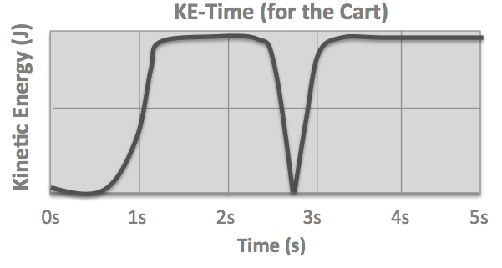
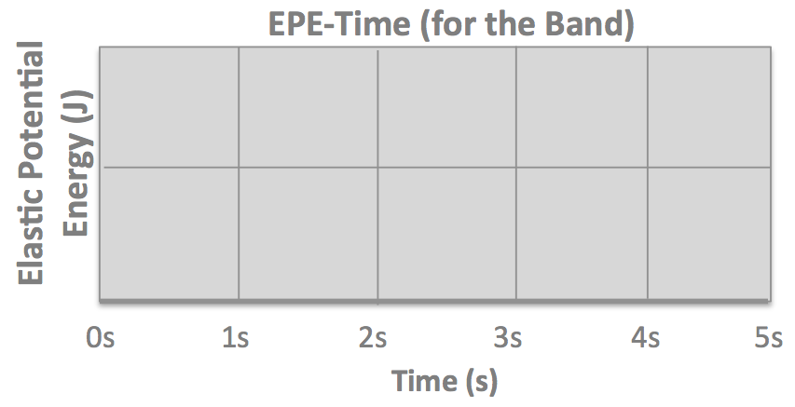

- In previous science classes, you have no doubt heard that “energy cannot be created or destroyed” (the Law of Conservation of Energy). Using the ideas of system, surroundings, and evidence from this activity, write a Scientist Idea for conservation of energy.

1.5 Scientist Ideas Reading
Instructions: Read the Scientist Ideas, paying careful attention to each key idea. When you read, try to think about how the key ideas relate to the evidence you collected in the activity.
Potential Energy Idea: When elastic objects are stretched they are able to store energy. This energy is called elastic potential energy and it is available as the object goes back to its unstretched state.
Amount of Energy Idea: The amount of elastic potential energy an object has available is proportional to how much it is stretched.
Have you ever jumped on a trampoline and wondered why you are able to jump so much higher on a trampoline than when you are just jumping from the ground? This is because potential energy is stored in the trampoline when it is stretched. The amount of energy available is proportional to the amount the object is stretched.
When a person jumps on a trampoline energy is converted from one form to another: kinetic energy associated with the persons speed is converted into elastic potential energy as the person lands on the trampoline and the trampoline is stretched. Then, as the trampoline goes back to its original position (becomes less stretched), the person is launched upward as elastic potential energy is converted back to kinetic energy.
Energy Can be Converted Idea: Energy can be converted from one form to another. For example, kinetic energy can be converted into elastic potential energy as an object changes shape.
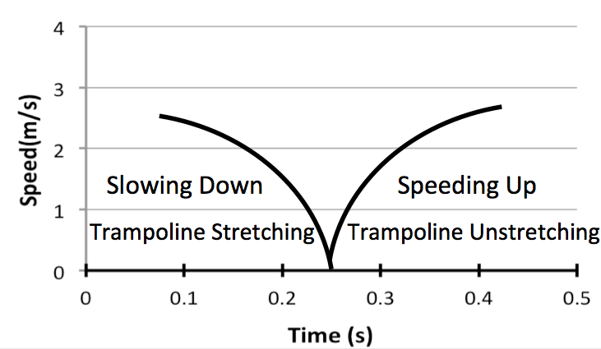
When energy is converted from one type (elastic potential) to another type (kinetic), there is a decrease in elastic potential energy and an increase in kinetic energy. When kinetic energy is converted to elastic potential energy, there is a decrease in kinetic energy and an increase in elastic potential energy.
Speed-Time for Child on a Trampoline
A speed-time graph can show how the person’s speed changes throughout the jumping process on a trampoline.
System and Surroundings Idea: A system is one or more objects that you focus on when talking about energy. The system idea is useful when you want to talk about the amount of energy that goes into a system, the amount of energy that stays in a system, or the amount of energy leaves a system. Everything outside of the system is the surroundings.
If you are interested in where energy comes from or where energy goes to, you can define a system and discuss the energy that moves into the system and moves out of the system. The total amount of energy that enters the system is equal to the amount of energy that remains in the system plus the amount of energy that leaves the system. The system shown in the energy diagram below is made up of the person and the trampoline. The person and the trampoline take turns being energy givers and receivers. Since all of the energy remains in the system, we do not need to consider the surroundings in this case. Since there are two energy transfers happening, a chain interaction diagram is necessary to represent how energy is converted from one form to another.
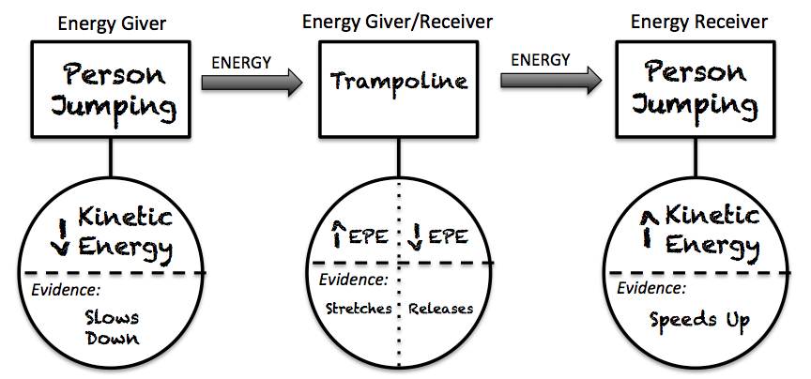

Energy Conservation Idea: The total amount of energy in the universe always stays the same; energy is conserved. Even though you can talk about an energy leaving a system, it does not simply disappear—it goes into the surroundings.
Energy is always conserved. This means that all of the energy that is available in the universe is already here and is not going to disappear. However, it can (and constantly does) change forms as it is converted, for example from kinetic to elastic. It can also be transferred from one object to another, for example when kinetic energy of one cart is transferred from to the kinetic energy of another cart. When an object suddenly gains energy (such as a cart that is pushed by a hand) the energy did not just appear out of nowhere, it is usually converted or transferred from a different stretchy or rigid object.
Respond to the following questions individually in your lab notebook:
- When a person jumps on a trampoline, how does her energy change? What type of energy is changing and where is it coming from or going to?
- What evidence supports the claim that the more an elastic object is stretched, the more energy it is able to transfer to other objects?
- Why do we say that objects with Elastic Potential Energy or Chemical Potential Energy are “storing” energy?
- In a situation where a cart collides with an elastic band and then reverses direction, when the kinetic energy of the cart decreases, the elastic potential energy ___________________, and when the kinetic energy of the cart increases, the elastic potential energy ___________________.
- The graph on the right shows the velocity of a cart that was pushed toward an elastic band and then reversed direction when coming in contact with the band. Sketch the graph in your laboratory notebook.
  - Label when the kinetic energy of the cart is increasing and when it is decreasing
  - Label when the elastic potential energy of the band is increasing and when it is decreasing
  - Label when the chemical potential energy of the hand is decreasing.
- In your own words, describe the difference between collisions that involve rigid objects and collisions that involve stretchy objects.
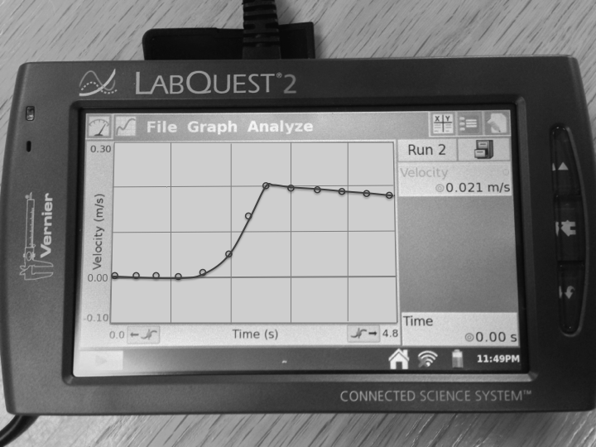
- What is different about a situation when energy is transferred versus one where the energy is converted?
- The graph on the right shows a cart that was given a push and then slowed down due to friction while moving along the track. Assume we define the system as the cart.
  - When is energy entering the system? What is your rationale?
  - When is energy leaving the system? What is your rationale?

