Mathematical Models: Building
Discuss each of the following questions with your group and respond in your lab notebook.
For this mathematical activity, you can assume air resistance is negligible.
Exploration: What is the relationship between height, mass, and gravitational potential energy?

Step 1: Evaluate the graph and the table shown below. The graph shows the gravitational potential energy for three different objects at different heights.
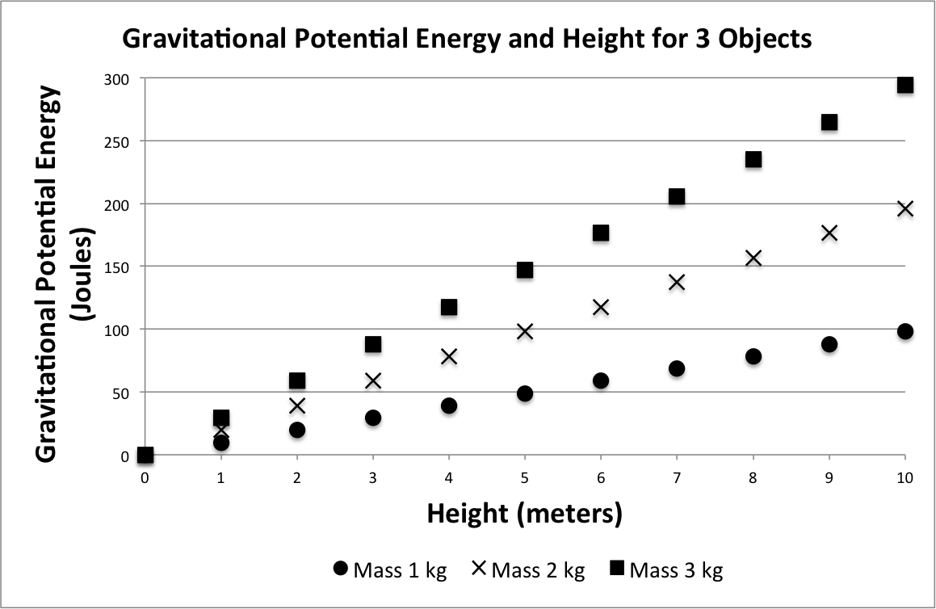
Height (m) | Gravitational Potential Energy (J)
 | Mass 1 kg | Mass 2 kg | Mass 3 kg
1 | 9.8 | 19.6 | 29.4
2 | 19.6 | 39.2 | 58.8
3 | 29.4 | 58.8 | 88.2
4 | 39.2 | 78.4 | 117.6
5 | 49 | 98 | 147
6 | 58.8 | 117.6 | 176.4
7 | 68.6 | 137.2 | 205.8
8 | 78.4 | 156.8 | 235.2
9 | 88.2 | 176.4 | 264.6
10 | 98 | 196 | 294

- What are some of the things that are different about the objects shown in the graph above?
- What information does the graph provide? Hint: this is not a velocity-time graph!
- What do you think you can infer about the relationship between gravitational potential energy and height? What claims do you think you could make about the relationship between gravitational potential energy and mass?

If you think you are ready to write the relationships between GPE and mass and between GPE and height, you may skip the next step. If you need additional support, use the next step to help you.
Step 2: Look only at the height of 4 meters for the three masses, shown in the table.
- When the three objects are 4 meters above the ground, what is each of their gravitational potential energies?
- How is gravitational potential energy different for an object with 2 kg compared to an object of 1 kg? What about for an object of 3kg compared to 1 kg?
- At a height of 4 meters, how much gravitational potential energy do you think an object with a mass of 4 kg would have?

Step 3: Based upon your conclusions from evaluating the graph and table and/or your responses to the previous three questions, determine the mathematical relationships below.
- What is the relationship between gravitational potential energy and mass? Explain in a sentence and complete the mathematical relationship.
$$GPE∝ ____________$$
- What is the relationship between gravitational potential energy and height? Explain in a sentence and complete the mathematical relationship.
$$GPE∝ ____________$$

Remember that scientists use the “proportional to” symbol ($∝$) instead of an equal sign (=) when there are other variables or numbers involved in the full relationship.

Step 4: Combine your two relationships from above to write the relationship between gravitational potential energy, mass, and height.
$$GPE∝ ____________$$

- Look back to the data table (on the previous page). Would it be ok to write the relationship using an equal sign?
In other words, does it work to say that $GPE=m⋅h$? Describe why or why not.
- Defend your response to the previous question using values from the data table. If you think that something is missing from the equation, make a prediction about what constant may be involved.
You likely discovered that the gravitational potential energy is proportional to both the mass and the height.
$$Gravitational Potential Energy∝height⋅mass$$
In the past, you’ve been given the value of the missing constant in an equation. The steps below can help you find the missing constant yourself.
You can assume:
$$Gravitational Potential Energy=constant⋅height⋅mass$$
To find the value of the constant, you need to rearrange the equation (above) to get the constant on one side of the equal sign. You need to divide both sides by the height and the mass. The height and mass will cancel out:
$$\frac{Gravitational Potential Energy}{height⋅mass}=\frac{constant⋅height⋅mass}{height⋅mass}$$
The “height” in the numerator (top of the fraction) and the “height” in the denominator (bottom of the fraction) cancel out because whenever something is divided by itself, it equals one. The same is true for the mass
$$For example: \frac{2}{2}=1 and \frac{height}{height}=1$$
So the new equation for the constant is:
$$constant= \frac{Gravitational Potential Energy}{height⋅mass}$$
Step 5: Calculate the constant using information in the data table (on the first page).
Hint: pick a height and mass. For that height and mass, use the gravitational potential energy to find the constant. Then check your answer by using a different height and mass.
- What height, mass, and gravitational potential energy did you use? What value did you find for the constant? Show your work.
- What was the second value of height, mass, and gravitational potential energy that you used? What value did you find for the constant? Show your work.
- Complete the full equation by adding in the constant.
$$GPE=_____ ⋅m⋅h$$
Step 6: To check your equation, select a mass and a height that are shown on the graph. Plug in the values for the mass and the height into the equation you determined. Calculate the GPE. Then check your value of GPE with either the table or the graph.
- Do you think you found the correct equation for calculating GPE? Describe why or why not.
3.1 Mathematical Ideas Reading
Instructions: Read the Mathematical Ideas, paying careful attention to each key idea
 | Gravitational potential energy is proportional to the mass and proportional to the height: The GPE is directly proportional to both height and mass. | $GPE∝m$ass  $$GPE∝height$$
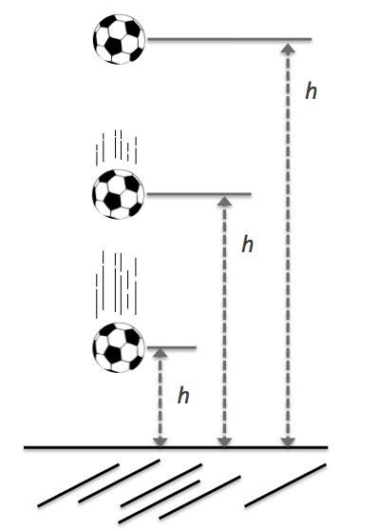
It probably doesn’t surprise you that the Earth-object system has more gravitational potential energy when the object is lifted farther off the ground. You found this in the laboratory activity when you looked at the amount of kinetic energy that the ball gained when the ball was dropped from different heights. You were able to infer that the amount of gravitational potential energy in the Earth-ball system is proportional to the ball’s height above the ground (distance between the Earth and the ball)
The mass of the object also affects the amount of gravitational potential energy in the Earth-object system. Like the height, the gravitational potential energy is also directly proportional to the mass of the object.
 | Gravitational potential energy equation: GPE equals the mass, times the height, times the value of the acceleration due to gravity (9.8 $m/{s^{2}}$). | $$GPE=mass⋅g⋅height$$  $$g=9.8 m/{s^{2}}$$
The equation to calculate the value of gravitational potential energy in an Earth-object system involves gravitational acceleration (g). Remember from the previous activity that all objects near Earth fall with an acceleration of 9.8$m/{s^{2}}$.
 | Unit
Mass | kilograms (kg)
Gravitational Acceleration | $${meters}/{{second}^{2} }({ m}/{s^{2}})$$
Height | meters (m)
In Chapter 1 you used units of Joules for energy. But what is a Joule? We are able to evaluate the meaning of a Joule by plugging the appropriate units into the gravitational potential energy equation. The standard units for mass, acceleration, and height are shown on the right.

So the units of a Joule are kilogram times meters squared, divided by seconds squared. Whenever using the gravitational potential energy equation, it is important that the mass is in kilograms and the height is in meters so that the energy will be calculated in joules.
$$The unit of GPE is: kg∙\left(\frac{m}{s^{2}}\right)∙m= \frac{kg∙m^{2}}{s^{2}}which is called a Joule$$
Mathematical Models: Practice
Respond to the following questions in your laboratory notebook. Show your work.
Support Questions: The first four questions include fill-in-the-blank supports to help you learn how to set up the problems. If you already feel comfortable solving these problems, consider trying to solve them without using the fill-in-the-blank supports. You can check your work using the supports.
- A 6 kilogram object is at a height of 12 meters.
  - Fill in the units below to get joules for the gravitational potential energy.
What are the units for mass? __________
What are the units for gravitational acceleration? __________
What are the units for height? __________
$$GPE=6 _____∙(9.8_____)∙12_____$$
  - What is the gravitational potential energy for this object? Hint: solve the equation above.
$$GPE=_____ _____$$
What units make up a Joule? __________

- A 0.135 kg apple is hanging from a tree branch that is 7 meters above the ground. What is the potential energy of the Earth-apple system?
$GPE=mass∙(9.8\frac{m}{s^{2}})∙height$
Optional
Fill-in-the-Blank
Supports
mass = __________ (What is the mass of the apple?)
height = _____________ (What is the height of the apple?)
$$GPE=_____∙(9.8\frac{m}{s^{2}})∙_____= ______ Joules$$

- The apple falls to the ground. If all of the energy stays in the system (the GPE is converted to KE), what will be the KE of the apple just before it hits the ground?
All GPE is converted into KE (GPE_{initial} = KE_{final})
KE = __________

- Using the kinetic energy you found in the previous question, calculate the speed of the apple just before it hit the ground.
Here’s how we solved for v:
$$2⋅KE=\left(\frac{1}{2}⋅m⋅v^{2}\right)⋅2$$
$$\frac{2KE}{m}=\frac{m⋅v^{2}}{m}$$
$$\sqrt{\frac{2KE}{m}}=\sqrt{v^{2}}$$
$$\sqrt{\frac{2KE}{m}}=v$$
$KE=\frac{1}{2}mv^{2}$
Rearrange this equation to solve for velocity:
$$v= \sqrt{\frac{2∙KE}{m}}$$
Now use the new equation to solve for the velocity:
$$v= \sqrt{\frac{2∙______}{_______}}=_______m/s$$

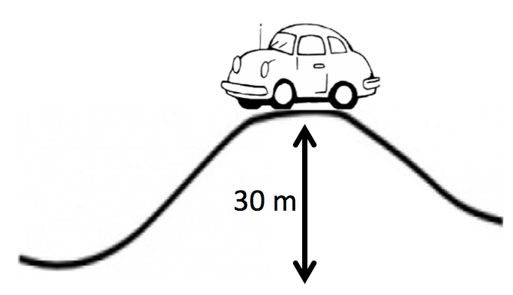
- What is the gravitational potential energy (GPE) of a car that is 750 kg and at the top of a 30 m hill?
- If the same car is on a different hill and the car has 882,000 J of gravitational potential energy, how high is the hill it is on?
- A 90 kg leopard sits 4 meters high on a tree branch.
  - What is the gravitational potential energy of this leopard?
  - If the leopard were half the mass, what would be its gravitational energy?
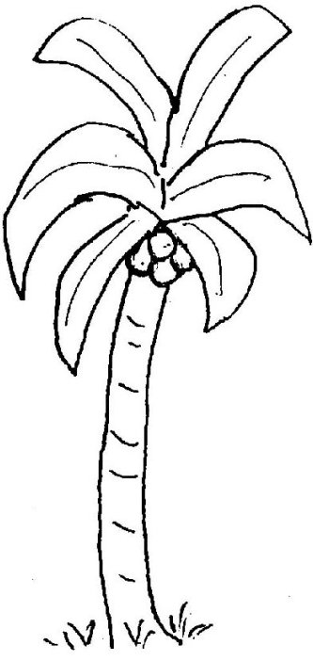
- Several coconuts are in a palm tree 11 meters above the ground.
  - One coconut has a mass of 1.2 kg. What is the gravitational potential energy in the Earth-coconut system?
  - The coconut falls to the ground. If all of the energy stays in the system (the GPE is converted to KE), what will be the kinetic energy of the coconut just before it hits the ground?
  - What is the coconut’s speed just before it hits the ground (at a height of zero)?
  - Imagine that four coconuts fell together. What is the gravitational potential energy in the Earth-coconut system when they are 9 meters above the ground?

Challenge Yourself: These problems are about the same mathematical ideas, but are more challenging. Respond to these questions in your laboratory notebook and show your work.
- Again consider the same coconut from the previous question that is 11 meters above the ground. For these problems, you can assume the energy stays in the system.
Hints for solving these problems:
When all of the energy stays in the system:
- All of the GPE is converted to KE
- Total energy in the system doesn’t change
- GPE + KE = Total Energy in the System

  - For the coconut that is 1.2kg, what is the total energy in the Earth-coconut system?
  - If the coconut falls, what is the kinetic energy of the coconut when it has fallen half way?
  - What is the kinetic energy of the coconut when it has fallen 8 meters?
  - What is the coconut’s speed when it has fallen 8 meters?
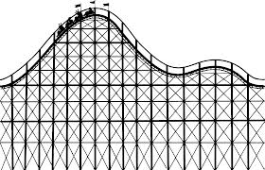
- The leopard from the previous question (with the mass of 90 kg, sitting 4 meters above the ground in a tree), jumps from the branch. The leopard adds 350 Joules of energy to the Earth-leopard system when jumping. What is the leopard’s speed just before hitting the ground?
- A roller coaster reaches its maximum height of 50 meters and has a GPE of 981,000 joules at that height. Assume that all the energy stays in the system, so the GPE is all converted to KE.
  - What is its mass?
  - When it is half way down (at a height of 25m), what is its GPE?
  - What is the difference in GPE from 50 m to 25 m?
  - What is its speed when it is half way down the track?
- You’re walking past an office building when a bowling ball lands next to you. You manage to get a rough idea of the speed – 9 m/s and it is labeled as a 10lb (4.5kg) ball. Let’s see if we can figure out the floor it was dropped from.
  - What was the KE of the ball just before it smashed into the pavement?
  - How much total energy did the ball have?
  - Assuming it started with KE = 0, what was the initial GPE?
  - What was the initial height?
  - If each floor is 4m tall, how many floors above you did the ball come from?
  - Not entirely sure of your speed estimate, calculate how fast it would have been going if it had come from 4m higher (the floor above your estimate)
  - If air resistance were not negligible, would the ball’s final velocity be higher or lower than predicted in f? What does this mean for our floor estimate?
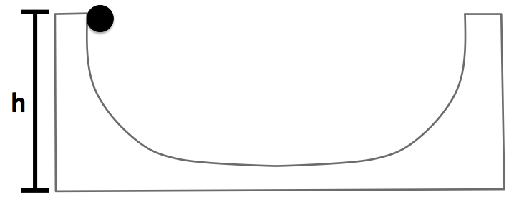
- Which has greater GPE (measured from ground): a rock (weighing 70 N) 10m above the surface of the Moon or one (weighing 140 N) 5m above the Earth’s surface? (Recall $a_{g,Moon}=1.6 m/s^{2}$)
- In the diagram to the right, a ball starts at a height h. It then rolls to the right, reaching some maximum height up the other ramp before stopping and rolling back. How will the two heights (initial left and maximum right) compare?
- In one experiment, Galilleo dropped two balls from the Leaning Tower of Pisa. The tower is about 56m tall, and let’s consider a ball of 10 kg and one of 18kg.
  - What is the GPE of the 10kg ball at the top? The 18kg ball?
  - What is the KE of the 10kg ball just before it hits the ground? The 18kg ball?
  - What is the speed of the 10kg ball just before hits the ground? The 18kg ball?
  - How does the speed of the balls seem to depend on mass (assuming same inititial height)? Does this agree with our discussion of gravitational force?
  - Predict the speed of a 30kg ball dropped 56m.

