Learning Target: You will determine the relationship between the pushing force and the pushing back force.

When two objects are in contact, how does the strength of the pushing force compare to the strength of the pushing back force?

Initial Ideas:
Complete the following questions individually in your lab notebook:

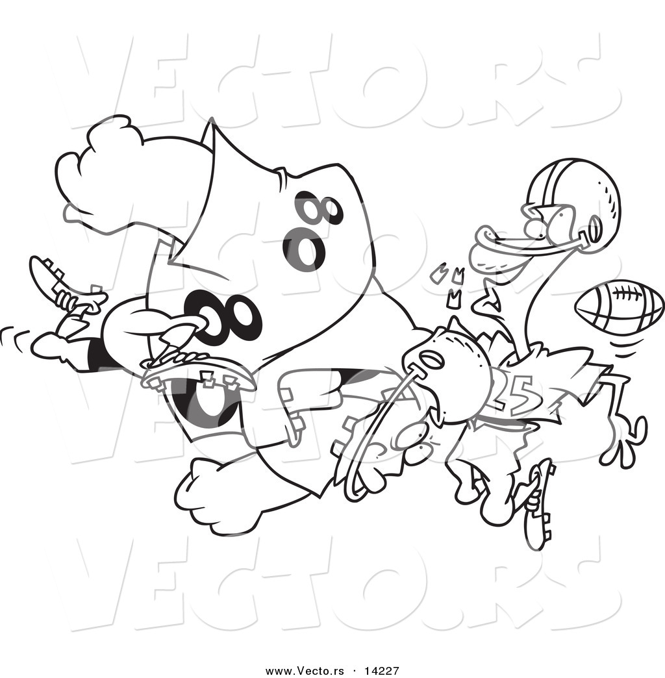
Imagine football players that are involved in a collision…
- Which player would experience the greatest force by the other player, if either?
- Which player would you rather be? Describe why.

Share your ideas with your group members.
On a presentation board, record your group’s thoughts about the Initial Ideas.

Collecting and Interpreting Evidence:
Experiment #1: Do objects push back?
Note: This experiment involves three experiment stations. The stations do not need to be completed in any particular order.

Step 1: With your group members, work through each of the experiment stations. Once you have collected evidence from each of the stations, use your evidence to respond to the steps and questions on this page.

---------------- COMPLETE EACH STATION EXPERIMENT NOW ----------------

Experiment #1, Station #1: Do Objects Push Back? - Rubber Band
Materials:
- Rubber band

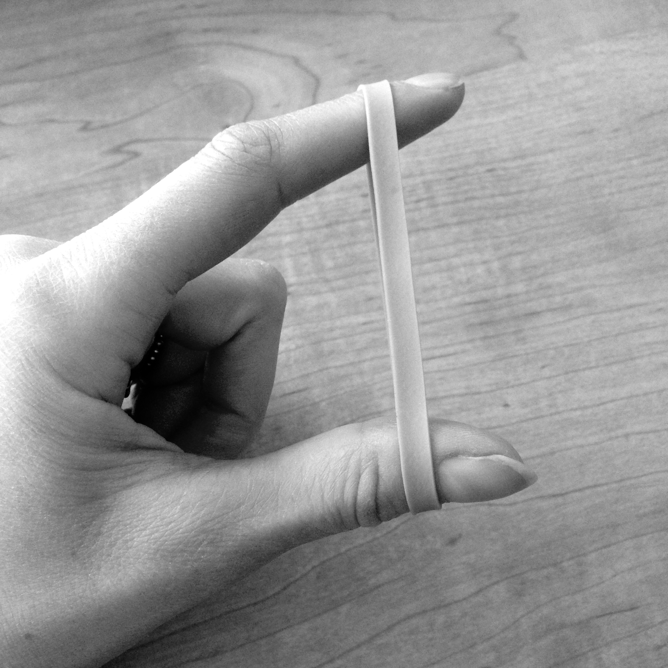
Step 1: Place the rubber band on your thumb and index finger so that the band is stretched tight. Do this so that the rubber band is horizontal.

Step 2: Have another group member push down gently on the rubber band.
- Does the rubber band exert a force the person pushing down? If so, in what direction does the force act?

Step 3: Push down harder on the rubber band so that it is stretched more.
- When pushing down harder on the rubber band, does the strength of the force exerted by the rubber band on the finger that is pushing down change? How can you tell?
- How does the strength of the upward force change when the strength of the downward force increases?
- Draw two free-body diagrams, one for the rubber band and the other for the pushing finger. Include a force arrow for the force of the finger pushing on the rubber band and for the force of the rubber band pushing on the finger.

Experiment #1, Station #2: Do Objects Push Back? - Spring-Scale Tug of War
Materials:
- Spring scale

Step 1: Using two spring scales, have two group members gently play “tug of war” with the spring scales. Observe the readings on the two scales during the tug of war (don’t pull too hard!).
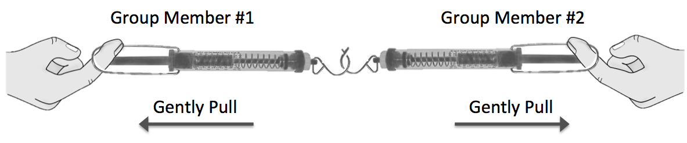
- Describe the readings on the scales.
- Can you and your partner pull in a way that will produce a higher reading on one scale than the other?
- Can you and your partner pull in a way that will produce a reading of zero on one scale but not on the other? Explain your answer.

Step 2: Now have one of the group members hold the spring scale (and not pull) while the other group member gently pulls on his/her spring scale. Observe the readings on the two scales.
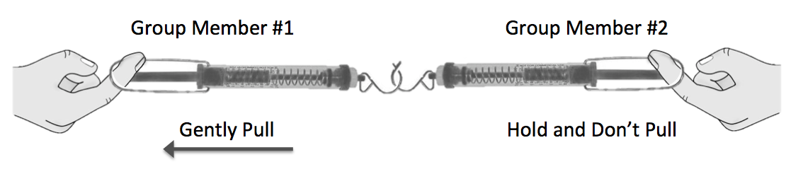
- Describe the readings on the scales.
- What can you say about the strength of the pulling force compared to the pulling back force?

Experiment #1, Station #3: Do Objects Push Back? - Bathroom Scale
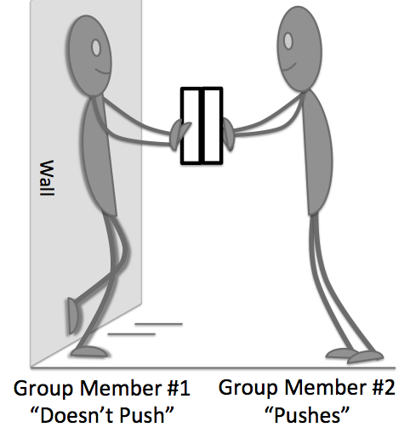
Materials:
- 2 Bathroom Scale
- Wall

Step 1: Have one group member stand with his or her back against the wall holding a bathroom scale (Group Member #1). Then, have a second group member put another bathroom scale up against the first scale (Group Member #2).

Step 2: The group member with his/her back against the wall should not push at all. Have the second group member push on the bathroom scale.
- How do the readings compare?
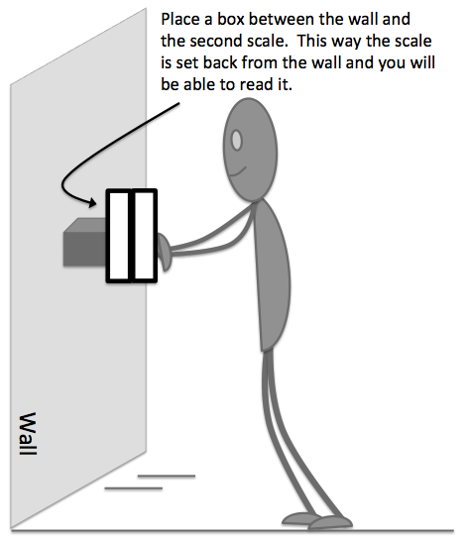
- Can you and your partner push in a way that will produce a higher reading on one scale than the other?

Step 3: Now remove the group member who had his/her back against the wall. This time the group member pushing against the wall will only push against the two scales. You will need to place something between the second scale and the wall so that you can read the scale.
- How do the readings compare?
- Can the person pushing push in a way that will produce a higher reading on one scale than the other?
- What can you say about whether the wall “pushes back” when the person exerts a force on it? What evidence supports your idea? Is this a surprise to you? Why or why not?

---AFTER COMPLETING EACH STATION EXPERIMENT, RESPOND TO THESE QUESTIONS---

Step 2: Look back at your results from each of the stations. With your group members, discuss how the strength of the pushing force compares to the strength of the pushing back force in each case. Summarize your findings by answering the questions below.
- In your lab notebook, complete the statement below about the relationship between the pushing force and the pushing back force.
When pushing on an object, the object pushes back with a force that is __________________________________ the pushing force.
(Greater than, less than, or equal to)

Step 3: Look back to your initial idea about the two players that were involved in a collision.
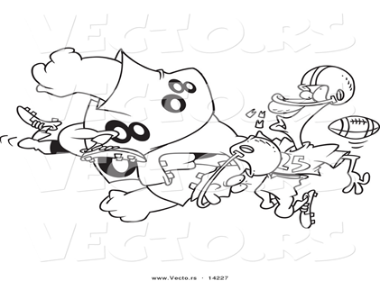
- How did you think the strength of the force from the large player on the small player compared to the strength of the force from the small player on the large player?
- Did you collect any evidence that caused you to change your idea(s)? If so, what was it, and why did it cause you to change your idea(s)?

Summarizing Questions Name: _______________________________
When two objects are in contact, how does the strength of the pushing force compare to the strength of the pushing back force?
Learning Target: You will determine the relationship between the pushing force and the pushing back force.
- A small sports car collides head on with a massive truck.
  - Which vehicle will experience the greatest force: the car, the truck, or neither? What evidence supports your idea?
  - Which will have the greatest acceleration? What evidence supports your idea?
- Think again about the collision between the two players that you thought about in the Initial Ideas. It is a very common idea to think that the large player exerts a greater force on the small player (than the small player exerts on the large player). Based upon your observations from this activity, explain why this is a common idea.
- Use the mathematical form of Newton’s Second Law to write an explanation for how it is possible that a large player and a smaller player exert the same strength force on one another (in opposite directions) when they collide.

Up to now, we have been calling the forces the pushing force and the pushing back force. Scientists call these force pairs.
- For each of the situations below, identify the force pairs:
  - Snowball hits a girl in the back
  - A baseball player catches a ball
  - A swimmer pushes off of the wall of a pool
  - A soccer player kicks a ball
- What force pair pair is responsible for pushing a car forward?

2.2 Scientist Ideas Reading
Instructions: Read the Scientist Ideas, paying careful attention to each key idea. When you read, try to think about how the key ideas relate to the evidence you collected in the activity.
Force Pair Idea: Whenever a pushing force exists, there is always a pushing back force that is the same strength, but in the opposite direction. These two forces are called force pairs.
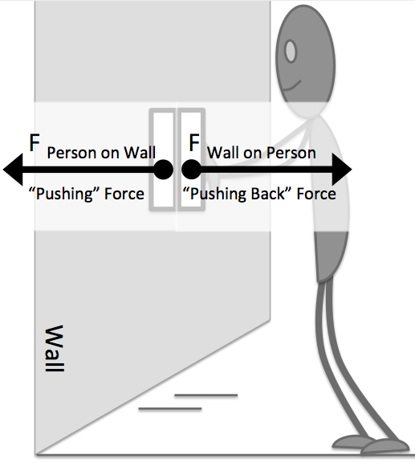
It comes as a surprise to many people that whenever there is a pushing force, there will always be a force pushing back that is the exact same strength. It doesn’t matter whether this is between two people, two trucks, or a person and a wall. The mass of the two objects also doesn’t matter. As you observed in this experiment, when pushing against the wall, the bathroom scale measuring the pushing force and the bathroom scale measuring the “pushing back” force from the wall showed the exact same readings. This was true even though the wall is much more massive than the person pushing on it. It is also true even though the wall may not seem to be exerting a force back on the person.

Newton’s Third Law:
When one object exerts a force on a second object, the second object exerts a force on the first object that is the same magnitude but in the opposite direction.
For every acting force, there is always a “reaction” force that is the same size (magnitude), but in the opposite direction. These are called force pairs.
When thinking about the accelerations of the two players that you examined in the initial ideas, it is first important to think about the strength of the force they are exerting on one another. Based upon Newton’s Third Law, the force pairs must be equal in magnitude (size), but in the opposite direction.
F_{small player on large} player
F_{large on small player}
Same Force with Different Mass Idea: When two objects are acted upon by the same strength force, but the objects have different masses, they will have different accelerations.
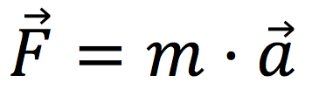
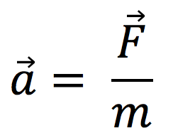
To understand how the trucks accelerate differently, it is necessary to think about Newton’s Second Law:
We can rearrange this equation to solve for force:

Since the two forces are the same (F _{Big player} = F _{Little player}), we can just compare their masses and accelerations (m*a _{large player} = m*a _{Little player}). Since their masses are different, we know that their accelerations must also be different. The mathematical equations below visually represent (with the size of the font) how this can be.
F = ma F = ma

ma = ma

The mass (m) is much greater for the big truck and the acceleration is much smaller for the big truck. This is why the little truck slows down so much more quickly in the accident than the big truck.

Respond to the following questions individually in your lab notebook:

- When two objects collide, how does the strength of the pushing force compare to the pushing back force? Does the mass of the object affect the strength of the force? Draw a force diagram to support your response.

- For each of the situations below, identify the force pairs:
  - A student jumps off the ground
  - One car “rear ends” another car

- Draw free body diagrams for each of the following force pairs
- Two cars in in a car crash | - A person pushes on a wall
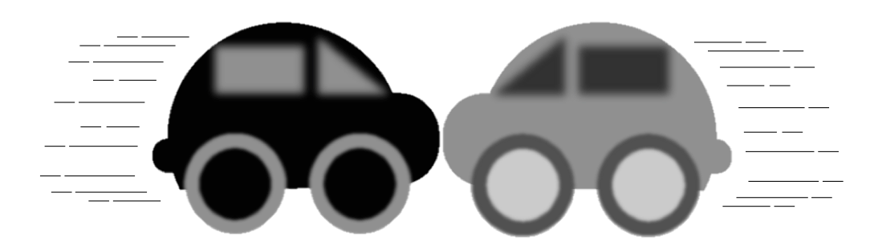 | 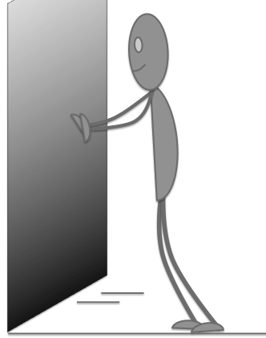

- This Scientist Ideas Reading discussed how you might use font size to visually represent how the force pairs are equal when objects of different mass collide, but the accelerations are different. Summarize this idea in your own words.
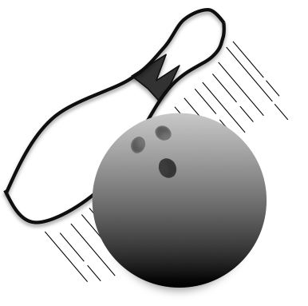
- Use Newton’s Second Law and Newton’s Third Law to describe why a bowling pin goes flying and the bowling ball hardly changes speed when the bowling ball collides with the bowling pin.

