**Collecting and Interpreting Evidence:**

**Computer Activity: Why does a cart continue to move after a quick tap?**

**Materials:**

* Computer

|  |  |  |
| --- | --- | --- |
| Tool Icon | In this simulator we will use force-time graphs to determine when a force is acting on an object and how the force affects the object’s speed. Force-time graphs show when an object is pushed and the strength of the push. Note: Force is measured in a unit called a **Newton** (N). | Macintosh HD:Users:Belleau:Dropbox:Screenshots:Screenshot 2014-05-16 14.19.12.png |

**Step 1:** Go to: http://phet.colorado.edu/en/simulation/forces-1d

* Click the green button **Run Now!**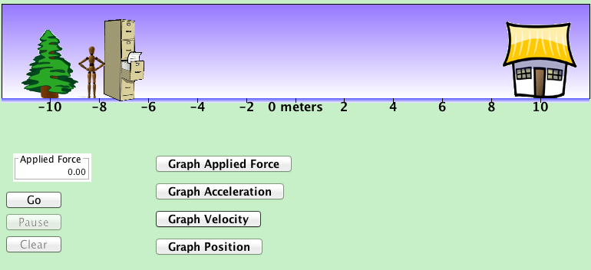
* A new window will open with a man and a filing cabinet.
* Click the button **Graph Applied Force**
* Click the button **Graph Velocity**
* Take 5 minutes to experiment with the simulator

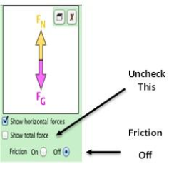

**Step 2:** On the toolbar on the right of the simulator, (1) uncheck the box **Show Total Force**, and (2) turn friction **off**.

In this experiment we are just looking at how forces affect motion, we will work with friction in the next experiment.

**Step 3:** Using the computer mouse, have the man push the filing cabinet until it starts to move. After it starts to move quickly let go (so the man stops pushing the filing cabinet), then push the filing cabinet again and quickly let go.

1. Draw the velocity-time graph and the force-time graph.
2. According to the force-time graph, is a force acting on the filing cabinet after the man stopped pushing it?
3. What happens to the filing cabinet’s speed when the force *is acting* on it (when the man is actually pushing it)?
4. What can you say about whether a force is acting on an object by looking at its velocity-time graph?
5. According to the velocity-time graph, *after* the man stopped pushing the filing cabinet it continued to move at a constant speed. How can it be that the cabinet continues to move even though there is no force pushing it (try to discuss this using energy ideas)?

**Step 4:** Summarize your understanding from this experiment by responding to the following two questions.

1. Describe the velocity of an object when a constant force is applied in the same direction it is moving. Use evidence to support your answer.
2. Describe the velocity of an object when no force is acting on the object. Use evidence to support your answer.

**Learning Target:** You will determine the effect that balanced and unbalanced combinations of forces have on stationary and moving objects.

Purpose:

Up until now you have only examined situations in terms of a *single* force acting on an object. But what if there are multiple forces? In this activity, you will investigate how combinations of forces affect the motion of objects.

|  |  |
| --- | --- |
| Key Icon | How does an object move when more than one force acts on the object, either in the same direction or opposite directions? |

Initial Ideas:

*Complete the following questions* ***individually*** *in your lab notebook:*

1. 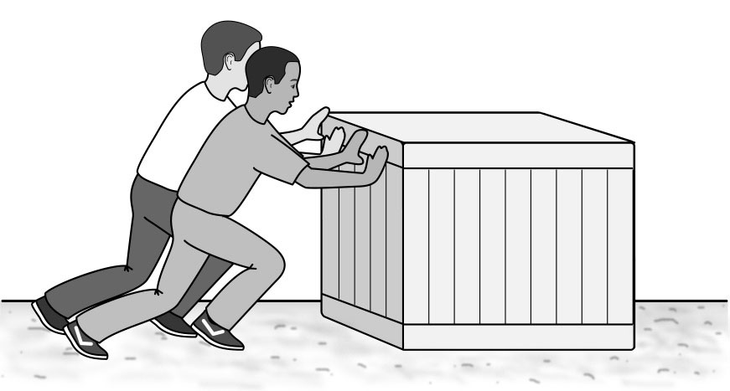The two boys push on a *stationary* box with a force of 200 N each, while a friction force of 400 N opposes them. Describe how you think the box would move.
2. The boys get the box moving and they push it so that it moves at a *constant speed*. Draw a force diagram that shows all the forces when the box is moving at a constant speed. Be sure your arrows represent the relative sizes of the forces.

|  |  |
| --- | --- |
| Talk Icon | *Share your ideas with your group members.* |
| Icon_Whiteboard | *On a presentation board, record your group’s thoughts about the Initial Ideas.* |

Collecting and Interpreting Evidence:

Experiment #1: What effect do combinations of forces have on an object when they are pushing the same direction?

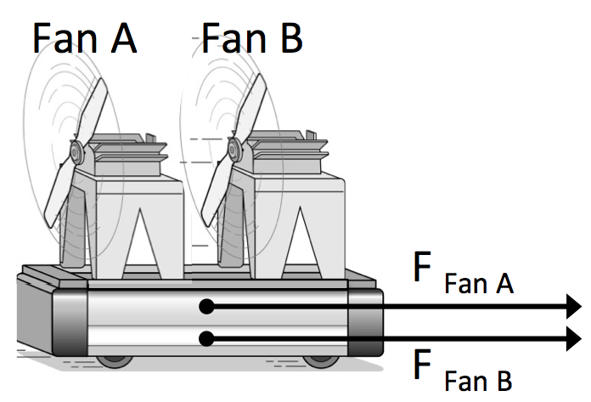

**Step 1:** Imagine placing two fans on a cart (Fan A and Fan B) so that they push in the **same direction**.

**Step 2:** Draw the table of force diagrams shown below in your laboratory notebook. *Notice that each cart is initially stationary.*

|  |  |  |
| --- | --- | --- |
|  | Force Diagram | Batteries in Fans |
| Cart 1 | F Fan A | Fan A: 4 Batteries  Fan B: OFF |
| Cart 2 | F Fan A  F Fan B | Fan A: 4 Batteries  Fan B: 4 Batteries |
| Cart 3 | F Fan A  F Fan B | Fan A: 4 Batteries  Fan B: 2 Batteries |
| Cart 4 | F Fan A  F Fan B | Fan A: 2 Batteries  Fan B: 2 Batteries |

**Step 3:** Predict how each of the carts will move by ranking their accelerations. List the carts in order of increasing acceleration, #1-4, 4 being Greatest acceleration.

|  |  |
| --- | --- |
| **Macintosh HD:Users:Belleau:Box Documents:01_PET-hs Revision:06_Graphics:Icons:Icon_Discussion.png** | *Your instructor may lead a whole-class discussion for students to share their predictions.* |

Materials:

* Low-friction cart
* Track
* Motion sensor
* Two fans
* Data collection tool

**Step 4:** Test your predicted rankings of the carts’ accelerations and collect velocity-time graphs for the carts shown in the table. Use two fans, each with the number of batteries shown in the table. Remember to replace batteries with dummy slugs if the fans require fewer than four batteries.

1. On one set of axes, draw the graphs you observed in the experiment. Label the lines in the graph “Cart 1,” “Cart 2,” “Cart 3,” and “Cart 4.”
2. How do the accelerations compare with your predicted rankings? Discuss any differences with your group.

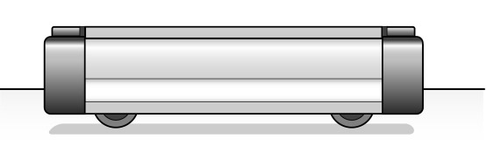

F Fan A

F Fan B

**Step 5:** Aaron and Amelia were discussing their observations and trying to describe the total amount of force acting on Cart 3. Read their comments.

I disagree. I think that the total force on Cart 3 is greater than just the force from Fan A. I think it is the force of Fan A plus the force of Fan B.

I think that the force from Fan A takes over, so the total force is just the force from Fan A. The force from Fan B doesn’t make a difference.



Aaron Amelia

1. Write a response to Aaron and Amelia.

I measured the arrows for each force on Cart 4 and it seems like they are the same total length as Cart 1. I wonder if this means Cart 1 and Cart 4 have the same amount of total force acting on them…?

**Step 6:** Samantha was trying to compare the strength of the total force acting on Cart 1 and Cart 4.

1. Write a response to Samantha.
2. In your lab notebook, complete the statement below about the total force on an object.

*When multiple forces are acting on an object, the total force is equal to \_\_\_\_\_\_\_\_\_\_\_\_\_\_\_\_\_\_\_\_\_\_\_\_\_\_.*

Collecting and Interpreting Evidence:

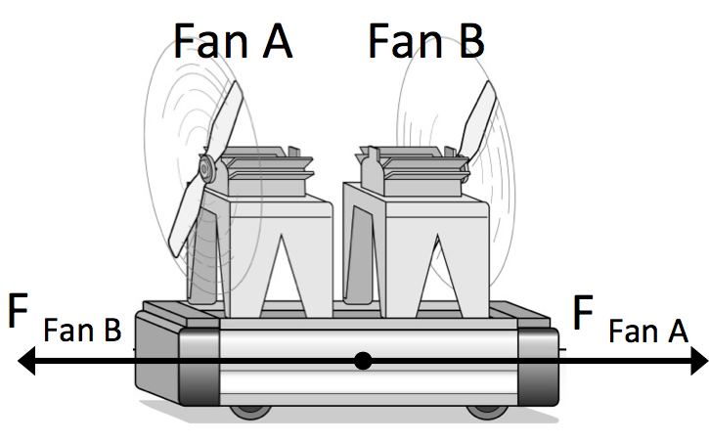Experiment #2: What effect do combinations of forces have on a stationary object when they are pushing the opposite directions?

**Step 1:** Imagine placing two fans on a cart (Fan A and Fan B) so that they push in the **opposite directions**.

**Step 2:** Draw the table of force diagrams shown below in your laboratory notebook. E*ach cart is initially stationary.*

|  |  |  |
| --- | --- | --- |
|  | Force Diagram | Batteries in Fans |
| Cart 1 | F Fan B  F Fan A | Fan A: 4 Batteries  Fan B: 4 Batteries |
| Cart 2 | F Fan B  F Fan A | Fan A: 2 Batteries  Fan B: 2 Batteries |
| Cart 3 | F Fan B  F Fan A | Fan A: 2 Batteries  Fan B: 4 Batteries |
| Cart 4 | F Fan B  F Fan A | Fan A: 4 Batteries  Fan B: 2 Batteries |

**Step 3:** Predict how each of the carts will move by ranking their accelerations. List the carts in order of increasing acceleration, #1-4, 4 being Greatest acceleration.

|  |  |
| --- | --- |
| **Macintosh HD:Users:Belleau:Box Documents:01_PET-hs Revision:06_Graphics:Icons:Icon_Discussion.png** | *Your instructor may lead a whole-class discussion for students to share their predictions.* |

**Step 4:** To test your predicted rankings of the carts’ accelerations, your instructor will lead a demonstration for Cart 1 and Cart 2.

1. On a blank set of axes, draw the graphs you observed in the demonstration. Label the lines “Cart 1” and “Cart 2.”
2. How do the graphs of Cart 1 and Cart 2 compare? Is this what you expected, why or why not?

Materials:

* Low-friction cart
* Track
* Motion sensor
* Two fans
* Data collection tool

**Step 5:** Test your predicted rankings for Cart 3 and Cart 4 by collecting velocity time graphs. Use two fans, each with the number of batteries shown in the table. Remember to replace batteries with dummy slugs if the fans require fewer than four batteries.

1. On the same set of axes as the graph you created in the previous step, draw the graphs you observed in the experiment. Label the lines “Cart 3” and “Cart 4.”
2. How do the accelerations compare with your predicted rankings? Discuss any differences with your group.

|  |  |
| --- | --- |
| Macintosh HD:Users:Belleau:Dropbox:Screenshots:Screenshot 2014-05-30 15.07.34.pngTool Icon | When an object is acted upon by the *same strength force in opposite directions*, scientists say that the forces are **balanced** (like in the case of Cart 1 and Cart 2). When the forces that are acting on an object don’t cancel, scientists say that the forces are **unbalanced** (like in the case of Cart 3 and Cart 4). |

1. What happens to the motion of a *stationary object* when it is acted on by **balanced forces**?
2. What happens to the motion of a *stationary object* when it is acted on by **unbalanced forces**?
3. Why do you think it was necessary for your instructor to lead a demonstration of Cart 1 and Cart 2? What do you think your instructor did *prior* to leading the demonstration?
4. In your lab notebook, complete the statement below about the total force on an object.

*When forces are acting on an object in opposite directions, the total force is equal to \_\_\_\_\_\_\_\_\_\_\_\_\_\_\_\_\_\_\_\_\_\_\_\_\_\_.*

1. What happens to the motion of a *moving object* when it is acted on by **unbalanced forces**?
2. If you observed an object moving at constant speed, would you make the inference that forces on the object were **balanced** or **unbalanced**?
3. In your lab notebook, complete the statements below about the total force on an object.

*For an object to remain stationary, the total force is equal to \_\_\_\_\_\_\_\_\_\_\_\_\_\_\_\_\_\_\_\_\_.*

*For objects moving at a constant speed, the total force is equal to \_\_\_\_\_\_\_\_\_\_\_\_\_\_\_\_\_\_\_\_\_.*

*For accelerating objects, the total force is NOT equal to \_\_\_\_\_\_\_\_\_\_\_\_\_\_\_\_\_\_\_\_\_.*

Summarizing Questions Name: \_\_\_\_\_\_\_\_\_\_­­\_\_\_\_\_\_\_\_\_\_\_\_\_\_\_\_\_\_\_\_\_

|  |  |
| --- | --- |
| Key Icon | How does an object move when more than one force acts on the object, either in the same direction or opposite directions? |

**Learning Target:** You will determine the effect that balanced and unbalanced combinations of forces have on stationary and moving objects.

1. A stationary box is being pushed by three different forces:

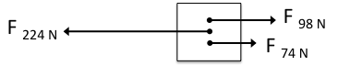

* 1. Does the box stay stationary? If not, describe how it moves (speed and direction).
  2. Draw a force diagram to show what **single force** would cause the box to move the same way.****

1. Think about a cart that is pushed by two fans facing different directions (Fan A and Fan B). The cart is initially stationary. **Complete the table below:**

|  |  |  |  |
| --- | --- | --- | --- |
| **Force Strengths** | **Balanced or Unbalanced?** | **Force Diagram** | **Description of Motion**  (speed and direction) |
| Fan A = 30 N  Fan B = 15 N |  | low-friction_cart1 |  |
| Fan A = 10 N  Fan B = 30 N |  | low-friction_cart1 |  |
| Fan A = 10 N  Fan B = 10 N |  | low-friction_cart1 |  |
| Fan A = 20 N  Fan B = 10 N |  | low-friction_cart1 |  |

1. When the forces acting on an object are balanced, what can you say about the object’s acceleration? Does this apply to stationary objects, moving objects, or both? What evidence supports your idea?
2. 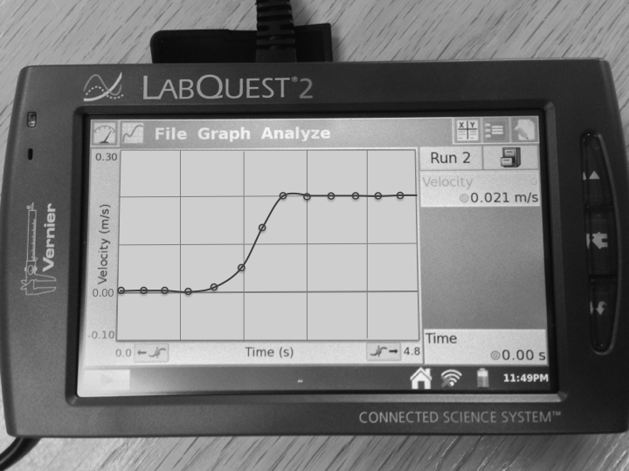A group of students collected the following velocity-time data for a cart with a fan and a friction pad.
   1. Describe *why* the cart moved at a constant speed after the initial push.
   2. Draw a force diagram for the cart: (1) when it is speeding up (around 2 seconds) and (2) when it is moving at a constant speed (around 3 seconds).



Speeding Up Constant Speed

1. Two students were discussing their ideas about balanced forces:

I just can’t see how an object with balanced forces can be moving at a constant speed. Surely, if it’s moving in any way, the force in the direction of motion must be stronger than the opposing force.

What I can’t understand is how an object with balanced forces can be moving at all. After all, didn’t we learn that an object that isn’t moving, with balanced forces acting on it, will stay stationary?

Dave Luisa

How would you respond to Dave and Luisa with evidence?

1. Describe a general rule for combining forces that can tell us if an object is accelerating or if an object is moving at a constant speed. You may want to refer to the fill in the blank questions in the lab.

**2.3 Scientist Ideas Reading**

***Instructions:*** *Read the Scientist Ideas, paying careful attention to each key idea. When you read, try to think about how the key ideas relate to the evidence you collected in the activity.*

|  |  |
| --- | --- |
| Key Icon | **Balanced and Unbalanced Force and Idea:**   * When the forces on a stationary object are *balanced*, the object will *remain stationary*. * When the forces acting on an object with an *initial velocity* are *balanced*, the object will continue to move at a constant speed. * When the forces acting on a stationary or moving object are *unbalanced*, the object will *accelerate* in the direction of the stronger force. |

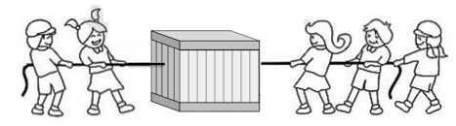Imagine five children who are pulling on a box so that the force pulling left on the box is exactly the same as the force pulling to the right.

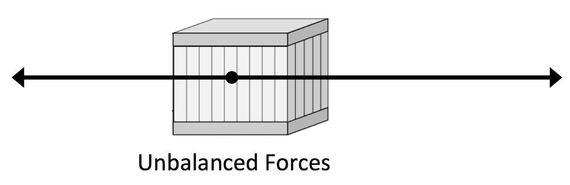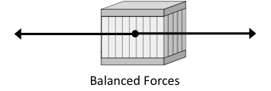When the total strength of all the forces pushing (or pulling) one way is exactly the same as the total strength in the opposite direction, we say that the forces on the object are **balanced**.

Now imagine *each child* is pulling with the same strength force. Since there are more children pulling to the left than to the right, there would be more overall force to the left. In this case, the forces are **unbalanced**.

|  |  |
| --- | --- |
| Key Icon | **Net Force Idea:** When more than one force acts on an object, scientists add and substract the forces to find the **Net Force** (**NET**). |

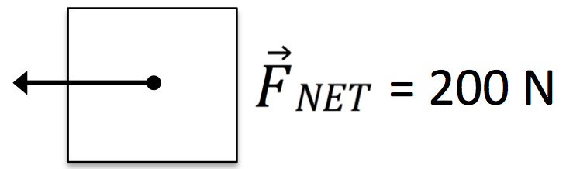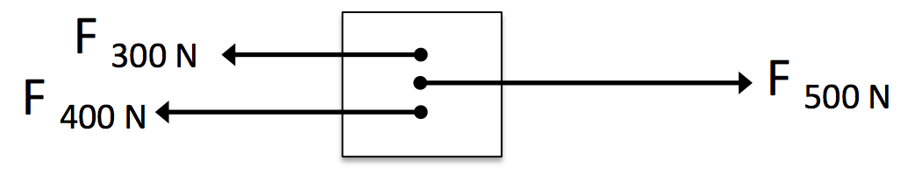To calculate net force, add up the forces pushing right and subtract the forces pushing left. The net force for the box on the right is:

NET = 500N – 400N – 300N = –200N

(200 N to the left)

Remember that a **vector** is represented by an arrow and provides information about direction and magnitude (size). You use vectors to represent velocity of an object; objects moving right have a positive velocity and objects moving left have a negative velocity. Force is also a vector, so it is necessary to state both the size and direction of a force. Forces pushing to the right are positive and forces pushing to the left are negative.

Think back to the Initial Ideas where two boys who were each exerting a force of 200N on a stationary box. When the friction force is 400N, the forces on each side of the box are equal. This means the net force is zero (NET = 0) and the box will not move.

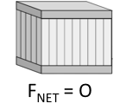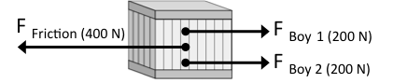

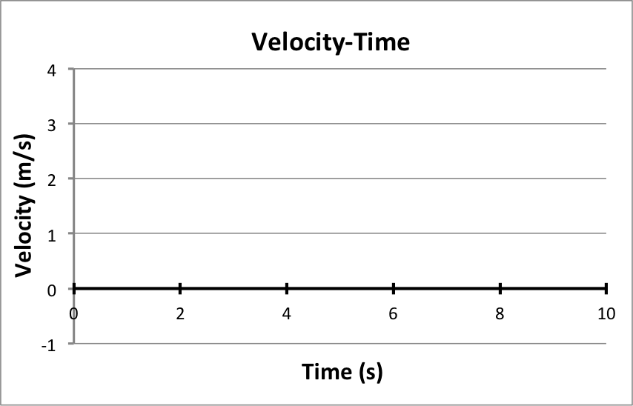

NET = 0

NET = 0

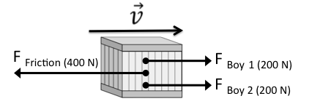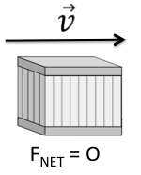However, once the boys push harder than the friction force, the sum of the forces is no longer zero (NET not equal to 0). The box will then accelerate in the direction of NET. Once the box is moving, if the boys again push with a force equal to friction force, the sum of the forces is zero (NET = 0). The box will then move at a constant speed:

|  |  |
| --- | --- |
| Key Icon | **Newton’s First Law:**  When an object is acted upon by balanced forces or no forces (zero net force), if it is stationary, it will remain stationary, and if it is in motion, it will continue to move in a straight line path at a constant speed. |

This is the same idea as **inertia**, (that you explored in the previous activity). Remember that objects tend to resist change in motion unless a force is applied. You may have heard Newton’s First Law stated as: “An object in motion remains in motion unless acted upon by a force.”

*Respond to the following questions* ***individually*** *in your lab notebook:*

1. Draw a force diagram for an object that is acted upon by multiple forces where NET ­= 0 (the forces are balanced).
2. Draw a force diagram for an object that is acted upon by multiple forces where NET ­is not equal to zero (the forces are unbalanced).
3. When the forces on a stationary object are unbalanced, how does the object move (discuss speed and direction)?
4. What is **net force**? How do you calculate net force?
5. 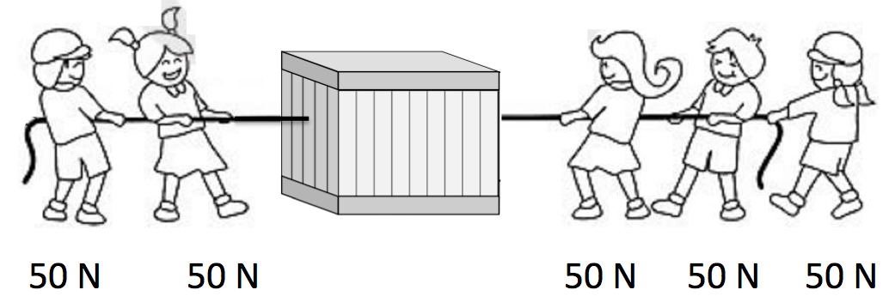Each child pulls on the box with a force of 50 N.
   1. Draw a force diagram showing all the forces:
   2. **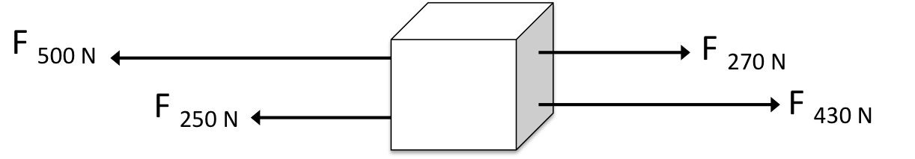**Draw a force diagram of the net force.
6. Four people push on a large box with the forces shown on the right. Will the box accelerate? If so, in what direction.
7. Complete the following sentences by filling in the blank with the object’s speed.

*When the forces acting on a stationary object are balanced, the object will \_\_\_\_\_\_\_\_\_\_\_\_\_\_\_\_\_\_\_\_\_\_\_\_\_\_\_\_\_\_\_\_\_\_\_\_.*

*When the forces acting on a stationary object are balanced, the object will \_\_\_\_\_\_\_\_\_\_\_\_\_\_\_\_\_\_\_\_\_\_\_\_\_\_\_\_\_\_\_\_\_\_\_\_.*

1. Imagine you want to push a heavy sofa across a carpeted floor. Answer the following questions:
   1. If the sofa were stationary, would you have to push with a force **less than**, **equal to**, or **greater than** the friction force resisting the movement of the sofa?
   2. After you start the sofa moving, what would you have to do to make it move across the floor at a **constant speed**? Briefly explain your reasoning.
2. Summarize Newton’s First Law *in your own words.*
3. What evidence have you collected that supports Newton’s First Law?
4. Describe how Newton’s First Law is just a special case of Newton’s Second Law (when NET = 0).

**2.3 Practice Questions**

**Instructions:** Complete the practice problems **in your laboratory notebook**. Work individually, and then check your responses with your group.

1. 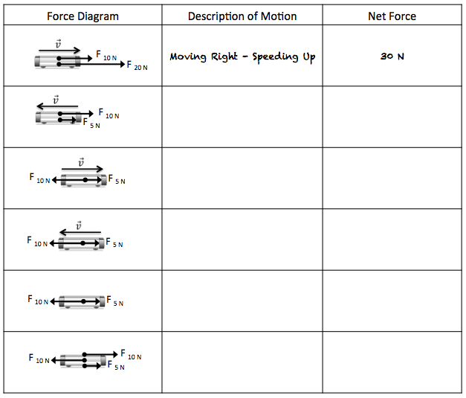Complete the table below by describing the motion of each cart (include speed and direction) and by determining the single force that would cause the cart to move the same way (include both size and direction of the force).
2. Remember that the mathematical model for acceleration is: a =

**FNET**

m

**\_\_**

This is the mathematical way of representing Newton’s Second Law. Does Newton’s Second Law apply to an object with balanced forces? Explain why.

*Hint: what is the net force is when balanced forces are acting*

1. Draw a force diagram for a box that is pushed with 60 Newton’s of force to the right and is opposed by 30 Newtons of force. How would this box move?
2. Draw a force diagram for a car that is being pushed by two girls. Each girl is pushing with a force of 80 Newtons. The car is moving at a constant speed.