**Learning Target:**

You will collect and interpret data to determine the relationship between force, mass, and acceleration.

Purpose:

Investigate h*ow the mass of the object or the strength of the force pushing the object affects the change in speed of the object.*

|  |  |
| --- | --- |
| Key Icon | How do forces on an object affect its motion?   1. What evidence suggests that a force is acting on an object in the same or in the opposite direction as its motion? 2. When a force acts on an object, how is the object’s motion affected by the strength of the force and the object’s mass? |

Initial Ideas:

*Complete the following questions* ***individually*** *in your lab notebook:*

*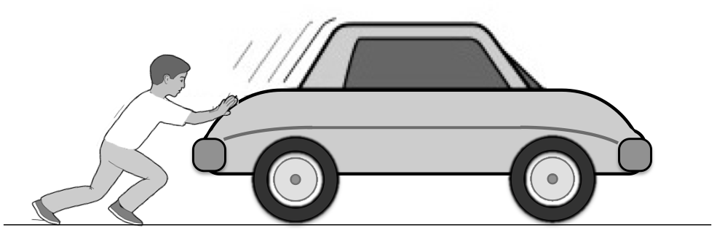* 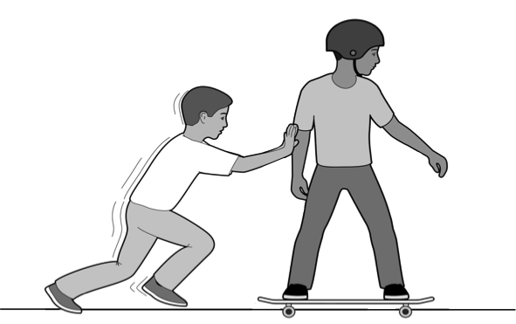

1. Imagine applying the same amount of force to a person on a skateboard and to a car (that doesn’t have its breaks on). Predict what the velocity-vs-time graph would look like for the car and the skateboarder.
2. Now imagine trying to stop the person on the skateboard and the car (traveling at the same speed) by pushing against the motion. If you were to apply the same amount of force to each, which one would slow down faster?

|  |  |
| --- | --- |
| Talk Icon | *Share your ideas with your group members.* |
| Icon_Whiteboard | *On a presentation board, record your group’s thoughts about the Initial Ideas.* |

Collecting and Interpreting Evidence:

Experiment #1: How does direction of the force affect the motion?

**Materials:**

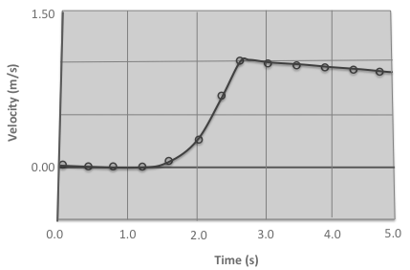

Velocity-Time for a Cart

* Skateboard
* Student

**Step 1:** The motion sensor graph on the right was taken from a cart that is given a push to start moving. The cart seems to be slowing down slightly.

1. What do you think caused the cart to slow down?

**Step 2:** Place volunteer student on skateboard. After the student is moving, apply a force in the direction to his/her motion (apply a gentle force that the person does not reverse direction).

1. How did the skateboard move when a force was applied in the direction of motion?
2. Sketch a diagram of the student/board system. Draw an arrow showing the direction of velocity above the diagram.

Check out this video to see what a vector is <http://www.youtube.com/watch?v=bOIe0DIMbI8>

1. Draw and label the magnitude and direction of the forces on the diagram.

**Step 3:** Place volunteer student on skateboard. After the student is moving, apply a force in the direction opposite to his/her motion (apply a gentle force that the person does not reverse direction).

1. How did the skateboard move when a force was applied opposite to the motion?
2. Sketch a diagram of the student/board system. Draw an arrow showing the direction of velocity above the diagram.
3. Draw and label the magnitude and direction of the forces on the diagram.

**Step 4:** Imagine there was not a student to push and slow the student on the skateboard.

1. Sketch a diagram of the student/board system. Draw an arrow showing the direction of velocity above the diagram.
2. Draw and label the magnitude and direction of the forces on the diagram.
3. Would you say that friction is a force? What evidence would you use to support your answer?

Experiment #2:

How can you demonstrate the relationship between force, mass, and acceleration?

**Part 1 :** Design a demonstration that will answer either question a or question b. You will show your class the demonstration. Use supplies available to you in class. Draw and explain the demonstration in your notebook.

1. How does magnitude of force affect acceleration?

Think about:

* What variables need to stay constant?
* How does a large force versus a small force affect the change in motion?

1. How does mass affect acceleration?

Think about:

* What variables need to stay constant?
* How does a large mass versus a small mass affect the change in motion?

Experiment #3:

What affect will a constant force have on an objects motion?

**Materials:**

* 1 low-friction cart
* 1 fan
* 1 track
* 1 motion sensor
* 1 data collection device

**Step 1:** Imagine you are pushing your friend in an office chair. You have a scale to measure that you are pushing with a constant force (same force the whole time).

1. Predict what will happen to the person in the chair’s velocity by sketching a velocity graph.

**Step 2:** You probably noticed it is challenging for you to keep up with pushing the chair and apply constant strength force. For the next steps, you will use a fan to apply a constant strength force to the cart. Attach the fan to the cart.

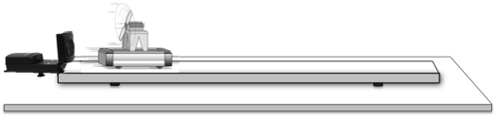

**Step 3:** Place the cart on the track in front of the motion sensor so the fan pushes the cart away from the sensor. Begin collecting velocity-time data and then turn on the fan and let go of the cart (do not push or pull the cart). Draw a velocity-vs-time graph for the motion of the cart.

1. What evidence from the velocity-vs-time graph suggests a force is *continuously* acting on an object in the direction it is moving?

|  |  |  |
| --- | --- | --- |
| Tool Icon | It is possible to change the strength of the push from the fan by changing the number of batteries. You can decrease the force of the fan on the cart by removing two of the batteries and replacing them with *dummy slugs*. A *dummy slug* allows the fan to still run, but doesn’t provide any power to the fan. | Macintosh HD:Users:Belleau:Box Documents:01_PET-hs Revision:06_Graphics:Graphics:02_Chapter 2:2.4 Cart wo mass.png |

**Step 4:** After reading the *Tools of the Trade reading* (above), reduce the force of the fan by only using two active batteries. Collect velocity data as you did in step 3. On the same axes as in step 3, graph the velocity graph for the reduced force fan. Label the lines on your graph: “stronger force” and “weaker force.”

1. Draw a force diagram for each scenario (the strong fan and the weak fan). Include the velocity vector (arrow) above each diagram.
2. Describe how the magnitude of force is related to changes in velocity.

|  |  |
| --- | --- |
| Tool Icon | Scientists use the term **acceleration** to discuss how quickly velocity changes. An object that speeds up quickly has a greater acceleration than an object that speeds up slowly. Scientists also use the term acceleration to express how quickly an object *slows down*. An object that slows down quickly has a greater acceleration than an object that slows down slowly. The slope on a *velocity-time graph* shows the acceleration. |
| Macintosh HD:Users:Belleau:Dropbox:Screenshots:Screenshot 2014-05-23 08.26.19.png | Macintosh HD:Users:Belleau:Dropbox:Screenshots:Screenshot 2014-05-23 08.26.07.png **Speeding Up Slowing Down** |

**Step 9:** Read the Tools of the Trade about acceleration. Respond to the questions below about motion, acceleration, and force.

1. When speeding up (carts with equal mass), which cart had a greater acceleration, the cart with greater fan force or less fan force? What is your reasoning?
2. When slowing down (carts with equal mass), which cart had a greater acceleration, the cart with greater fan force or less fan force? What is your reasoning?
3. What does the slope of the line on a velocity-time graph tell you about an object’s motion? Provide an example from your experiment.

**Step 10:** To summarize your understanding of acceleration and force, discuss the questions below with your group members and write your group’s ideas in your laboratory notebook.

1. Summarize *acceleration* in your lab notebook.
2. Using evidence from this lab, describe the relationship between force and acceleration.

Experiment #4: How does mass affect slowing down?

**Materials:**

1 low-friction cart 1 fan 1 cart mass

1 track 1 motion sensor 1 data collection device

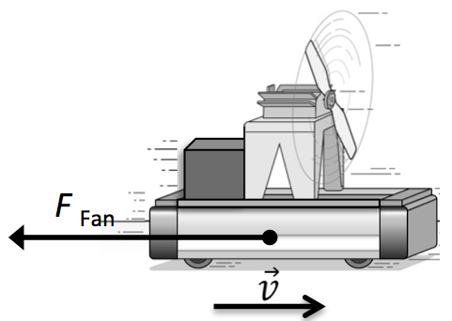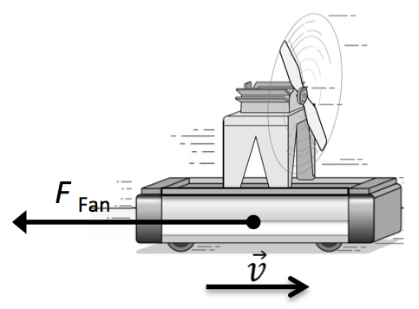**Step 1:**  Imagine the fan is attached to the cart so that it will be used to **slow** the carts down after an initial push. You will try one time with the cart to record data and then you will add a metal block to one of the carts so that it has a greater mass.

**Less Mass More Mass**

1. Predict (draw and label) what the velocity-time graphs will look like for the cart with more mass and the cart with less mass when they slow down from the fans.

**Step 2:** Place the cart at the starting position and turn it around so that the fan will cause the cart to slow down after an initial push. Give the cart a quick push. Start collecting data.

1. On a set of axes, draw a velocity-vs-time graph of the cart’s motion.

**Step 3:** Place the additional mass on the cart. Place the cart at the starting position and turn it around so that the fan will cause the cart to slow down after an initial push. Give the cart a quick push (try to give the cart the same amount of push as you did in step 2. Start collecting data.

1. On the same set of axes as before, draw a velocity-vs-time graph of the cart’s motion. Label the lines “more mass” and “less mass”.
2. Which cart slowed to a stop first?
3. How did mass affect the acceleration?
4. In your lab notebook, complete the statements below about the relationship between mass and slowing down.

*The object with the greater mass will slow down \_\_\_\_\_\_\_\_\_\_\_\_\_\_\_\_\_\_\_\_\_\_\_\_\_\_.*

*The object with the greater mass will have a \_\_\_\_\_\_\_\_\_\_\_\_\_\_\_\_\_\_\_\_\_\_\_\_\_\_* acceleration.

Step 3: Look back to your prediction about how two carts would decrease in speed if one cart had more mass than the other.

1. How did your experimental graphs compare to your prediction graphs?

**Summarizing Questions** Name: \_\_\_\_\_\_\_\_\_\_­­\_\_\_\_\_\_\_\_\_\_\_\_\_\_\_\_\_\_\_\_\_

|  |  |
| --- | --- |
| Key Icon | When a force acts on an object, how is the object’s motion affected by the strength of the force and the object’s mass? |

**Learning Target:** You will collect and interpret data to determine the relationship between force, mass, and acceleration.

1. Amara and Victor were discussing their observations and trying to describe why the cart with more mass had less acceleration. Read their comments.

Yeah, I think more massive objects are harder to stop and harder to get going. Maybe mass has a property that resists change in speed. More mass, more resistance to change in motion.

The object with more mass is more resistant to changing speed than the object with less mass. This is the case with speeding up or slowing down. Mass resists change in motion.



Amara Victor

1. What do you think about how Amara and Victor are trying to describe their observations?
2. What is the relationship between how strong a force pushes an object and the object’s acceleration? Is this true for both speeding up and slowing down? What evidence supports your answer?
3. **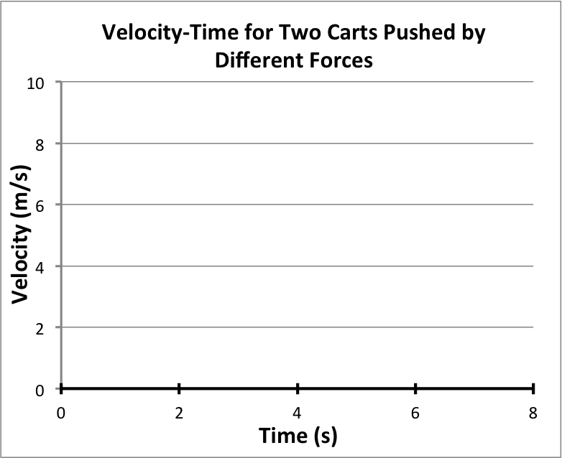**Two carts (with the same mass) begin stationary and increase in speed because of a constant and continuous force on each. The force on **Cart A** is stronger than **Cart B**.
4. On the velocity-time graph (on the right), sketch the graphs for each carts motion. Label the lines: **Cart A** (stronger force) and **Cart B** (weaker force)**.**
5. Draw and label force diagrams for the two carts below.

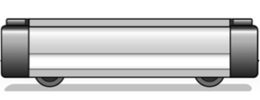 Cart A Cart B

1. The graph (on the right) shows a cart that was given a quick push and then gradually slowed down. Which force do you think was stronger, the initial push or friction? Explain using the graph as evidence.

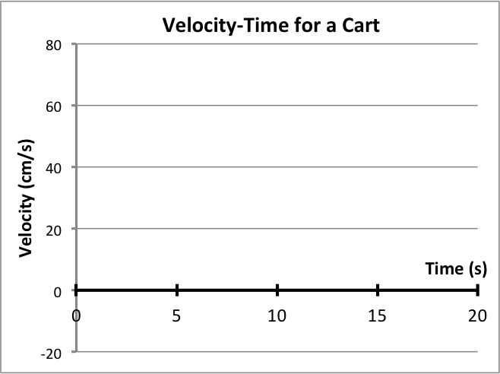

1. Which is more likely to resist change in speed, an object with more mass or an object with less mass? Describe your ideas using evidence.
2. ****In this activity, you had a race between two carts that had different masses but the same strength force pushing them. If you wanted to make the race a tie, what would you need to do to the strength of the fan pushing on the cart with more mass?



1. Which would be easier to start moving with a push, a soccer ball or a bowling ball? Which would be easier to stop if they were moving at the same speed? Why do you think this is?



1. ****In the previous question, you thought about the motion of a soccer ball and bowling ball when the same strength force acted on them for the same period of time.Now, think about the soccer ball and bowling ball both moving at the exact same speed.

In order to stop the bowling ball and soccer ball in the same amount of time, how would the strength of the force need to be different on each ball? Explain your thinking.

1. Describe a general rule that relates force, mass, and acceleration.

****

**2.1 Scientist Ideas Reading**

***Instructions:*** *Read the Scientist Ideas, paying careful attention to each key idea. When you read, try to think about how the key ideas relate to the evidence you collected in the activity.*

|  |  |
| --- | --- |
| Key Icon | **Acceleration and Force Idea:** How quickly or slowly an object changes speed is described by its acceleration. The greater the strength of the force on an object, the greater its acceleration. |

Increasing one variable (force) causes another variable (acceleration) to also increase, scientists call this a **directly proportional relationship.** Scientists use the symbol $∝$ to represent a proportional relationship ($\vec{a}∝\vec{F}$).

Increasing

FORCE

Increased

ACCELERATION

*Causes…*

**Directly Proportional Relationship**

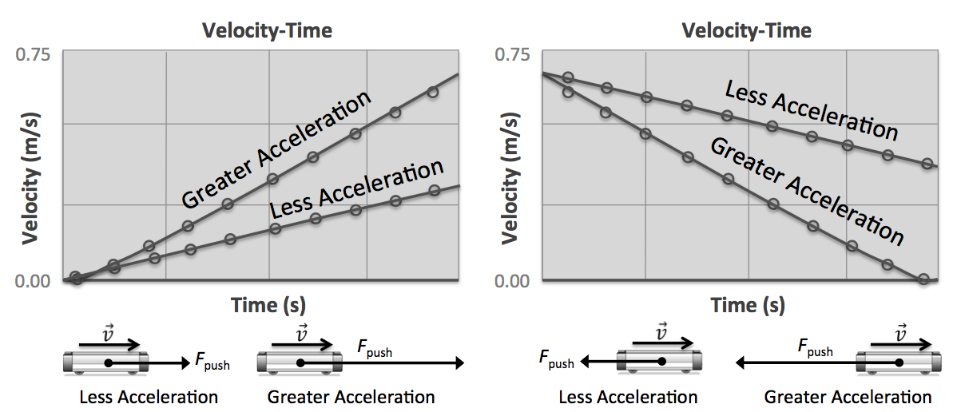The slope of the line on the velocity-time graph shows the strength of force on an object: a steeper slope means greater force (if the masses are the same).

|  |  |
| --- | --- |
| Key Icon | **Resistance to Change (Inertia) Idea:** Objects with greater mass have greater resistance to changes in speed. |

Really massive objects are harder to get started. Really massive objects are also harder to stop than objects with less mass. Scientists call this **inertia.** **Inertia** is the “resistance to change” property of objects – they want to keep doing what they are already doing. Objects moving “don’t want” to stop.

|  |  |
| --- | --- |
| Key Icon | **Acceleration and Mass Idea:** When a force acts on an object with *greater* mass, the object will have less acceleration than when the same force acts on an object with *less* mass. |

The slope of the line on the velocity-time graph tells us something about mass. As long as the force is constant, a steeper slope implies less mass. Increasing one variable (mass) causes another variable (acceleration) to decrease, scientists call this an **inversely proportional relationship** ($\vec{a}∝\frac{1}{m}$).

Increasing

MASS

Decreased

ACCELERATION

*Causes…*

**Inversely Proportional Relationship**

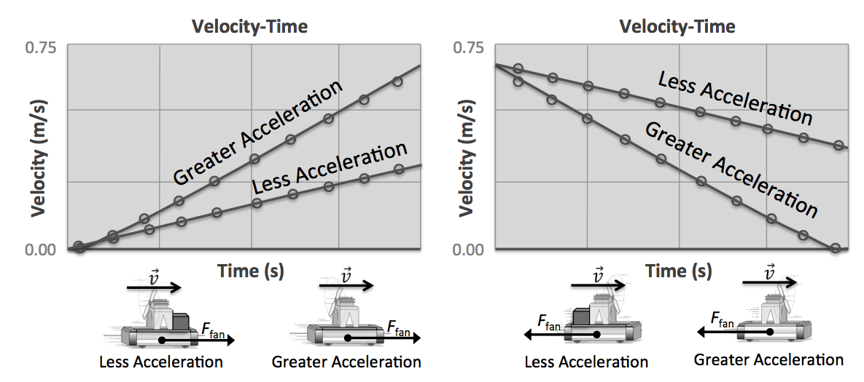

|  |  |
| --- | --- |
| Key Icon | **Newton’s Second Law:**  Macintosh HD:Users:Belleau:Dropbox:Screenshots:Screenshot 2014-06-07 12.41.20.pngIf an unbalanced force acts on an object, its velocity will change continuously as long as the force is acting (it will accelerate). How quickly the object accelerates is directly proportional to the strength of the force and inversely proportional to the object’s mass. |

*Respond to the following questions* ***individually*** *in your lab notebook:*

1. What does the term **slope** mean?

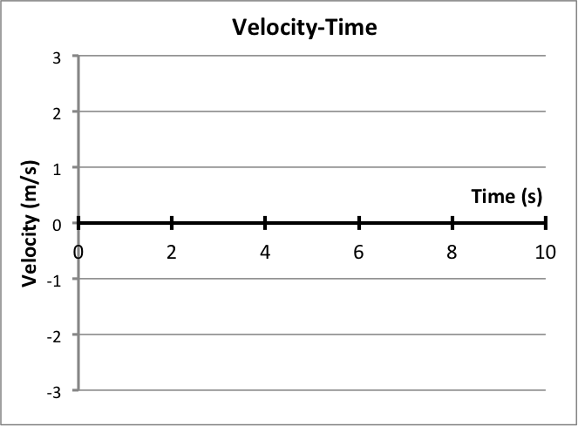

1. What is acceleration?

Object A

Object A

1. Which object (from the graph on the right) was pushed by a greater force? How do you know?
2. What evidence did you collect that force and acceleration are **directly proportional**?
3. What is an example of a directly proportional relationship in your life?
4. What evidence did you collect that mass and acceleration are **inversely proportional**?
5. What is an example of an inversely proportional relationship in your life?
6. Summarize Newton’s Second Law *in your own words.*
7. Complete the following sentences:

If the force is held constant, adding more mass will cause the acceleration to…

If the force is held constant, removing mass will cause the acceleration to…

1. Copy the velocity-time and force-time graphs (on the right) into your laboratory notebook.

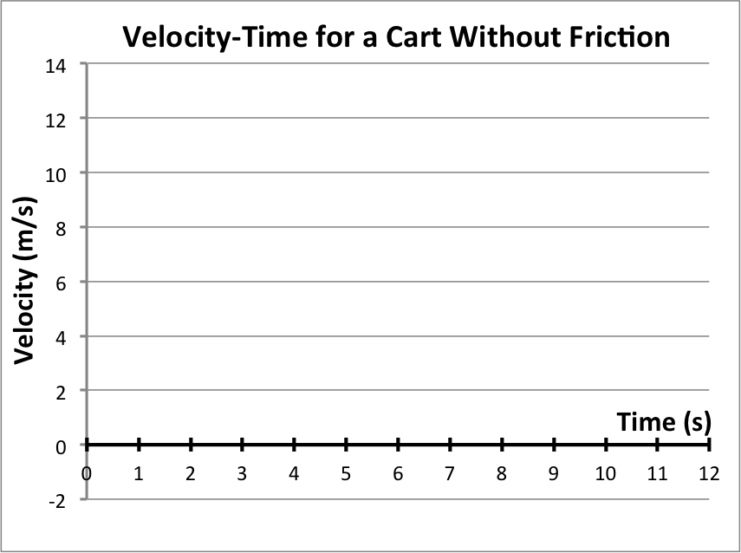

* 1. Circle each part on the velocity-time graph that shows a force was acting on the cart.
  2. Explain how you are able to tell if a force is acting on an object by looking at the *velocity-time graph.*
  3. Describe how you are able to tell if no forces are acting on an object by looking at the *velocity-time graph*.

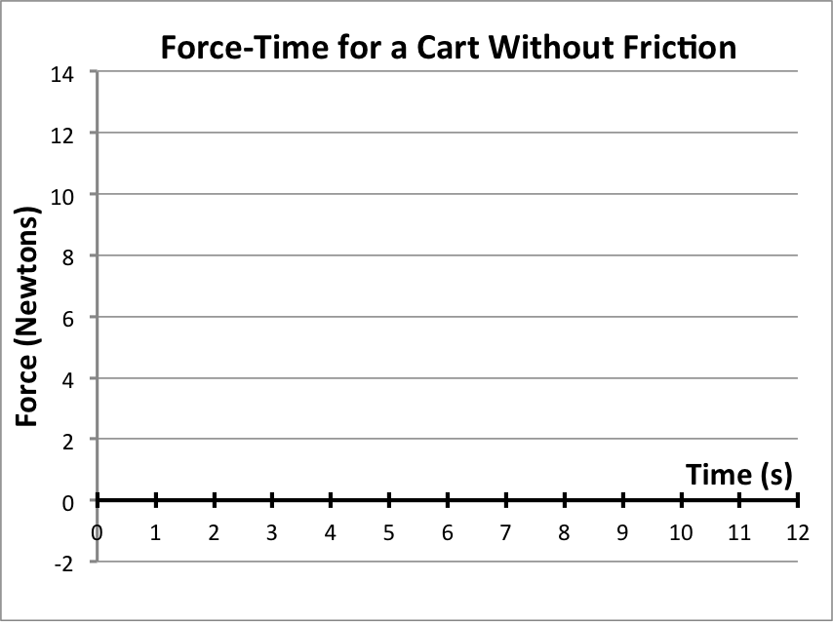

* 1. Describe how the *force-time graph* supports your ideas from the previous two questions (hint: use the time intervals to help you).
  2. Based upon the *velocity-time graph* and the *force-time graph*, how does the slope of the *velocity-time graph* relate to the amount of force on the cart? Why does this make sense?

1. What does the **slope** on a velocity-time graph tell us about acceleration?