Chapter Problems
Newton’s 2nd Law:
Class Work
- A 0.40 kg toy car moves at constant acceleration of 2.3 m/s². Determine the net applied force that is responsible for that acceleration.

- If a net horizontal force of 175 N is applied to a bike whose mass is 43 kg what acceleration is produced?

- What average net force is required to stop a 7 kg shopping cart in 2 s if it’s initially traveling at 3.5 m/s?

- A 7.5 kg cannon ball leaves a canon with a speed of 185 m/s. Find the average net force applied to the ball if the cannon muzzle is 3.6 m long.

- A wooden block is pulled at a constant acceleration of 1.4 m/s². Find the net applied force on the block if its mass is 0.6 kg.

- A 95 N net force is applied to an ice block with a mass of 24 kg. Find the acceleration of the block if it moves on a smooth horizontal surface.

- A net force of 345 N accelerates a boy on a sled at 3.2 m/s². What is the combined mass of the sled and boy?

- What average net force is required to stop an 8500 kg truck in 10 s if it’s initially traveling at 20 m/s?

- What average net force is required to accelerate a 9.5 g bullet from rest to 650 m/s over a distance of 0.85 m along the barrel of a rifle?

Homework
- A physics student pushed a 50 kg load across the floor, accelerating it at a rate of 1.5 m/s². How much force did she apply?

- A 10,000 N net force is accelerating a car at a rate of 5.5 m/s². What is the car’s mass?

- A boy pedals his bicycle with a net horizontal force of 235 N. If the total mass of the boy and the bike is 40 kg, how much are they accelerating?

- A 45 kg swimmer starting from rest can develop a maximum speed of 12 m/s over a distance of 20 m. How much net force must be applied to do this?

- A net force of 3000 N is accelerating a 1200 kg elevator upward. If the elevator starts from rest, how long will it take to travel up 15 m?

- A 57 kg paratrooper falls through the air. How much force is pulling him down?

- A net force of 34 N is applied to accelerate an object at a rate of 2.5 m/s². What is the mass of the object?

- A runner exerts a net force of 225 N to accelerate at a rate of 3.0 m/s². What is the runner’s mass?

- What average net force is required to stop a 4 kg bowling ball in 0.5 s if it’s initially traveling at 10 m/s?

- A hockey puck with a mass of 0.18 kg is at rest on the horizontal frictionless surface of the rink. A player applies a horizontal force of 0.5 N to the puck. Find the speed and the traveled distance 5 s later.

Mass and Weight:
Class Work
- A woman weighs 580 N. What is her mass?

- Find the weight of a 2000 kg elephant.

- An astronaut has a mass of 85 kg. Calculate his weight on Earth and on the Earth’s moon
(g_{moon} = 1.6 m/s²). Does his mass change when he goes from Earth to its moon?

- A car weighs 14500 N. What is its mass?

- Calculate the weight of a 4.5 kg rabbit.

- At the surface of Mars the acceleration due to gravity is 3.8 m/s². A book weighs 34 N at the surface of the Earth. What is its mass on the earth’s surface? What are its mass and weight on Mars’s surface?

Homework
- A boy weighs 270 N. What is his mass?

- Find the weight of a 60 kg table.

- A Martian weighs 17 N on the surface of Mars. Calculate his weight on Earth and on the Earth’s moon. Does his mass change along the flight from Mars to the Moon to the Earth? The acceleration due to gravity on Mars is 3.8 m/s² and the acceleration due to gravity on the Moon is 1.6 m/s².

- Find the weight of a 2 g computer chip.

- What is the mass of a 330 N television?

- The mars rover, Spirit has a mass of 836 kg. Calculate its weight on Earth and on Mars. The acceleration due to gravity on Mars is 3.8 m/s²

Free-Body Diagram Problems:
Class Work
- A box sits at rest on a tabletop. Draw and clearly label all the forces acting on the box; compare their magnitudes and directions.

- A wooden block moves at a constant speed on a rough horizontal surface. Draw a free-body diagram clearly showing all the forces applied to the block; compare their magnitudes and directions.

- A boy pulls a sled horizontally at a constant speed by holding a rope that is connected to the sled.
  - Show all the forces exerted on the sled (do not ignore friction);
  - Show all the forces exerted on the boy (do not ignore friction);
  - Show all the forces acting on the rope;
  - Use Newton’s Law to explain the directions and the magnitudes of all the forces; compare “action” and “reaction”.

Homework
- A crane lifts a load at a constant speed. Draw a free-body diagram for the load and compare the magnitudes and directions of the all forces.

- A crate is accelerated at a constant rate along a rough horizontal floor. Draw a free-body diagram for the crate and compare all the forces exerted on the crate.

- A hockey puck slides on a rough horizontal surface. Draw a free-body diagram for the puck and compare the magnitudes and the directions of all the forces exerted on it.

Kinetic Friction:
Class Work
- The coefficient of kinetic friction between an object and the surface upon which it is sliding is 0.25. The weight of the object is 20N. What is the force of friction?

- The force of friction between an object and the surface upon which it is sliding is 12N. The weight of the object is 20N. What is the coefficient of kinetic friction?

- The coefficient of kinetic friction between an object and the surface upon which it is sliding is 0.40. The mass of the object is 3.2 kg. What is the force of friction?

- The force of friction between an object and the surface upon which it is sliding is 15N. The mass of the object is 20kg. What is the coefficient of kinetic friction?

- The coefficient of kinetic friction between an object and the surface upon which it is sliding is 0.40. The weight of the object is 80N. What is the force of friction?

- The coefficient of kinetic friction between an object and the surface upon which it is sliding is 0.6. The mass of the object is 12 kg. What is the force of friction?

- The force of friction between an object and the surface upon which it is sliding is 12N and the coefficient of friction between them is 0.70. What is the weight of the object?

- The force of friction between an object and the surface upon which it is sliding is 250N and the coefficient of friction between them is 0.80. What is the mass of the object?

- The force of friction between an object and the surface upon which it is sliding is 36N. The weight of the object is 85N. What is the coefficient of kinetic friction?

Homework
- The coefficient of kinetic friction between an object and the surface upon which it is sliding is 0.10. The mass of the object is 8.0 kg. What is the force of friction?

- The force of friction between an object and the surface upon which it is sliding is 46N and the coefficient of friction between them is 0.30. What is the weight of the object?

- The force of friction between an object and the surface upon which it is sliding is 360N. The mass of the object is 95kg. What is the coefficient of kinetic friction?

- The force of friction between an object and the surface upon which it is sliding is 126 N and the coefficient of friction between them is 0.20. What is the mass of the object?

- The force of friction between an object and the surface upon which it is sliding is 12 N and the coefficient of friction between them is 0.60. What is the weight of the object?

- The coefficient of kinetic friction between an object and the surface upon which it is sliding is 0.15. The mass of the object is 16kg. What is the force of friction?

- The force of friction between an object and the surface upon which it is sliding is 3.5N. The mass of the object is 4 kg. What is the coefficient of kinetic friction?

- The force of friction between an object and the surface upon which it is sliding is 100 N and the coefficient of friction between them is 0.24. What is the mass of the object?

Static Friction
Class Work:
A stationary 15 kg object is located on a table near the surface of the earth. The coefficient of static friction between the surfaces is 0.40 and the coefficient of kinetic friction is 0.25.

- A horizontal force of 20 N is applied to the object.
  - Draw a free body diagram with the forces to scale.
  - Determine the force of friction.
  - Determine the acceleration of the object.

- A horizontal force of 40 N is applied to the object.
  - Draw a free body diagram with the forces to scale.
  - Determine the force of friction.
  - Determine the acceleration of the object.

- A horizontal force of 60 N is applied to the object.
  - Draw a free body diagram with the forces to scale.
  - Determine the force of friction.
  - Determine the acceleration of the object.

- A horizontal force of 100 N is applied to the object.
  - Draw a free body diagram with the forces to scale.
  - Determine the force of friction.
  - Determine the acceleration of the object.

A stationary 250 kg object is located on a table near the surface of the earth. The coefficient of static friction between the surfaces is 0.30 and the coefficient of kinetic friction is 0.15.

- A horizontal force of 300 N is applied to the object.
  - Draw a free body diagram with the forces to scale.
  - Determine the force of friction.
  - Determine the acceleration of the object.

- A horizontal force of 500 N is applied to the object.
  - Draw a free body diagram with the forces to scale.
  - Determine the force of friction.
  - Determine the acceleration of the object.

- A horizontal force of 750 N is applied to the object.
  - Draw a free body diagram with the forces to scale.
  - Determine the force of friction.
  - Determine the acceleration of the object.

- A horizontal force of 1500 N is applied to the object.
  - Draw a free body diagram with the forces to scale.
  - Determine the force of friction.
  - Determine the acceleration of the object.

Homework
A stationary 2.0 kg object is located on a table near the surface of the earth. The
coefficient of static friction between the surfaces is 0.80 and the coefficient of kinetic friction is 0.65.

- A horizontal force of 5 N is applied to the object.
  - Draw a free body diagram with the forces to scale.
  - Determine the force of friction.
  - Determine the acceleration of the object.

- A horizontal force of 10 N is applied to the object.
  - Draw a free body diagram with the forces to scale.
  - Determine the force of friction.
  - Determine the acceleration of the object.

- A horizontal force of 16 N is applied to the object.
  - Draw a free body diagram with the forces to scale.
  - Determine the force of friction.
  - Determine the acceleration of the object.

- A horizontal force of 20 N is applied to the object.
  - Draw a free body diagram with the forces to scale.
  - Determine the force of friction.
  - Determine the acceleration of the object.

Tension and Apparent Weight:
Class Work
- A 1500 kg elevator moves up and down on a cable. Calculate the tension in the cable for the following cases:
  - The elevator moves at constant speed upward
  - The elevator moves at constant speed downward
  - The elevator accelerates upward at a constant rate of 1.2 m/s²
  - The elevator accelerates downward at a constant rate of 1.2 m/s²

- A crane accelerates a 175 kg load is upward. The tension in the cable is 2000 N. Find the magnitude and direction of the elevator’s acceleration.

- A 65 kg woman is inside an elevator. Calculate her apparent weight for the following cases:
  - The elevator moves at constant speed upward
  - The elevator moves at constant speed downward
  - The elevator accelerates upward at a constant rate of 2.4 m/s²
  - The elevator accelerates downward at a constant rate of 2.4 m/s²

- An 800 N man stands on a scale in a motionless elevator. When the elevator begins to move, the scale reads 650 N. Find the magnitude and direction of the elevator’s acceleration.

Homework
- A 56 kg object is attached to a rope, which can be used to move the load vertically.
  - What is the tension force in the rope when the object moves upward at a constant velocity?
  - What is the tension force in the rope when the object accelerates downward at a constant acceleration of 1.8 m/s²?
  - What is the tension force in the rope when the object accelerates upward at a constant acceleration of 1.8 m/s²?

- A 140 kg load is attached to a crane, which moves the load vertically. Calculate the tension in the cable for the following cases:
  - The load moves downward at a constant velocity
  - The load accelerates downward at a rate 0.4 m/s²?
  - The load accelerates upward at a rate 0.4 m/s²?

- An 88 kg worker stands on a bathroom scale in a motionless elevator. When the elevator begins to move, the scale reads 900 N. Find the magnitude and direction of the elevator’s acceleration.

- A cable in which there is 12500 N of tension force supports an elevator. What is the magnitude and direction of the acceleration of the elevator if its total mass is 1175 kg?

General Problems
Class Work
- A train with a mass of 25000 kg increases its speed from 10 m/s to 25 m/s in 20 seconds. Assume that the acceleration is constant and that you can neglect friction.
  - Find the acceleration of the train
  - Find the distance traveled during this 20 s?
  - Draw a free- body diagram for the train;
  - Find the average net force supplied by the locomotive.

Homework
- A 150 kg motorcycle starts from rest and accelerates at a constant rate along a distance of 350m. The applied force is 250 N and the coefficient of kinetic friction is 0.03.
  - Draw a free-body diagram for the motorcycle showing all applied forces to scale. Next to that diagram show the direction of the acceleration;
  - Find the net force applied to the motorcycle;
  - Find the acceleration of the motorcycle;
  - What is its speed at the end of 350 m?
  - Find the elapsed time of this acceleration.

Class Work

- Two blocks, with masses m₁ = 400 g and m₂ = 600 g, are connected by a string and lie on a frictionless tabletop. A force F = 3.5 N is applied to block m₂.

  - Draw a free-body diagram for each block showing all applied forces to scale. Next to each diagram show the direction of the acceleration of that object.
  - Find the acceleration of each object.
  - Find the tension force in the string between two objects.

Homework
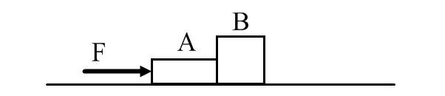
- Two boxes are placed on a horizontal frictionless surface, as shown above. Box A has a mass of 10 kg and box B has a mass of 16 kg. A force of 54 N is pushing box A.

  - Draw a free-body diagram for each block showing all applied forces to scale. Next to each diagram show the direction of the acceleration of that object.
  - Find the acceleration of the system of two boxes.
  - Find the force of contact that each box exerts on its neighbor.

Class Work
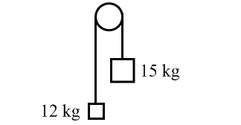

- A 12 kg load hangs from one end of a rope that passes over a small frictionless pulley. A 15 kg counterweight is suspended from the other end of the rope. The system is released from rest.

  - Draw a free-body diagram for each object showing all applied forces in relative scale. Next to each diagram show the direction of the acceleration of that object.
  - Find the acceleration each mass.
  - What is the tension force in the rope?
  - What distance does the 12 kg load move in the first 3 s?
  - What is the velocity of 15 kg mass at the end of 5 s?
Homework
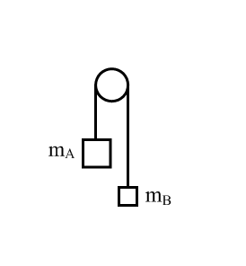

- The masses of blocks A and B are 4.5 kg and 3.7 kg respectively. The blocks are initially at rest and are connected by a massless string passing over a massless, frictionless pulley. The system is released from rest.

  - Draw a free-body diagram for each block showing all the applied forces in relative scale. Next to each diagram show the expected direction of acceleration.
  - What is the acceleration of blocks?
  - What is the tension force in the rope?
  - How high will the 3.7 kg block move in the first 2.5 s?
  - Find the speed of the 4.5 kg block at the end of 5th second.

Class Work
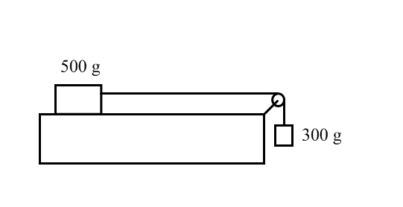

- A 500 g block lies on a horizontal tabletop. The coefficient of kinetic friction between the block and the surface is 0.25. The block is connected by a massless string to the second block with a mass of 300 g. The string passes over a light frictionless pulley as shown above. The system is released from rest.

  - Draw clearly labeled free-body diagrams for each of the 500 g and the 300g masses. Include all forces and draw them to relative scale. Draw the expected direction of acceleration next to each free-body diagram.
  - Use Newton’s Second Law to write an equation for the 500 g mass.
  - Use Newton’s Second Law to write an equation for the 300 g mass.
  - Find the acceleration of the system by simultaneously solving the system of two equations.
  - What is the tension force in the string?
- An 800 g block lies on a horizontal tabletop. The friction between the table and the block is negligible. The block is connected by a massless string to the second block with a mass of 400 g. The string passes over a light frictionless pulley as shown above. The system is released from rest.
400 g
800 g

  - Draw clearly labeled free-body diagrams for each of the 800 g and the 400g masses. Include all forces and draw them to relative scale. Draw the expected direction of acceleration next to each free-body diagram.
  - Use Newton’s Second Law to write an equation for the 800 g mass.
  - Use Newton’s Second Law to write an equation for the 400 g mass.
  - Find the acceleration of the system by simultaneously solving the system of two equations.
  - What is the tension force in the string?

Homework
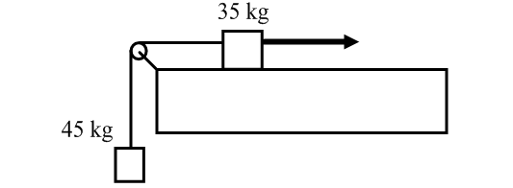

- A crate with a mass of 45 kg is suspended from a massless rope that runs vertically upward over a light pulley. The other end of the rope is connected to a 35 kg crate, which lies on a tabletop. The coefficients of the kinetic friction and the static friction between the crate and the surface are 0.3 and 0.5 respectively. An applied force, F, pulls the 35 kg crate to the right.

  - In the first case, the applied force is just sufficient to keep the crates from sliding. Draw clearly labeled free-body diagrams for each crates including all forces drawn to scale.
  - How much force would need to be applied in this first case?
  - In the second case, the 35 kg crate is sliding to the right with a constant velocity. Draw clearly labeled free-body diagrams for each crate including all forces drawn to scale.
  - How much force would need to be applied in this second case?
  - In the third case, the 35 kg crate moves to the right at a constant acceleration of 0.5 m/s². Draw clearly labeled free-body diagrams for each crates including all forces drawn to scale. In this instance, draw the direction of acceleration next to each diagram.
  - How much force would need to be applied in the third case?

Class Work
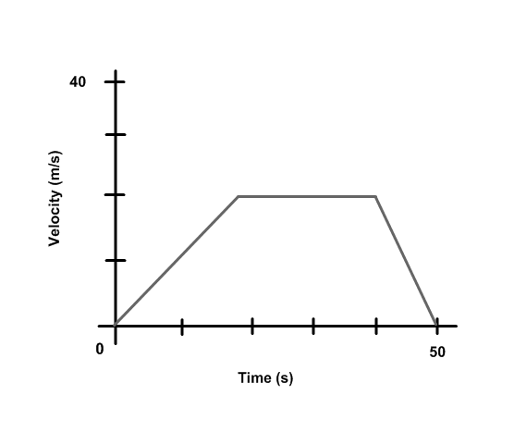
- A 2000 kg car travels in a straight line on a horizontal road. The relationship between car’s velocity and the time are given by the above graph.

  - What is the car’s acceleration during first 20 s?
  - What is the net force applied by the engine during the first 20 s?
  - What is the car’s acceleration from 20 s to 40 s?
  - What is the net force applied by the engine during this time?
  - What is the car’s acceleration from 40 s to 50 s?
  - What is the net force applied by an engine during this time?

Homework
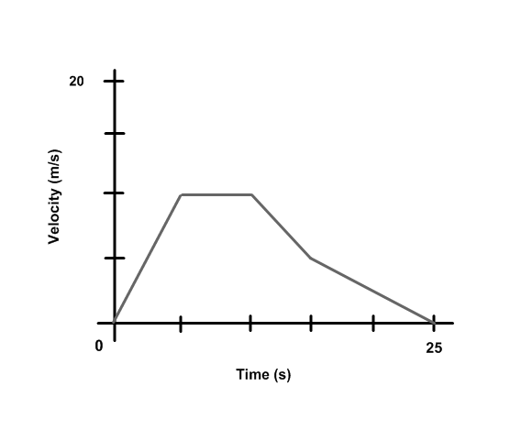
- A 180 kg motorcycle travels in a straight line on a horizontal road. The relationship between motorcycle’s velocity and time are given by the above graph.

  - What is the acceleration during the first 5 s?
  - What is the net force during first 5 s?
  - What is the acceleration from 5 s to 10s?
  - What is the net force from 5 s to 10 s?
  - What is the acceleration from 10 s to 15 s?
  - What is the net force from 10 s to 15 s?
  - What is the acceleration from 15 s to 25s?
  - What is the net force from 15 s to 25 s?

Answers
- 0.92 N  - 4.07 m/s²  - -12.25 N  - 35,651 N  - 0.84 N  - 3.96 m/s²  - 107.8 kg  - -17,000 N  - 2361 N  - 75 N  - 1818 kg  - 5.875 m/s²  - 162 N  - 3.46 s  - 558.6 N  - 13.6 kg  - 75 kg  - -80 N  - 13.9 m/s  34.75 m  - 59.2 kg  - 19600 N  - 833 N  136 N  No  - 1479.6 kg  - 44.1 N  - 3.47 kg  3.47 kg  13.2 N  - 27.6 kg  - 588 N  - 43.8 N  7.16 N  No  - 0.0196 N  - 33.7 kg  - 8192.8 N  3176.8 N  32-37) see last page  - 5 N  - 0.6  - 12.5 N  - 0.077  - 32 N  43) 70.56 N  44) 17.1 N  45) 31.9 kg  - 0.42  - 7.84 N | - 153.3 N  - 0.39  - 64.3 kg  - 20 N  - 23.52 N  - 0.09  - 42.5 kg  for 55)-58):  F_{static} ≤ 58.8N  F_{kinetic} = 36.75N  - a) balanced  b) 20 N  c) 0 m/s²  - a) balanced  b) 40 N  c) 0 m/s²  - a) F_{applied}>F_{static}  b) 36.75 N  c) 1.55 m/s²  - a) F_{applied}>F_{static}  b) 36.75 N  c) 4.22 m/s²  for 59)-62):  F_{static} ≤ 735 N  F_{kinetic} = 367.5N  - a) balanced  b) 300 N  c) 0 m/s²  - a) balanced  b) 500 N  c) 0 m/s²  - a) F_{applied}>F_{static}  b) 367.5 N  c) 1.53 m/s²  - a) F_{applied}>F_{static}  b) 367.5 N  c) 4.53 m/s²  for 63)-66):  F_{static} ≤ 15.7 N  F_{kinetic} = 12.7 N  - a) balanced  b) 5 N  c) 0 m/s² | - a) balanced  b) 10 N  c) 0 m/s²  65) a) F_{applied}>F_{static}  b) 12.7 N  c) 1.65 m/s²  66) a) F_{applied}>F_{static}  b) 12.7 N  c) 3.65 m/s²  - a) 14700N  b) 14700N  c) 16500 N  d) 12900 N  - 1.63 m/s²  - a) 637 N  b) 637 N  c) 793 N  d) 481 N  - -1.84 m/s²  - a) 548.8 N  b) 448.0 N  c) 649.6 N  - a) 1372 N  b) 1316 N  c) 1428 N  - +0.43 m/s²  - +0.84 m/s²  - a) 0.75 m/s²  b) 350 m  c) net force in  direction of F_{app}  d) 18750 N  - a) net force in direction of F_{app}  b) 205.9 N  c) 1.37 m/s²  d) 31 m/s  e) 22.6 s  - a) m₁ F_{N} a=  F_{T}  m₁g  m₂ F_{N} a=  F_{T} F_{A}  m₂g  b) a = 3.5 m/s²  c) T = 1.4 N | - a) A F_{N}  F_{B-A} F_{A}  m_{A}g  m_{B}g  F_{A-B}  m_{B}g  b) a = 2.08 m/s²  c) T = 33.3 N  - a) F_{T} F_{T}  m₁g m₂g  b) a = 1.09 m/s²  c) T = 130.7 N  d) x = 4.91 m  e) v = 5.45 m/s  - a ) F_{T} F_{T}  m₁g  m₂g  b) a = 0.96 m/s²  c) T = 39.8 N  d) x = 3 m  e) v = 4.8 m/s  - b) F_{T}-F_{FR}=m₁a  c) -F_{T}+m₂g=m₂a  d) a = 2.14 m/s²  e) T = 2.3 N  - b) F_{T} =m₁a  c) -F_{T}+m₂g= m₂a  d) a = 3.27 m/s²  e) T = 2.61 N  - b) F = 269.5 N  d) F = 543.9 N  f) F = 583.9 N  - a) 1 m/s²  b) 2000 N  c) 0 m/s²  d) 0 N  e) -2 m/s²  f) -4000 N  - a) 2 m/s²  b) 360 N  c) 0 m/s²  d) 0 N  e) -1 m/s²  f) -180 N  g) -0.5 m/s²  h)-90 N
32)
F_{N}
mg

F_{N}
mg
F_{fr}
F_{applied}
33)

F_{N}
mg
F_{T}
F_{fr}
F_{N}
mg
F_{fr}
F_{T}
34) a) sled b) boy c) rope
Sled Boy

35)
F_{T}
mg

36)
F_{N}
mg
F_{fr}
F_{applied}

F_{N}
mg
F_{fr}
37)

