Learning Target: You will evaluate how energy changes forms when an object falls, and you will describe the relationship between these energy conversions and the total energy of the system.

Purpose:
We live on a world where all objects fall to the ground if not supported. Even if we throw a ball straight upward, eventually it reverses direction and falls back down.
You have explored many types of energy transfers, and you have observed that energy can change forms (energy conversions) when energy transfers occur. In this activity, we will explore the types of energy conversions that occur when an object is released and falls to the ground. We will also explore energy conversions when an object is thrown up in the air and then falls back down.

How can we account for all the different forms of energy in a system as an object falls?

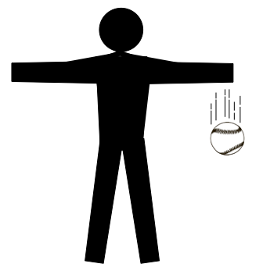
Initial Ideas:
Complete the following questions individually in your lab notebook:
- Think about a baseball that is dropped to the ground. What are the different types of energy that are involved as the object falls? Where do you think the kinetic energy of the ball comes from as it falls?
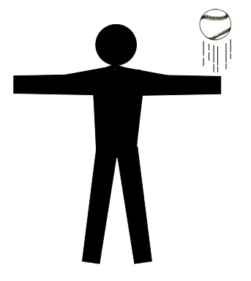
- Now think about a baseball that is thrown straight up in the air and then falls to the ground:
  - What types of energy conversions are taking place while the ball is moving upward, if any?
  - What types of energy conversions are taking place while the ball is moving back downward, if any?
  - Draw a picture of the ball’s motion. On the picture, label when you think it is moving the fastest and when you think it is moving the slowest.

Share your ideas with your group members.
On a presentation board, record your group’s thoughts about the Initial Ideas.

Collecting and Interpreting Evidence:

Experiment #1: Where does the energy of a falling object come from?

Materials:
- Large ball (such as a soccer ball or basketball)
- Motion sensor
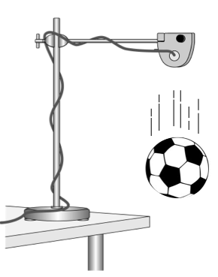
- Data collection device
- Ringstand to mount the motion sensor (optional)

Step 1: Mount a motion sensor on a ringstand or have a group member hold the motion sensor so that it is pointing down toward the floor (at least 2 m above the floor).

Step 2: Hold the ball about 20 cm below the motion sensor and start to collect data. Release the ball (do not throw it downward, just let it go). Stop data collection when it hits the floor.
- From the graph, what was the maximum final speed of the ball?
Drop Height (m) | Maximum Speed (m/s)

Step 3: In the next steps, you are going to collect data to determine the relationship between the height the ball is dropped from and the maximum final speed of the ball. Copy the data table (on the right) into your laboratory notebook.

Step 4: Decide on three different heights from where you will release the ball. Note: you will want to release the ball from heights that will produce a measurable difference in the maximum speed. This may take a few trials. Before deciding on your drop heights, consider dropping the ball from several different heights to determine how different the drop heights need to be.

Step 5: Using the motion sensor, collect maximum speed data when the ball is released from the different heights. Record these data in your laboratory notebook.
- From what drop height did the ball have the highest final speed?
- From what drop height did the ball have the highest kinetic energy?
- What inference can you make about the amount of energy stored in the system at each drop height?
Remember that potential energy is a type of energy that has to do with how objects are arranged. For example, chemical potential energy is related to how the atoms of a substance, like food, are arranged, and it can change when we eat and use our muscles. Elastic potential energy is related to the distance an elastic object stretched. Each of these types of energy may be converted into kinetic energy.

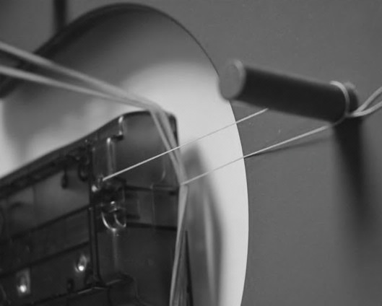
Step 6: For the next few steps in this experiment, we are going to use an analogy to help build our understanding of the potential energy associated with falling objects. Think back to the activity in Chapter 1 when you pulled a cart back with a rubber band, tied it back with a string, and then cut the string so that the rubber band launched the cart.
- In the experiment from Chapter 1, what variable did you change so that the cart gained the greatest amount of kinetic energy?
- Now think about the evidence you collected in this activity by dropping the ball. What variable did you change so that the ball gained the greatest amount of kinetic energy?
- What evidence might support the idea that some form of potential energy is involved when an object is lifted up and then dropped? Use ideas from the cart-band experiment to support your response.
- In the experiment with the cart and the rubber band, the cart gained kinetic energy when elastic potential energy stored in the band was transferred to the cart. What other object do you think is involved as the falling ball gains kinetic energy? Hint: the person is no longer touching the ball!

Step 8: Read the Tools of the Trade below and respond to the following questions.
Gravitational Potential Energy is the stored energy that is converted into kinetic energy as objects fall.
Remember from the previous activity that the Earth exerts a gravitational force on objects. The Earth is always involved in a system of falling objects. When discussing the energy of falling objects, we will refer to the energy in the Earth-Object System. So, with the falling ball, we talk about the energy stored in the Earth-Ball System.

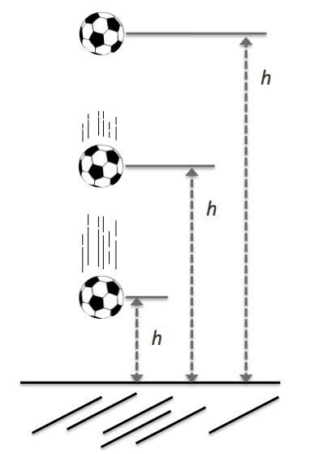
Step 9: Now think of the ball as it falls toward the ground (so you are no longer comparing the ball dropped from different heights, but instead looking at the ball as it falls to the ground).
- As the ball falls toward the ground, (a) what happens to its kinetic energy? (b) where is the kinetic energy coming from?
- During the time the ball is falling toward the ground, when does the Earth-Ball System have the greatest amount of stored energy? What is your rationale?
Note: it may be useful to think back to the time when the cart-band system stored the most amount of energy.
- When does the Earth-Ball System have the least amount of stored energy? What is your rationale?

Step 10: In your lab notebook, complete the statement below about the energy in the Earth-Object System.
The gravitational potential energy in the Earth-Object System _______________________________ when an object falls toward the Earth.

Experiment #2: What happens to an object’s energy when the object is thrown upward and then falls back down?

Materials:
- Large ball (such as a soccer ball or basketball)
- Motion sensor
- Data collection device
- Ringstand to mount the motion sensor (optional)
- Energy Skate Park (PhET Sim as Teacher-Led Demo)

Step 1: Look back to the Initial Ideas about a baseball that is first thrown up before it falls back to the ground.
- What types of energy conversions do you think are taking place when the ball is moving upward? How have your ideas changed (if at all) based upon evidence from the previous experiment?
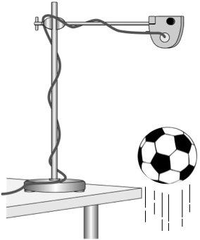
- What types of energy conversions do you think are taking place when the ball is falling? How have your ideas changed (if at all) based upon evidence from the previous experiment?

Step 2: Set up the motion sensor so that it is pointing down toward the floor.

Step 3: Hold the ball near the floor, so that you have enough space to throw the ball upward toward the motion detector. Start to collect data. Gently toss the ball upward so that it changes direction and starts falling just before reaching the motion detector. Stop data collection when it hits the floor.
- Draw the velocity-time graph of the ball’s motion from the time it leaves your hand to the time just before it hits the ground.
- As the ball is moving upward, what is happening to its speed? What can you infer about its kinetic energy as it moves upward?
- During the time that the ball is moving upward and slowing down, where do you think the ball’s kinetic energy going?
- During the time that the ball is falling and speeding up, where do you think the ball’s kinetic energy coming from?
Step 4: In your lab notebook, complete the statements below about how rising and falling objects change energy.
When the ball is moving further away from the Earth, the amount of gravitational potential energy “stored” in the Earth-ball system is _______________________________.
When the ball is moving closer to the Earth, the amount of gravitational potential energy “stored” in the Earth-ball system is _______________________________.

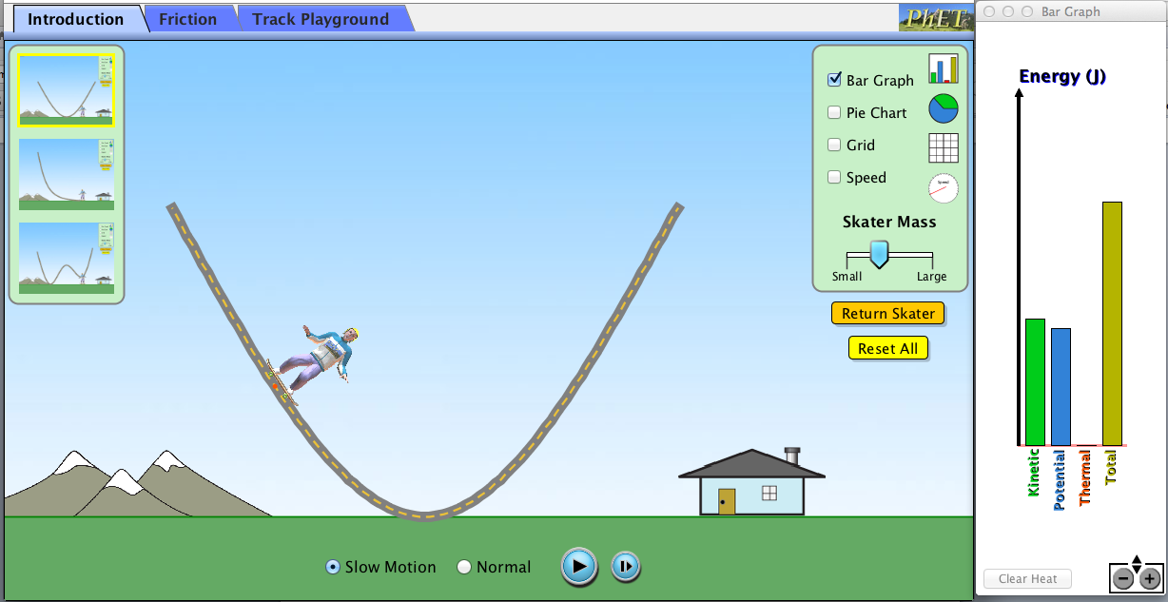
Step 5: Your instructor will show you a simulator with a skateboarder moving up and down a half-pipe. The simulator also shows an energy bar graph with the potential and kinetic energy in the Earth-Skateboarder System).
- When is the skateboarder’s speed the greatest?
- When is the gravitational potential energy in the Earth-Skateboarder System the greatest?
- Are your responses to the previous two questions consistent with your laboratory evidence from this experiment? Explain why or why not.
- How does the total energy in the Earth-Skateboarder System change as the skater moves in the half-pipe?
- What is the relationship between the total energy, the kinetic energy, and the potential energy?

Summarizing Questions Name: _______________________________
How can we account for all the different forms of energy in a system as an object falls?
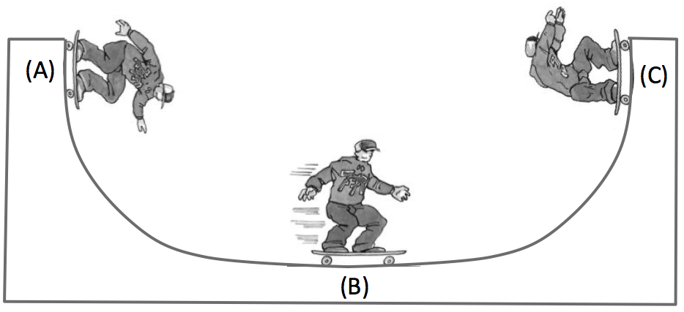
Learning Target: You will evaluate how energy changes forms when an object falls, and you will describe the relationship between these energy conversions and the total energy of the system.
- Think about a skateboarder who skates down and then up the sides of a half-pipe.
  - Is there any point where the gravitational potential energy is zero? Describe your rationale.
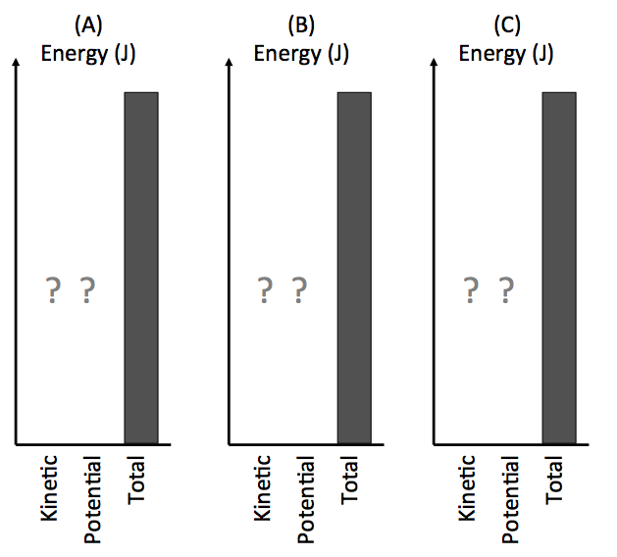

  - Complete the energy bar graphs (on the right) for the kinetic energy and gravitational potential energy of the Earth-Skateboarder System at points A, B, and C.
  - Summarize the energy conversions that occur when the skateboarder moves from position A to position C.

  - Explain (in terms of energy) why building a taller half-pipe would cause the skateboarder to have a greater amount of kinetic energy at position B. In your response, be sure to discuss the total energy.

- Think about standing outside of a building and tossing a package up to a friend who is at a second story window. Answer the following questions for the time after you release the package, when it is moving upward.
  - What happens to the package’s kinetic energy as it moves upward?

  - What happens to the package’s potential energy as it moves upward? Describe your rationale.

- A student in a previous class made the following statement:
“When I drop a ball it speeds up as it falls, so its kinetic energy increases. This means that the total energy of the system increases as the ball falls, so energy is created.”
How would you respond to this student? Remember to include evidence!

- In the lab, you tossed a ball upward so that it moved up and then it fell back toward the floor. For each of the statements, circle whether you agree or disagree.

As the ball moves upward:
AGREE DISAGREE The strength of the gravitational force gets weaker
AGREE DISAGREE The kinetic energy decreases
AGREE DISAGREE Energy disappears
AGREE DISAGREE Total energy in the Earth-ball system increases

As the ball falls down:
AGREE DISAGREE The strength of the gravitational force stays the same
AGREE DISAGREE Energy is created
AGREE DISAGREE Potential energy is converted to kinetic energy
- Challenge yourself! Do you think there is something special about the Earth that allows the Earth-Ball System to behave the way it does? What do you think about other stars, planets, or moons?

3.2 Scientist Ideas Reading
Instructions: Read the Scientist Ideas, paying careful attention to each key idea. When you read, try to think about how the key ideas relate to the evidence you collected in the activity.
Gravitational Potential Energy Idea: The Earth-Object System “stores” gravitational potential energy when the object is above the Earth’s surface.
Gravitational Potential Energy and Height Idea: The amount of gravitational potential energy in the Earth-Object System is proportional to the object’s height above the ground (distance between the Earth and the ball).
You have explored several forms of potential energy, including chemical potential energy and elastic potential energy. Remember that when objects are rearranged, the amount of potential energy can change. Gravitational potential energy (GPE) is proportional to the distance between an object and the surface of the Earth, or the height of an object above the ground. As the height of an object increases, the amount of gravitational potential energy stored in the Earth-Object System also increases.
Energy Can be Converted from One Form to Another Idea: Energy can be converted from kinetic energy to gravitational potential energy and from gravitational potential energy to kinetic energy.
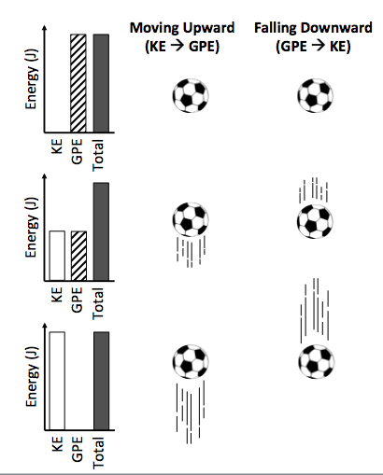
After a ball is tossed upward, the ball slows down as it is moving upward. During this time, the kinetic energy is being converted into gravitational potential energy, as evidenced by less velocity. When the ball falls back down, the gravitational potential energy is converted into kinetic energy as the ball increases in speed. During these conversions, the total energy in the Earth-Ball System stays the same.
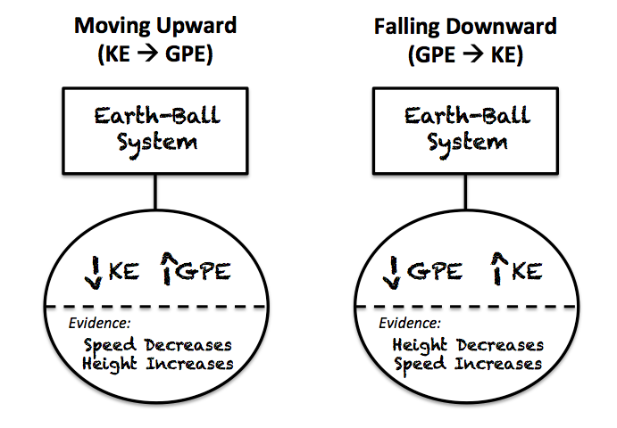

Law of Conservation of Energy:
The total energy within a group of objects (or a system) always remains the same; energy can be converted from one form to another but cannot be created or destroyed.
Energy is always conserved. As a ball is tossed upward, the ball’s kinetic does NOT just disappear. The object slows down because the kinetic energy is converted into gravitational potential energy. Similarly, when an object falls, kinetic energy is NOT created; it is converted from gravitational potential energy.
In the case of the skateboarder that you observed in the simulator, when friction is so small that it can be ignored (negligible), the kinetic energy plus the potential energy equaled the total energy (because thermal energy = 0 when friction isn’t present). When friction is present, the kinetic, potential, and thermal energies will equal the total energy.
No Friction: Total Energy = KE + PE
Friction: Total Energy = KE + PE + TE
Respond to the following questions individually in your lab notebook:
- Why is the Law of Conservation of Energy a Law?
- In this activity, you worked with several different types of representations (energy bar graphs, energy diagrams, and velocity-time graphs). What type of representation do you find to be the most useful when thinking about gravitational potential energy and kinetic energy in an Earth-Object System?
- Think about a baseball that is tossed up in the air and then falls to the ground.
  - When is the gravitational potential energy of the Earth-Ball System zero?
  - When the GPE is zero, what can we say about the relationship between total energy and KE?
- Think of a situation where the total energy is equal to the kinetic energy?
- List all of the types of potential energy you are familiar with. For each type of potential energy, describe what is “rearranged” when it changes.
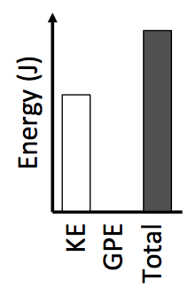
- Provide 1-2 specific examples from the experiment and simulator in this activity that show how gravitational potential energy is proportional to the height of the object.
- Complete the energy bar graph (shown on the right) in your lab notebook by adding a bar for GPE.
- If the object (from the energy bar graph) is increasing in GPE and decreasing in KE at the moment the bar graph is shown, is the object moving upward or downward? Describe your rationale.
- Why is it that when friction is present the total energy in the system also includes thermal energy?

