**Mathematical Models: Building**

*Discuss each of the following questions with your group and respond in your lab notebook.*

**Exploration 1: Mass and Gravitational Force on the Earth and the Moon**

|  |  |  |
| --- | --- | --- |
| Tool Icon | In the previous math activity, you explored that objects fall at different rates (have different gravitational accelerations) on different planets. Specifically, you compared the gravitational acceleration of objects on the Earth and on the Moon. | $${\vec{a}}_{g Earth}≠{\vec{a}}_{g Moon}$$ |

**Step 1:** Think about a bag of rice on the Earth and the same bag of rice on the Moon. Discuss the questions below with your group members and record your ideas.

1. If the bag of rice were dropped on the Earth and on the Moon, would it accelerate at the same rate or different rates?
2. Is the bag of rice acted upon by the same or different gravitational force on the Earth as on the Moon?
3. On the Earth, the bag of rice has ~29,000 grains of rice inside. On the Moon, does the same bag of rice have the same number or different number of rice grains?

|  |  |
| --- | --- |
| Tool Icon | Scientists define **mass** as the amount of matter in an object. |

1. Does the bag of rice have the same or different mass on the Earth as on the Moon? Defend your answer using both the definition of mass and your response to the previous question.

**Step 2:** Two scales are shown on the right. One of the scales is “on the Earth” and the other scale is “on the Moon.”

1. Make a claim about whether the scales are showing the *mass* of the bags of rice or the *Gravitational Force* acting on each bag.
2. Which scale represents the bag of rice on the Earth? Describe your rationale.

**Exploration 2: Mass and Weight**

Materials:

* Spring balance
* Digital scale
* 1 pound (lb) bag of rice
* Objects of various masses

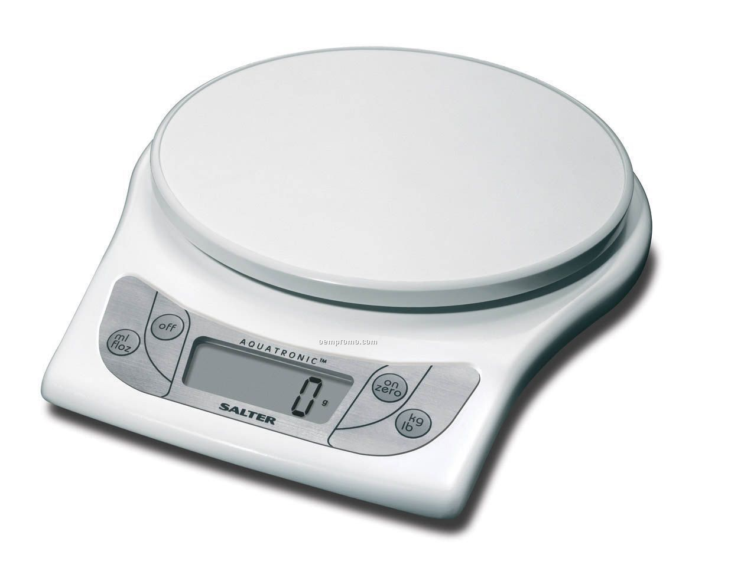

**Step 1:** Place the bag of rice on the digital scale and measure the **mass** of the bag of rice.

1. What is the mass of the rice? Be sure to include units.
2. What units did you use? Why did you use those units?
3. Use the mass you measured and the value of the gravitational acceleration on Earth to calculate the force on the bag of rice in kilograms on Earth.

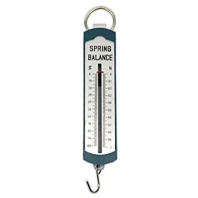

**Step 2:** A spring balance is a way to measure force. Use the spring balance to check your value for the **gravitational force** of the Earth on a bag of rice (that you calculated in the previous question).

1. What is the gravitational force on the rice? Be sure to include units.
2. What units did you use? Why did you use those units?
3. How does your experimental value of gravitational force compare to the value you calculated?

**Step 3:** Knowing that you have been working with a bag of rice that is approximately 1 pound, you can make an inference about the relationship between Newtons and pounds.

1. In your lab notebook, complete the statement below about the relationship between Newtons and pounds.

*I infer that the one pound is equivalent to __________ Newtons.*

1. Based upon your inference, what can you say about the strength of the gravitational force that acts on a 2 pound bag of rice? What about a 10 pound bag of rice?

|  |  |  |
| --- | --- | --- |
| Tool Icon | “Pounds” is just another unit that is used to express the strength of the gravitational force acting on an object. | $$1 Pound=4.4 Newtons$$ $$1 Newton=0.23 Pounds$$ |

1. If you took the same bag of rice (that you experimented with in previous steps) to the Moon, would it still be considered a 1-Pound bag of rice? Describe your rationale.
2. *Challenge:* What is strength of the gravitational force that acts on this bag of rice on the Moon in pounds?

Hints (Only use these hints if you think you need them!):

* Use your calculated value of the mass
* Use the gravitational acceleration on the Moon
* Convert from Newtons to pounds using the relationship you found between Newtons and pounds.

**3.1 Mathematical Ideas Reading**

***Instructions:*** *Read the Mathematical Ideas, paying careful attention to each key idea*

|  |  |
| --- | --- |
| Key Icon | **Weight is gravitational force idea:** Weight is just another way of saying “gravitational force.” |

It is not uncommon for people to confuse *mass* and *weight*. Mass and weight are very different, but closely related ideas. The mass of an object is determined by the amount of matter in the object. This is why the mass of the object will not change if it is on a different planet. Weight, however, is the strength of the gravitational force that acts on an object and therefore can change when on another planet. Weight and mass are related because weight is calculated using the mass of the object.

$${\vec{F}}_{gravity}=weight=m⋅ {\vec{a}}_{gravity}$$

Remember that the acceleration from gravity on Earth is abbreviated as $\vec{g}$. So the equation for weight is often expressed as:

|  |  |  |
| --- | --- | --- |
| Key Icon | **Converting between Newtons and pounds idea:** Since Newtons and pounds are both measures of gravitational force (and therefore weight), it is possible to convert between these two units using the equivalence statement shown on the right. | $$1 Pound=4.4 Newtons$$*Also written as: $$\frac{1 lb}{4.4 N} OR \frac{4.4 N}{1 lb}$$*  *Note that pounds is abbreviated lb* |

An **equivalence statement** shows how one unit can equals another unit. This only works if the units are measuring the same variable. For example, an equivalence statement can be made for two units of length, like miles and meters. But an equivalence statement cannot be made for units that measure different things, like meters and grams (length and mass).

You’ve no doubt used equivalence statements before. For example, you may have said that in one foot there are 12 inches. This statement expresses how the units of feet relate to the units of inches, and it can be used to convert from feet to inches (or inches to feet). We can write the equivalence statement as a fraction:

$$\frac{12 inches}{1 foot} or \frac{1 foot}{12 inches}$$

Since 12 inches is equal to 1 foot (12in=1ft), we can multiply by $\frac{12 inches}{1 foot}$ or divide by it, just like we can with the number one.

The example below shows how to use the equivalence statement to convert from feet to inches.

|  |  |
| --- | --- |
| Example | **Question:** If a person is 4 feet tall, what is his height in inches? |
| $$4 ft ⋅\frac{12 in}{1 ft}=48 in$$ Notice that we used the equivalence statement that allows the ft units to cancel out. This leaves the answer in inches. |

The example below shows how to use the equivalence statement to convert from pounds to Newtons.

|  |  |
| --- | --- |
| Example | **Question:** What is the strength of the gravitational force (in Newtons) of a 150 pound box full of books? |
| $$150 lbs ⋅\frac{4.4 N}{1 lb}=660 N$$ Again, notice that we used the equivalence statement that allows the original units to cancel out (in this case pounds). This leaves the answer in Newtons. |

**Mathematical Models: Practice**

*Respond to the following questions in your laboratory notebook. Show your work.*

**Support Questions:** The first three questions include fill-in-the-blank supports to help you learn how to set up the problems. If you already feel comfortable solving these problems, consider trying to solve them without using the fill-in-the-blank supports. You can check your work using the supports.

1. What is the strength of the gravitational force that acts on a 7 pound baby?

Use this equivalence statement so pounds will cancel out: $\frac{4.4 N}{1 lb}$

Optional

Fill-in-the-Blank

Supports

$______ lbs ⋅ =________ N$

*Weight in pounds (given in the problem)*

*Equivalence Statement*

1. What is the mass of the baby in the previous question (in kilograms)? *Note that the baby is on the Earth (so you can use the gravitational acceleration for Earth).*

$\vec{F}=m⋅ \vec{a}$ Rearrange this equation to solve for mass: *m = $\frac{\vec{F}}{\vec{a}}$*

$\vec{F}$ = _____________ (What value did you find for the gravitational force – in the previous question?)

$\vec{a}$ = _____________ (What is the gravitational acceleration for all objects on Earth?)

*m = $\frac{_______}{_______}$ = _____ kg*

*Gravitational Force*

*Gravitational Acceleration*

1. A small car experiences a gravitational force of 4,900 N. What is the weight in pounds of this car?

Which equivalence statement will you use so that the Newtons will cancel out?

$$\frac{1 lb}{4.4 N} OR \frac{4.4 N}{1 lb}$$

$$______ N ⋅ =________ lbs$$

1. Sometimes the most confusing thing about these types of conversion problems is remembering the units that go with each variable. Record the possible units for each of the variables below. *(Hint: remember that weight and gravitational force are a measure of the SAME THING, so their possible units should be the same.)*
   1. Mass
   2. Weight
   3. Gravitational Force
2. What is the weight (in pounds) of a 50 kg man on Earth?
3. What is the mass of a stone with a gravitational force of 196 N on it?
4. Calculate the weight of a 150 kg NFL lineman on Earth.
   1. First calculate the force in Newtons.
   2. Then convert the force (weight) to pounds (remember to use the equivalence statement for Newtons to pounds).
5. Now calculate the weight of that same lineman on the Moon. (Remember that the gravitational acceleration on Moon is 1.6 m/s2)
6. Gravitation acceleration is 26 m/s2 on Jupiter. Calculate the weight of the lineman on Jupiter.
7. Two students are discussing the idea of weight. Read their ideas.

I think that mass and weight are the same. They both measure how heavy an object is.

I think that mass and gravitational force are the same. They both measure how hard the Earth is pulling down on an object.



Amara Victor

What do you think about their ideas?

1. A fruit has a mass of 1 kilogram. Use the table below to figure out what type of fruit it is.

|  |  |
| --- | --- |
| **Fruit** | **Weight** |
| Watermelon | 6 lbs |
| Cantaloupe | 2.2 lbs |
| Apple | 0.5 lbs |

**Challenge Yourself:** These problems are about the same mathematical ideas, but are more challenging. *Respond to these questions in your laboratory notebook and show your work.*

1. A 10 kg stone is dropped. It takes 3 seconds to reach a speed of 15 m/s from 0 m/s.
   1. What is the change in velocity?
   2. What is the stone’s acceleration?
   3. Was the stone dropped here on Earth? Why or why not?
   4. What is the weight of the stone on the planet where it was dropped?
2. 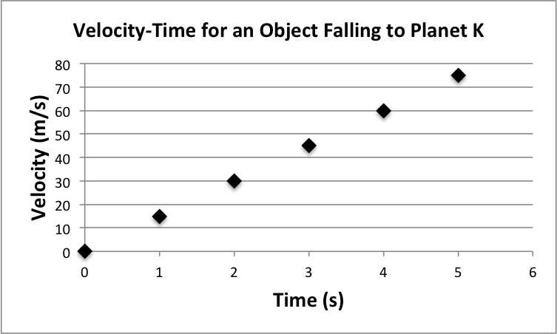The velocity-time graph on the right shows the velocity of an object falling on Planet K. What is the weight in pounds of an object of mass 10 kg on Planet K?
3. What is the acceleration of a 20 kg object falling on Planet K? How do you know?
4. What is the gravitational force on a 20 kg object falling on Planet K?