Mathematical Models: Building
Discuss each of the following questions with your group and respond in your lab notebook.

Exploration: What is the gravitational acceleration of falling objects to Earth?
$\vec{a}$ = $\frac{\vec{F}}{m}$
Step 1: Complete the table below by using Newton’s Second Law to calculate the acceleration.

- What pattern do you notice in the table?
Mass | Force | Acceleration
3 kg | 29.4 N
15 kg | 147 N
50 kg | 490 N
- Does this pattern align with what you observed in the experiment? Describe why or why not.
- Based on the pattern you see in the table, what do you predict is the gravitational acceleration of a 1.0 gram (g) pea? What about a 5,000 kilogram (kg) rock?
$\vec{a}$ = $\frac{{\vec{v}}_{f}-{\vec{v}}_{i}}{t_{f}-t_{i}}= \frac{Δ\vec{v}}{Δt}$
Step 2: Use the graph and table below to find the acceleration of a falling object (calculate the slope of the line). Hint: to find the most accurate value for acceleration, use the values in the table rather than estimating using the graph.
Time (s) | Velocity (m/s)
0 | 0
1 | 9.8
2 | 19.6
3 | 29.4
4 | 39.2
5 | 49
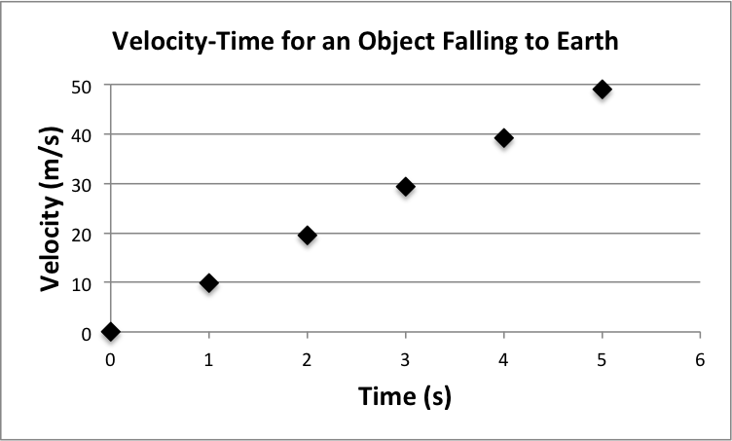

- How does the acceleration value you calculated for the object in the graph compare to the acceleration value you calculated for the objects in Step 1?
- Would the graph (from Step 2) be different if the object had twice the mass? Describe your rationale.
- In your lab notebook, complete the statements below about the gravitational acceleration for objects falling toward the Earth.
On Earth, falling objects __________________________ in speed by ________ meters per second every ______________.
In other words…
The gravitational acceleration for objects falling toward Earth is ________ $m/{s^{2}}$.

Step 3: Now think about an object that is dropped to the surface of the Moon.
- Do you think the gravitational acceleration will be different for the object dropped to the surface of the Moon compared to the same object dropped to the surface of the Earth?
$\vec{a}$ = $\frac{{\vec{v}}_{f}-{\vec{v}}_{i}}{t_{f}-t_{i}}= \frac{Δ\vec{v}}{Δt}$

Step 4: Use the graph and table below to find the acceleration of a falling object (slope of the line).
Time (s) | Velocity (m/s)
0 | 0
1 | 1.6
2 | 3.2
3 | 4.8
4 | 6.4
5 | 8
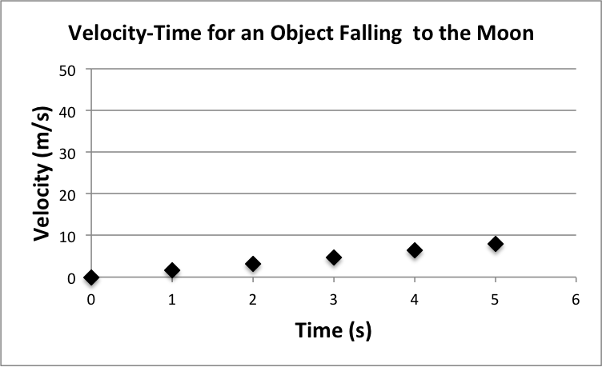
- How does the acceleration value you calculated for the object in the graph compare to the gravitational acceleration for objects falling to Earth (see graph on previous page)?
- In your lab notebook, complete the statement below about the gravitational acceleration for objects falling toward the Moon.
From these data, I infer that the gravitational acceleration for objects falling toward the Moon is __________ $m/{s^{2}}$.
3.1 Mathematical Ideas Reading
Instructions: Read the Mathematical Ideas, paying careful attention to each key idea
 | Gravitational acceleration is 9.8 m/s² for all objects near Earth idea: All objects falling toward the Earth, fall with an acceleration of 9.8 m/s². | $${\vec{a}}_{g}=9.8 m/{s^{2 }}=\vec{g}$$  Scientists often use $\vec{g}$ instead of ${\vec{a}}_{g}$.
In the laboratory activity, you dropped spheres of different mass to find that they all hit the ground at the same time. From this observation, you were able to infer that all objects fall with the same gravitational acceleration. In this math activity, you found that the acceleration for objects falling toward the Earth is 9.8 $m/{s^{2}}$. Because this value is so widely used in physics, scientists call it “g” and you’ll often just hear that g = 9.8 $m/{s^{2}}$ .

 | Gravitational acceleration is different for objects falling toward different massive objects (planets, moons, etc.) idea: Objects fall at different rates on different planets, moons, etc.. | $${\vec{a}}_{g Earth}≠{\vec{a}}_{g Moon}$$
As you inferred in this mathematical activity, objects fall at different rates depending upon the object they are falling toward. This is because the gravitational acceleration is different for different planets, moons, etc. While all objects fall toward the Earth at an acceleration of 9.8 $m/{s^{2 }}$, objects fall toward the Moon with an acceleration of 1.6 $m/{s^{2 }}$. In an upcoming activity, you will explore why the gravitational acceleration is different for objects on different planets.

Mathematical Models: Practice
Respond to the following questions in your laboratory notebook. Show your work.
Support Question: The first question includes fill-in-the-blank supports to help you learn how to set up the problems. If you already feel comfortable solving these problems, consider trying to solve them without using the fill-in-the-blank supports. You can check your work using the supports.
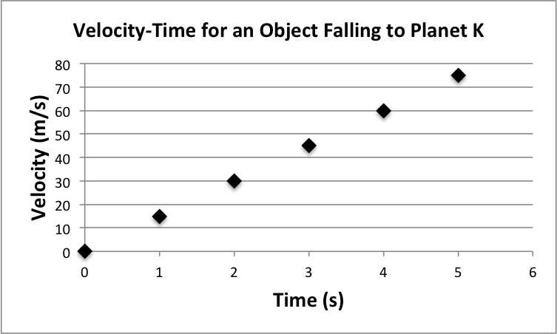
- Use the graph on the right to find the gravitational acceleration for an object falling toward planet K.
$\vec{a}$ = $\frac{{\vec{v}}_{f}-{\vec{v}}_{i}}{t_{f}-t_{i}}= \frac{Δ\vec{v}}{Δt}$
Optional
Fill-in-the-Blank
Supports
time interval = __________ (Pick a time interval to use)
t_{f} = _____________ (Final time in the time interval?)
t_{i} = _____________ (Initial time in the time interval?)
$\vec{v}$_{f} = _____________ (Final velocity in the time interval?)
$\vec{v}$_{i} = _____________ (Initial velocity in the time interval?)
$\vec{a}$ = $\frac{{\vec{v}}_{f}-{\vec{v}}_{i}}{t_{f}-t_{i}}= \frac{_____ - _____}{_____ - _____}= \frac{______}{______}= ____$ $m/{s^{2}}$

- A 10 kg stone is dropped. It takes 3 seconds to reach a speed of 15 m/s from 0 m/s.
  - What is the change in velocity?
  - What is the stone’s acceleration?
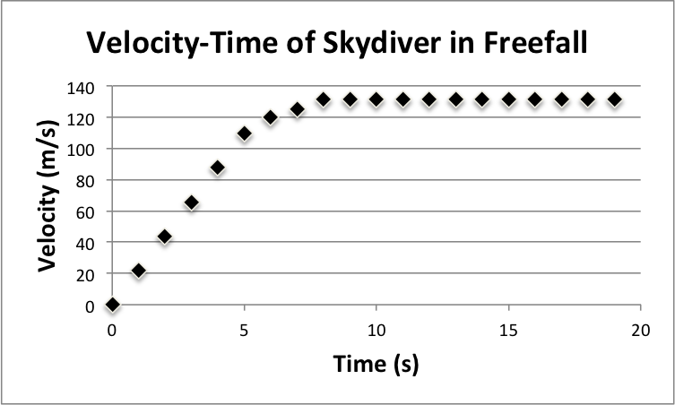
  - Was the stone dropped here on Earth? Describe how you know.
- Examine the graph on the right.
  - Describe the motion of the skydiver in terms of velocity from t=0 to t=20 seconds.
  - What is the acceleration of the skydiver from t = 0 s to t = 5 s?
  - What is the acceleration of the skydiver from t = 10 s to t = 20 s?
- A 60 kg skydiver steps out of an airplane. At the beginning of her fall, a gravitational force of 588.6 N is exerted on her.
  - Draw a force-diagram for the skydiver at the very beginning of her fall.
  - Calculate the acceleration of the skydiver using Newton’s Second Law.
$\vec{a}$ = $\frac{\vec{F}}{m}$
  - Is the acceleration value what you expected? Explain why or why not.
  - As the skydiver accelerates toward the ground, air resistance increases. Eventually, the force of air resistance upward equals the force due to gravity. We call this situation terminal velocity. Draw a force-diagram for the skydiver at terminal velocity.
  - What is the acceleration of the skydiver at terminal velocity?

Challenge Yourself: These problems are about the same mathematical ideas, but are more challenging. Respond to these questions in your laboratory notebook and show your work.
- The mass of a skydiver is 70 kg. Use Newton’s Second Law to find the strength of the gravitational force acting on this skydiver.
- Think about two skydivers, one who is 55 kg and the other who is 75 kg.
  - What is the gravitational acceleration for each of these skydivers?
  - What is the gravitational force acting on each of these skydivers?
  - Knowing that each skydiver accelerates at the same rate and knowing that the force of air resistance increases as velocity increases, describe which skydiver will reach terminal velocity first. Include force diagrams in your explanation.
- Once a skydiver opens his parachute, it takes him about 6 seconds to go from a velocity of 50 m/s to 3 m/s. The skydiver has a mass of 60 kg.
  - What is his acceleration during this time when the parachute is slowing him down? Pay careful attention to the sign of the acceleration.
  - What is the strength of the upward force from the parachute on the skydiver when the skydiver first opens the parachute?
  - Does the strength of the upward force from the parachute change or remain constant? Describe using your understanding of the properties that affect the strength of the air resistance force.
  - What is the upward force from the parachute when the skydiver is falling at a constant speed of 3 m/s?
- The velocity-time graph below shows a skydiver as she jumps from the airplane and then opens her parachute. Copy this graph in your laboratory notebook.
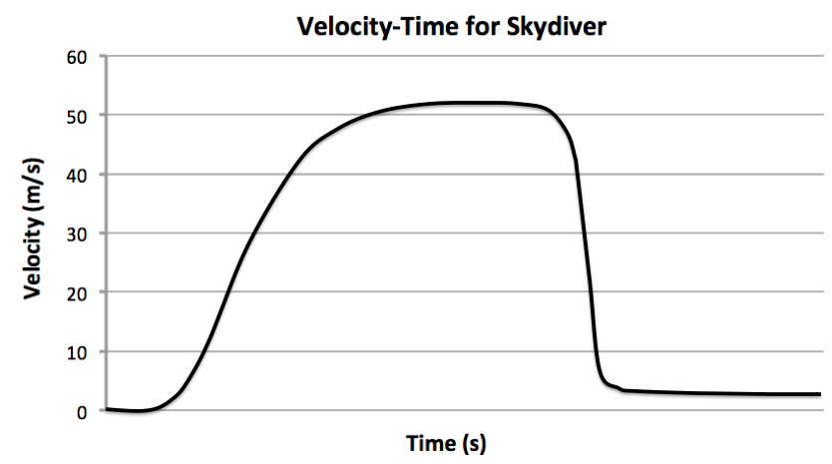
On the graph, label the following parts:
  - Skydiver jumps from the airplane
  - Skydiver at terminal velocity (parachute closed)
  - Skydiver opens parachute
  - Skydiver at terminal velocity (parachute open)

