Learning Target: You will determine the relationship between mass, acceleration, and gravitational force.
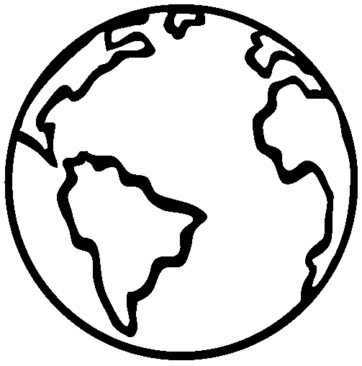
Purpose:
So far in the course, you’ve only observed interactions where contact must occur for a force to act on an object. Is this true of all forces? Think of some forces that don’t require contact.
In Chapter 1, you explored gravitational interactions in terms of energy and found that objects increase in kinetic energy as they fall. Your evidence was that the object was speeding up as it fell. What does this imply about the net force on the falling object?

How does the mass of an object affect: (1) the gravitational force on an object and (2) the rate at which it falls (gravitational acceleration)?

Initial Ideas:
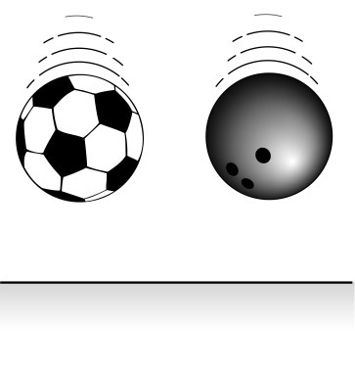
Complete the following questions individually in your lab notebook:
- What evidence suggests that a gravitational force exists on the Earth?
- Do you think the gravitational force is the same or different on a bowling ball and a soccer ball? Explain your thinking.
- If you were to drop a bowling ball and a soccer ball from the same height, which one do you think would reach the floor first, if either? Explain your thinking.

 | Share your ideas with your group members.
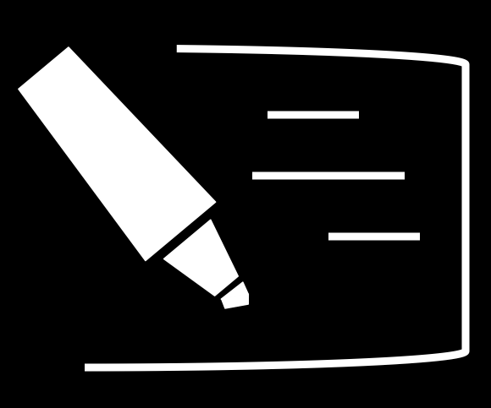 | On a presentation board, record your group’s thoughts about the Initial Ideas.
Collecting and Interpreting Evidence:
Experiment #1: Does the mass of an object affect the strength of the gravitational force exerted on it?
Materials:
- 100 g mass
- 1000 g mass (1 kg)

Step 1: Have a member of your group stand with one arm stretched out horizontally, palm upward. Place the 100 g mass on the palm of the outstretched hand.
- What forces are acting on the mass as your team member holds it? Are these forces balanced or unbalanced? How do you know?
- Draw a force diagram for the 100g mass being held motionless.
- How does the strength of the force being exerted on the mass by the hand compare with the strength of the gravitational force of the Earth acting on it? Describe your reasoning.

Step 2: Now have a group member stand with both their arms stretched out horizontally, palms upward. Place the 100 g mass on one palm, and the 1000 g mass on the other.
- Does it require the same effort to hold up both masses, or is one of the masses harder to hold up than the other? If so, which one?
- Draw a force diagram for the 1000 g mass. Be sure that the arrows are sized appropriately when compared to the diagram you drew for the 100 gram mass.
- What do the sizes of the force arrows in your diagrams imply about the strength of the force each hand has to exert to stop the masses from falling? Are both hands exerting the same strength force, or is a stronger force required to hold up one of the masses?
- Does your answer to the previous question suggest that the strength of the gravitational force of the Earth pulling downward on the 100 gram mass is the same as the 1000 gram mass? Or are the forces different? Describe your reasoning.
- What is the relationship between strength of the gravitational force on an object and the object’s mass?
Collecting and Interpreting Evidence:
Experiment #2: Does the mass of a falling object affect its motion?
Materials:
- Several objects with different masses (but similar size and shape)
- Hard board

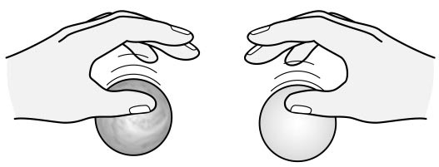
Step 1: Select two objects of about the same size but different mass and hold them (one in each hand) at the same height above the board. Release them at the same time. All your group members should watch and listen carefully as they hit the board.
- Does the more massive or the less massive object hit the board first, or do they both appear to hit at the same time? (You may want to repeat the experiment to check.)

Step 2: Now, repeat the experiment using different pairs of objects of varying masses.
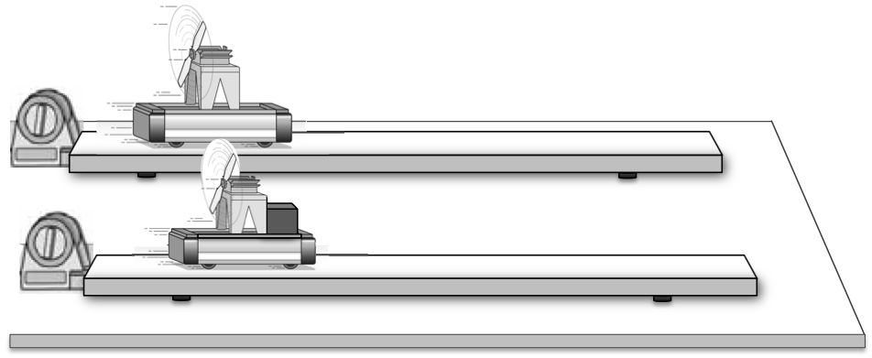
- Does there seem to be a relationship between the mass of an object and the time it takes to hit the ground? What evidence supports your conclusion?

Step 3: By thinking back to experiments from Chapter 2, you can build an explanation for the observations you’ve made in the previous two steps.

- If two carts with different masses are each acted on by the same strength force, which one will accelerate more rapidly, the more massive object or the less massive one? Explain your reasoning.
- What did you have to do to the strength of the force acting on the more massive cart to make it have the same acceleration as the less massive one? Why would this work?
- If two fan-carts with different masses ended a race in a tie, what could you conclude about the forces acting on the carts?
Step 4: Think again about the initial ideas question regarding dropping a bowling ball and a soccer ball.
- Because a bowling ball and a soccer ball will hit the ground at the same time, what can you infer about the forces acting on them?

Collecting and Interpreting Evidence:
Experiment #3: Does the shape of an object affect how it falls?
Materials:
- 2 sheets of paper

Step 1: Do all objects really fall at the same rate? Suppose you were to drop a bowling ball and a feather from the same height, at the same time.
- Which one do you think would reach the ground first? Explain your thinking.
Step 2: Crumple one of the pieces of paper. Hold the flat paper and the crumpled paper at the same height (about head high) above the ground. Release them at the same time and all your team members should watch carefully as they fall.
- Which piece of paper hit the ground first? Briefly describe the behavior of each as they fell.
- Why do you think the result of this experiment is different from what you observed in Experiment #2?
- What other force(s) might act on an object as it falls? Do you think other force(s) affect all objects the same way?

Step 3: Suppose you were to drop a heavy object (such as a hammer) and a bird’s feather from the same height at the same time in an environment where there was no air (in a vacuum).
- Imagine that in this airless environment you dropped the hammer and feather from the same height, at the same time. Do you think the result would be different from when the experiment was conducted in a place where there is air? Why?

Step 4: Your instructor will show you a video of two objects (one with a large mass and the other with a smaller mass) falling when there is no air.
- Describe the video and your observations.
- Draw a force diagram of the two objects. Be sure your force diagram accounts for your observation from the video.

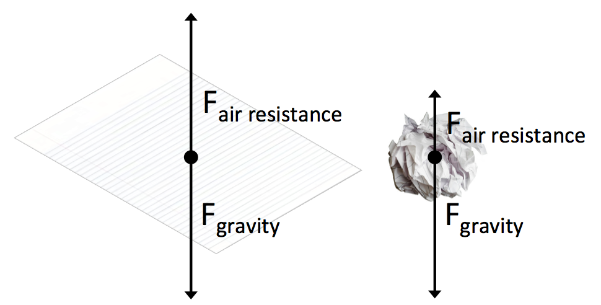
Scientists use the term air resistance or drag to refer to the force that the air exerts on an object moving through it. In the case of the flat paper compared to the crumpled paper, the downward gravitational forces are the same (because the masses of each are the same). Since the surface area of the crumpled paper is less than the surface area of the flat paper, the upper air resistance force is less.

Step 5: Think about the force you feel pushing on your hand when you hold it out of the window of a moving car.
- As the car speeds up, does this force seem to get weaker, stay the same, or get stronger?
- Do you think the strength of the force of air resistance acting on an object depends on how fast the object is moving? What would happen to the strength of the force of air resistance acting on an object if its speed were continuously increasing?
- Draw a force diagram of an object moving at a slow speed and then the same object moving at a faster speed.

Summarizing Questions Name: _______________________________
How does the mass of an object affect the gravitational force on an object and the rate at which it falls (gravitational acceleration)?
Learning Target: You will determine the relationship between mass, acceleration and gravitational force.
- Using the ideas you developed in this activity, compare and contrast the gravitational force and gravitational acceleration acting on a bowling ball and a soccer ball by responding to the questions below:
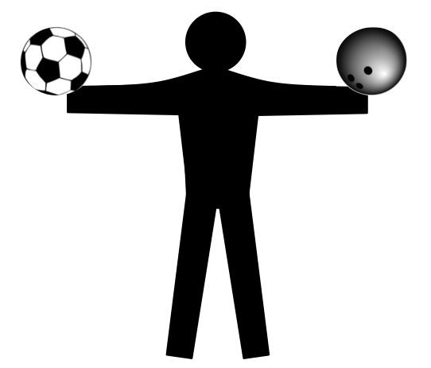
  - Does the Earth exert the same or different amount of force on a bowling ball and a soccer ball? What evidence from this lab supports your answer?

  - Complete the force diagram (on the right) for a person holding a bowling ball and a soccer ball. Include all of the forces acting on each ball.
  - If you were to drop a bowling ball and a soccer ball from the same height, which one would reach the floor first, if either? What evidence from this lab supports your answer?

  - What does your answer to the previous question tell you about the gravitational acceleration for objects with different masses?

- How can it be that two objects with different mass hit the ground at the same time (Hint: think of Newton’s Second Law)?

- What is the relationship between the speed of an object and the strength of the air resistance on the object? Provide an example.

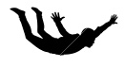
- When a skydiver jumps out of an aircraft he speeds up at first but eventually, his speed becomes constant. (This is before he opens his parachute.) Use your ideas about the forces acting on the skydiver as he falls to explain why this happens. Draw a force diagram of the skydiver (1) immediately after he jumped from the plane and (2) when his speed is constant.
- Now think about a cart with a fan that is released at one end of a very, very long track. For this problem, assume the force of friction between the wheels and the track is negligible.
  - What forces are exerted on the cart? How do these forces change as the cart moves along the track?

  - How does the net force on the cart change as it moves along the track? What effect does the changing net force have on the cart’s acceleration? Explain and draw force diagrams.

3.1 Scientist Ideas Reading
Instructions: Read the Scientist Ideas, paying careful attention to each key idea. When you read, try to think about how the key ideas relate to the evidence you collected in the activity.
Gravitational force is from the Earth idea: The Earth exerts a gravitational force on all objects. This force is abbreviated as F_{g}.
Gravitational force is different for objects of different mass idea: The Earth exerts more force on objects with greater mass.
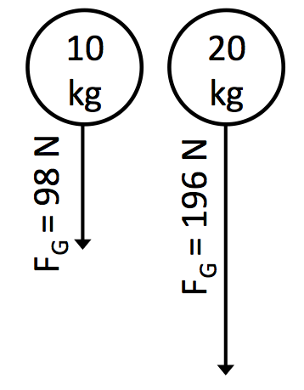
The Earth exerts a gravitational force on all objects, and the strength of the gravitational force is proportional to the masses of the objects. The greater the mass, the greater the gravitational force. It’s not hard to believe that an object with greater mass has a greater gravitational force, because we need to exert a greater amount of force to lift objects with more mass. This gravitational force can be represented on a force diagram (along with any other forces acting on the object).
Gravitational acceleration is the same for all objects idea: All objects (assuming air resistance is negligible) will fall with the same gravitational acceleration. This can be explained by applying Newton’s Second Law.
It may seem strange to you that falling objects of different mass have the same acceleration. This is an observation that was carefully documented as early as 1589 by Galileo. No one has ever observed anything different (as long as air resistance is the same for the objects). When scientists observe something over and over again without exception, they call it a law.
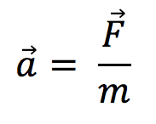
Newton’s Second Law shows us how it is possible for objects with different masses to have the same acceleration. The gravitational force on a more massive object is greater, but this is balanced out by a greater mass. An object with twice the mass will have twice the force from gravity. Because both the force (the numerator) and the mass (the denominator) double, the acceleration will stay constant.
Another way to think about this is to consider objects moving horizontally (left and right, not up and down). In order for a cart with greater mass to have the same acceleration as a cart with less mass, a greater force would need to be applied to the cart with greater mass. The same idea also applies to gravitational interactions.
Air resistance opposes gravitational force Idea: When objects move through the air, they are acted upon by a force in the opposite direction, this force is called air resistance.
Here on the Earth, the way an object moves (including how it falls) can be affected by an opposing force exerted by the air. Scientists call this force air resistance or drag. This force affects light objects with a large surface area much more than small, heavy objects.
The air resistance force increases as the speed of an object increases. For falling objects, the air resistance force can become equal to the gravitational force. When the forces on a falling object are balanced, the velocity is constant. The speed at which the forces are balanced and the speed remains constant is called the terminal velocity.
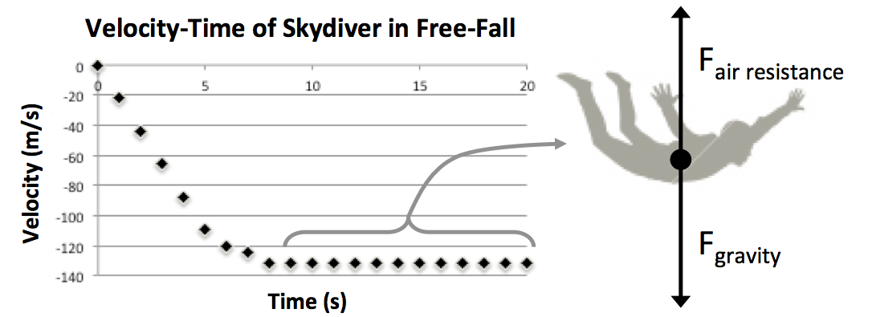

Respond to the following questions individually in your lab notebook:
- What variables do the strength of gravitational force depend on? What evidence did you collect to support your claim?
- Why do objects with different masses (that are the same size and shape) hit the ground at the same time?
- Use a horizontal motion situation (such as a fan-carts with different forces and masses) to explain why objects with different masses fall at the same rate?
- What is air resistance?
- What variables influence the strength of the force of air resistance on an object?
- What is terminal velocity? Draw a force diagram to support your response.
- Imagine a skydiver who is falling toward the ground and has not yet reached terminal velocity.
  - Draw a force diagram for the skydiver.
  - Are the forces acting on the skydiver balanced or unbalanced? If unbalanced, also state the direction of the net force.
  - Is the skydiver accelerating or moving at a constant speed?

