Mathematical Models: Building
Discuss each of the following questions with your group and respond in your lab notebook.
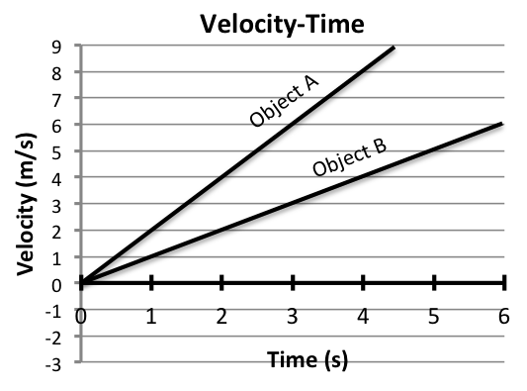
Exploration: How can you relate force, mass, and acceleration mathematically?

Step 1: The graph on the right shows the velocity versus time for two objects (Object A and Object B). Use the graph to answer these questions:
- Does Object A or Object B have a greater acceleration? How do you know from looking at the graph?
Assume that object A and object B are the same mass: | Now assume A and object B are being pushed by the same force:
- What can you say about the forces on the objects?  - Without adding or removing mass, how could you cause object A and object B to have the same acceleration? Be specific. | - What can you say about the mass of Object A compared to the mass of Object B?  - Without changing the force, how could you cause object A and object B to have the same acceleration? Be specific.

Step 2: Review the Calculating Acceleration Idea (from the 2.1 math activity)
 | Calculating Acceleration Idea: Acceleration is the change in velocity (Δ$\vec{v}$) divided by the change in time (Δt). Δ$\vec{v}$ is calculated by subtracting the initial velocity from the final velocity and Δt is calculated by subtracting the initial time from the final time. | $\vec{a}$ = $\frac{{\vec{v}}_{f}-{\vec{v}}_{i}}{t_{f}-t_{i}}= \frac{Δ\vec{v}}{Δt}$
- Using the graph in Step 1, calculate the acceleration for Object A.
- Using the graph in Step 1, calculate the acceleration for Object B.

Step 3: Evaluate the table below:
Force | Mass | Acceleration
10 N | 10 kg | 1 m/s²
20 N | 10 kg | 2 m/s²
20 N | 20 kg | 1 m/s²

- When the force pushing an object is doubled (and mass is held constant), what happens to the acceleration?
- When the mass is doubled (and force is held constant), what happens to the acceleration?

Step 4: Using the ideas you developed above, complete the two tables below (in your laboratory notebook):
Constant Force
Force | Mass | Acceleration
80 N | 10 kg | 8 m/s²
80 N | 20 kg
80 N | 40 kg
80 N | 80 kg

Constant Mass
Force | Mass | Acceleration
15 N | 15 kg | 1 m/s²
30 N | 15 kg
45 N | 15 kg
60 N | 15 kg

- Explain how you found acceleration when mass was constant and force was changed.
- Explain how you found acceleration when force was constant and mass was changed.

2.2 Mathematical Ideas Reading
Instructions: Read the Mathematical Ideas, paying careful attention to each key idea
 | Force, Mass, and Acceleration Relationship Idea: Acceleration is inversely proportional to mass and directly proportional to force. Acceleration is equal to the force divided by the mass. | $\vec{a}$ = $\frac{\vec{F}}{m}$
You have just determined the mathematical relationship between force and acceleration (when mass is held constant) and the relationship between mass and acceleration (when force is held constant).
Scientists say that the acceleration is proportional to the force ($\vec{a}∝\vec{F}$), and that the acceleration is inversely proportional to the mass ($\vec{a}∝ \frac{1}{m}$ ).
By combining these two relationships, scientists are able to relate force, mass, and acceleration:
$\vec{a}$ = $\frac{\vec{F}}{m}$

This equation is the mathematical expression of Newton’s Second Law.

Units of Force Idea: The unit for force is the “Newton” (N), named after Sir Isaac Newton for his work with force, mass, and acceleration.
We can better understand the units of force by rearranging the relationship for acceleration, force, and mass so that it solves for force.
$$\vec{F}=m⋅ \vec{a}$$
By plugging in the units for mass and acceleration, we can evaluate the units for force and see the fundamental units of a Newton.
$$Units for \vec{F} = kg⋅ m/{s^{2}}$$
So a “Newton” is just a shortened way of saying a “kilogram meter per second squared.”
$$1 Newton =1 kg⋅ m/{s^{2}}$$
Mathematical Models: Practice
Respond to the following questions in your laboratory notebook. Show your work.
Support Questions: The first two questions include fill-in-the-blank supports to help you learn how to set up the problems. If you already feel comfortable solving these problems, consider trying to solve them without using the fill-in-the-blank supports. You can check your work using the supports.

- What is the acceleration of a 22kg object with a 4 N force is pushing it?
Optional
Fill-in-the-Blank
Supports
$\vec{a}$ = $\frac{\vec{F}}{m}$
$\vec{F}$= ______ (What is the force acting on the object?)
$m$= ______ (What is the object’s mass?)
$\vec{a}$ = $\frac{\vec{F}}{m}$ = $\frac{______}{______}$ = _____ $m/{s^{2}}$
- What is the force that causes a 5kg object to accelerate at 8m/s²?
$$\vec{F}=m⋅ \vec{a}$$
$\vec{a}$= ______ (What is the object’s acceleration?)
$m$= ______ (What is the object’s mass?)
$$\vec{F}=m⋅ \vec{a}= _____ ⋅ _____= ______ N$$
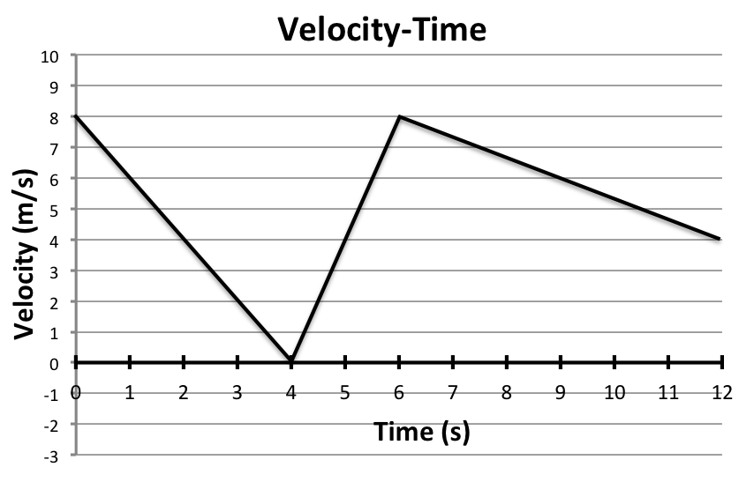
- A 15 N force is exerted on a 45 kg punching bag. What is the acceleration of the bag?
- Find the acceleration of a 10 kg object that is pushed by the following forces:
  - 20 N
  - 60 N
  - 90 N

- Use the velocity-time graph to find the acceleration of the cart during the following time intervals:
  - 0 to 3 seconds
  - 5 to 6 seconds
  - 9 to 11 seconds
- The cart (from the velocity- time graph) has a mass of 0.25 kg. Find the force exerted on the cart during each of the time intervals.
  - 0 to 4 seconds
  - 4 to 6 seconds
  - 6 to 12 seconds
- What do you think it means for a force to be negative?
- Use the graph on the right to answer the following two questions:
  - Assuming that Object A has a mass of 20 kg, what is the strength of force pushing this object?
  - Assuming that Object B is being pushed by a force of 35 N, what is the mass of Object B?
- Use the velocity-time and force-time graphs to find the mass of the cart (Hint: use the velocity-time graph below to find the acceleration).
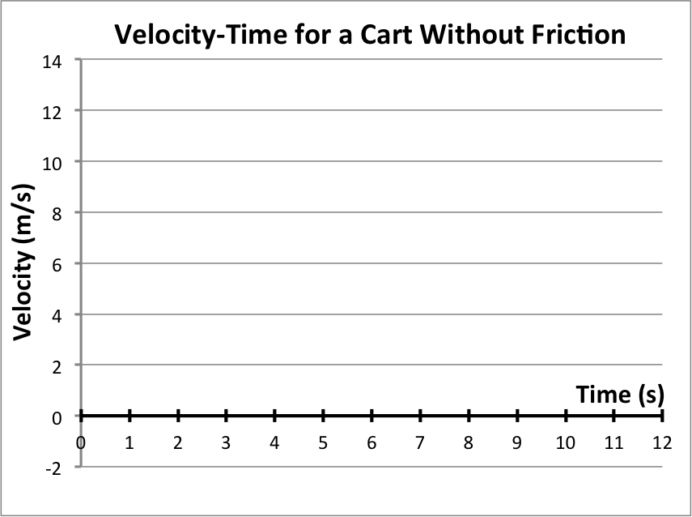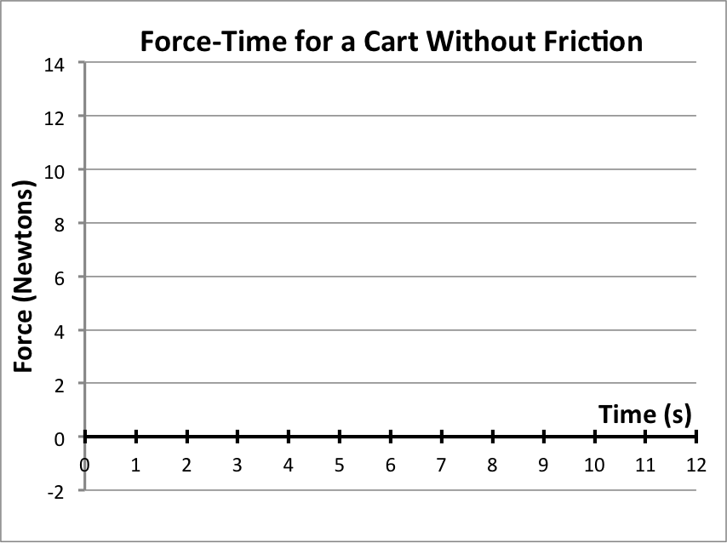
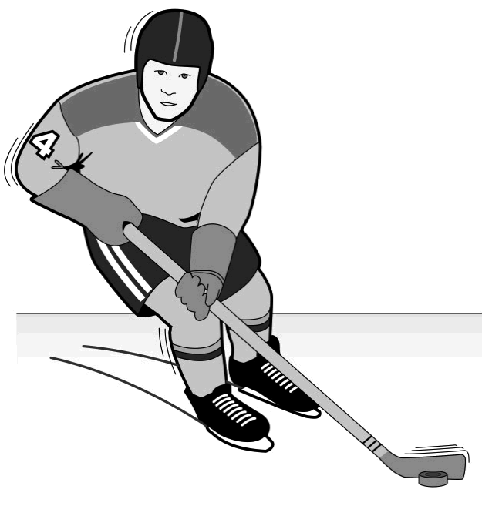
- A player has a mass of 92.7 kilograms. When stationary, another player collides with him causing him to accelerate at 6 m/s². What force did the player hit him with (to cause this acceleration)?
- A hockey puck accelerates at 30 m/s² when hit by a hockey player. The puck has a mass of 0.15 kg. With what force did the player hit the puck?

Challenge Yourself: These problems are about the same mathematical ideas, but are more challenging. Respond to these questions in your laboratory notebook and show your work.
- Use the equation that relates force (F), mass (m), and acceleration (a) to complete the following table. Show your work to the right of the table.
Force | Mass | Acceleration
400 N | 200 kg
4530 N |  | 10 m/s²
8988 N |  | 14 m/s²
 | 2000 kg | 25 m/s²
- A player has a mass of 92.7 kilograms. When stationary, another player collides with him, causing him to speed up to 2 meters per second in 0.5 seconds.
  - What is the acceleration of the player?
  - What force did the player hit him with (to cause this acceleration)?
- A hockey player hits the puck (making contact for only 0.1 seconds). The puck speeds up to 35 m/s during this contact.
  - What is the acceleration of the puck?
  - The puck has a mass of 0.15 kg. With what force did the player hit the puck?
- The velocity-time graph (shown below) is for a cart without friction. The cart has a mass of 3 kg. Use the mass and acceleration to find the forces acting on the cart. Then draw a force-time graph for the cart.
- Two people are ice-skating at $1 m/s$. One pushes the other ($60kg$). The contact lasts for $0.5s$ and the skater reaches a speed of $3 m/s$. What was the strength of the push force?

