Mathematical Models: Building
Discuss each of the following questions with your group and respond in your lab notebook.
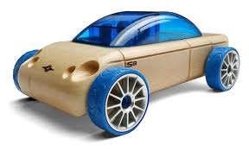
Exploration: What influences Kinetic Energy?
A wind-up car “stores” elastic potential energy using a rubber band. This elastic potential energy is converted to kinetic energy of the car.
Mass (kg) | Velocity (m/s) | Kinetic Energy (Joules)
1 | 2 | 2
1 | 3 | 4.5
1 | 4 | 8
1 | 5 | 12.5
1 | 6 | 18

Step 1: Below is a table of the velocity and kinetic energy (KE) of a 1.0 kg toy wind-up car. Create a line graph the data in your notebook.
- Is the data linear or exponential?
- What mathematical relationship can you use to represent this pattern? Check with another group to see if everyone in your lab group arrived at similar answer.

KE $∝$ _______

Relationships are very important in science. Understanding relationships about the world gives scientists great power because these relationships allow us to very accurately predict how objects act. For example, scientists can predict when a dangerous asteroid will strike the Earth.
Scientists sometimes use a symbol that looks like this $∝$ instead of an equal sign (=). They do this because they are unsure whether or not there are other variables or numbers in the relationship. The symbol $∝$ means “proportional to.”
For example, scientists thought that butter contained a lot of calories. This relationship is shown here:
butter $∝$ calories

However, it is much more useful to know exactly the relationship between calories and butter. Through careful experiments, scientists have found exactly how many calories are in butter:
1 stick of butter = 810 calories
Though it is useful to know that there are a lot of calories in a stick of butter, it can be more useful to know exactly how many calories there are in a stick of butter. Because the relationship is fully known, we replaced the $∝$ with the equal sign (=).
You probably found that the kinetic energy of an object depends upon the velocity of an object squared (v²). Because we have not found the other values that related KE and v, we will stay with the $∝$ for now.
KE $∝$ v²

- Discuss with your lab group the difference between the proportional sign ($∝$) and the equal sign (=). Summarize the difference in your lab notebook.

Mass (kg) | Velocity (m/s) | KE (J)
1 | 1 | 0.5
2 | 1 | 1
3 | 1 | 1.5
Step 2: Now you are going to determine the relationship between mass and kinetic energy. Three wind-up cars with different masses travel at 1 m/s. By holding speed constant we can determine how mass influences the kinetic energy. Create a line graph of the data in your journal.

- What patterns do you see in the data? Is it linear or exponential?
- What mathematical relationship can you use to represent this pattern? Check with another group to see if everyone in your lab group arrived at similar answer.

KE $∝$ _______

- Explain why an equal sign can NOT be used in previous question.

- Use the mathematical relationship you came up with to find the kinetic energy of a 5 kg car traveling at 1 m/s.

Step 3: Now, let’s combine the two relationships that you have just discovered (the relationship between KE and v from the previous page and the relationship between KE and m from the previous step).
The kinetic energy of an object is equal to the ½ times the mass and velocity squared.
KE = ½ mv²
Remember that mass is measured in kilograms (kg) and velocity is measured in meters per second (m/s). Kinetic energy, like all forms of energy, is measure in Joules (J).

Step 4: Use the equation for kinetic energy to calculate the kinetic energy of the object in the questions below.
- What is the kinetic energy of a 1 kg object traveling at 4 m/s?
- What is the kinetic energy of the same object (1 kg) traveling at 8 m/s?

Mathematical Models: Practice
Respond to the following questions in your laboratory notebook. Show your work.
Support Questions: The first three questions include fill-in-the-blank supports to help you learn how to set up the problems. If you already feel comfortable solving these problems, consider trying to solve them without using the fill-in-the-blank supports. You can check your work using the supports.

- A boy throws a 0.5 kg ball to his sister at 4 m/s. What is the KE of the ball at this speed?
KE = ½ mv²
Optional
Fill-in-the-Blank
Supports
KE = ½ (____) (____)² = ______ Joules
m v
- The boy’s sister catches the ball and throws it back to him at 10 m/s? What is the KE of the ball at this speed?
KE = ½ mv²
KE = ½ (____) (____)² = ______ Joules
- The boy then throws a ball with twice the mass, 1.0 kg, at 5 m/s. What is the KE of the ball at this speed?
KE = ½ mv²
KE = ½ (____) (____)² = ______ Joules
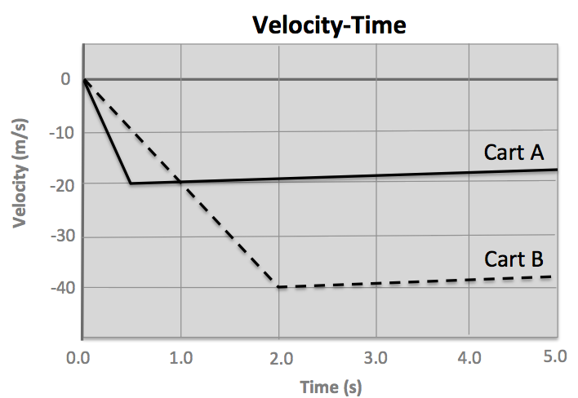
- If you wanted to increase the KE the most, would you double the mass or double the speed? How do you know from the mathematical relationship and from your work in the previous three questions?
- Use the velocity-time graph (on the right) to calculate the KE of Car A and Car B when they are at their maximum speed. Car A and Car B both have the same mass: 2.5 kg
- What inference can you make about the amount of elastic potential energy stored in the band when it was pulled back to launch Cart A?
- From the graph, calculate the kinetic energy of Cart B at 1.5 seconds.
- In the graph, the velocity-time data is negative (the carts are moving toward the origin). Does this affect the kinetic energy? What is your rationale?
- Make a claim about whether the direction an object is traveling influences the kinetic energy: towards (negative $\vec{v})$ or away (positive $\vec{v}$)? Explain in terms of the equation for kinetic energy.
Stretch Distance (m) | Maximum Speed (m/s) | Kinetic Energy (Joules)
.01 m
.02 m
.03 m
.04 m
.05 m
- In Experiment #1 of this activity, you found the maximum speed of a cart when it was launched from a rubber band launcher (different stretch distances). Use your data from Experiment 1 to calculate the kinetic energy of the cart when it was released at each stretch distance. The mass of the cart is approximately 250 grams (0.25 kg). Complete a table like the one shown on the right in your lab notebook.
- What is the kinetic energy of a car that is 750 kg and is moving at 14 m/s?
- If a sprinter runs at a speed of 10.4 meters per second and has a mass of 90 kilograms, what is the sprinter’s kinetic energy?
- A roller coaster cart has a mass of 300 kg. When it is moving at its maximum speed of 38 meters per second (this is 85 miles per hour!), what is its kinetic energy?
- Six people get into the roller coaster cart (from the previous question). The total mass of these people is 400 kilograms. When moving at its maximum speed, what is the kinetic energy of the cart with six people in it?
Challenge Yourself! These problems are about the same mathematical ideas, but are more challenging. Respond to them in your laboratory notebook and show your work.
- If you had information about the kinetic energy and the speed of an object, how could you rearrange the equation for kinetic energy in order to calculate the mass of the object?
$KE$= ½ m$v$²
- If you had information about the kinetic energy of an object and the mass of that object, how could you rearrange the equation for kinetic energy in order to calculate the speed of the object?
- If you knew the KE and mass of an object, would it be possible to calculate the velocity of the object? Why or why not?
- Complete the table (shown below) in your laboratory notebook.
Mass | Velocity (v) | KE
6 kg | 1 m/s
 | 3 m/s | 18 J
20 kg |  | 160 J

- In January 2012, an asteroid passed between the Earth and the orbit of the Moon. If the asteroid has a mass of 100,000,000 kg and a KE of 2.42 x 10¹⁶ Joules, what is its speed?
- The K-T asteroid had an estimated mass of at least 9 x 10¹⁰ kg and struck the Earth at 11,000 m/s, killing off up to 70% of all species on Earth. What was the KE of the K-T asteroid?
- A World War II era nuclear bomb can release up to 7.5 x 10¹³ Joules (750,000,000,000,000 Joules). How many of these bombs would equal the energy released by the K-T asteroid impact?
- An aircraft carrier has a mass of about 5 x 10⁸ kg (about 100,000 tons). What is the KE of an aircraft carrier cruising at 5 m/s (about 11 miles per hour)?
- A ski boat has a mass of about 1,500 kg (Around 3,000 pounds). What is the KE of a ski boat traveling at 5 m/s?
- If the ski boat in the question above has the same KE as the aircraft carrier, how fast is it moving?

