Learning Target: You will draw conclusions about energy from velocity data and represent energy transfers and changes using diagrams.
Purpose:
We use the idea of energy in many ways in everyday life. Perhaps you’ve heard talk of an “energy crisis” when fuel supplies run low; people eat “energy bars” to keep them going; and we say small children have “lots of energy” when they run around. Think about different types of energy you have heard of or experienced in your life.
What is needed to change the energy of an object? How can we represent these energy changes?

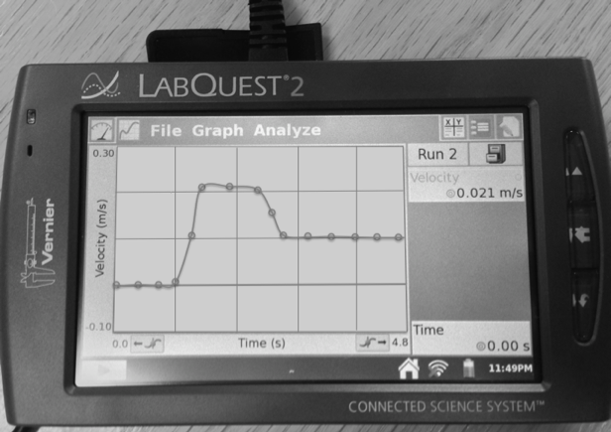
Initial Ideas:
Using a low-friction cart, track, motion sensor, and data collection device, a lab group collected the velocity-time graph shown on the right. One group member pushed the cart so that it increased in speed. Then another group member gave the cart a gentle push the opposite way and then let go so the cart slowed down, but did NOT come to a complete stop.
Complete the following questions individually in your lab notebook:
- Copy the graph into your laboratory notebook. On the graph, circle all of the times when you think the hand was in contact with the cart.
- During the time shown on the graph:
  - When do you think the cart had the most energy?
  - When do you think the cart had the least energy?
  - When do you think the energy of the cart was changing?
Share your ideas with your group members.
On a presentation board, record your group’s thoughts about the Initial Ideas.
Collecting and Interpreting Evidence:
Thought Experiment #1: What are observations and inferences?
Materials:
- Pictures and graphs for making observations and inferences

So far in this class we have been making lots of observations. Observations are what you do with your senses—what you see, taste, feel, hear, or smell. Sometimes, you need to draw conclusions from your observations. Conclusions that you come to based on observations are called inferences.
For example, when you observe someone who is smiling, you could make the inference that the person is happy. What are some other possible inferences you can make from this observation?

Step 1: Using the Tools of the Trade reading about observations and inferences, talk about the differences between an observation and an inference with you group members. Decide on a group definition for each.
- What is the difference between an observation and an inference?
 | Observations | Inferences
Picture 1
Picture 2

Step 2: Your instructor will provide you with various pictures and graphs. With your group members, evaluate each of the pictures and graphs.
- Make a table (like the one shown on the right). In the table, record 2 observations and 3 inferences for at least 2 of the pictures and 2 of the graphs.

Your instructor will lead a whole-class debrief for students to share observations and inferences of the pictures and agree on the meaning of the terms observation and inference.

- What inferences do you think you can make about an object’s energy from observations of the object’s velocity?

In the previous activities, you made observations of the speed of a cart. These observations can be used to make inferences about the energy of the cart. When you observe the speed of the cart increasing, you may infer that the “motion energy” of the cart is also increasing. When you observe that the speed of the cart is decreasing, you may infer that the “motion energy” is also decreasing. And when you observe that the cart is stopped, you may infer that the moving energy of the cart is zero.
The direction the cart is traveling does not make a difference in the “motion energy” of the cart. Imagine two carts are traveling the exact same speed, but one cart is traveling toward the origin and the other is traveling away from the origin. You can infer that these two carts have the same “motion energy.”

Step 3: Evaluate each of the velocity time graphs below. From observations of speed (from the graphs), make inferences about whether the moving energy of the cart is increasing, decreasing, constant, or zero. Record your inferences in your laboratory notebook.
a. 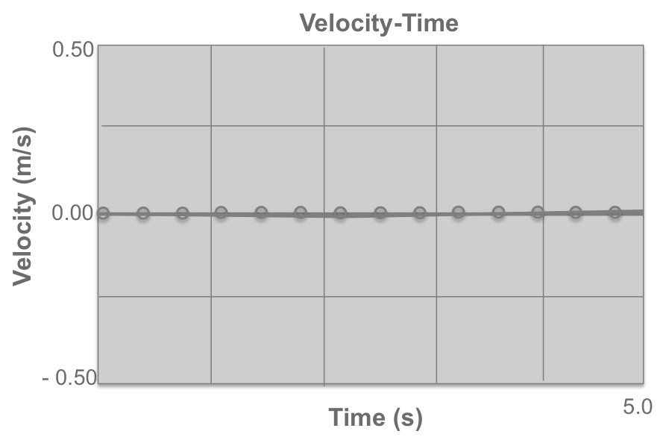 | b. 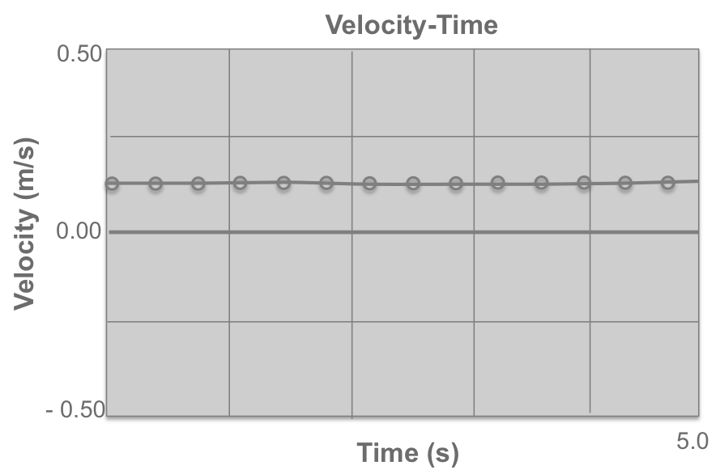
c. 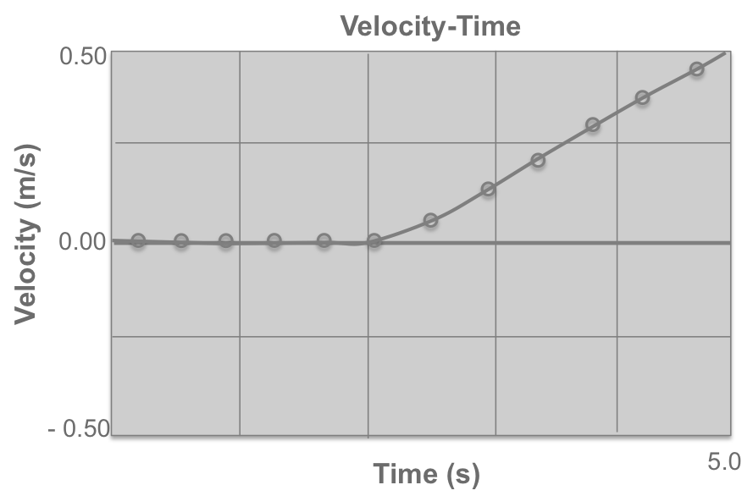 | d. 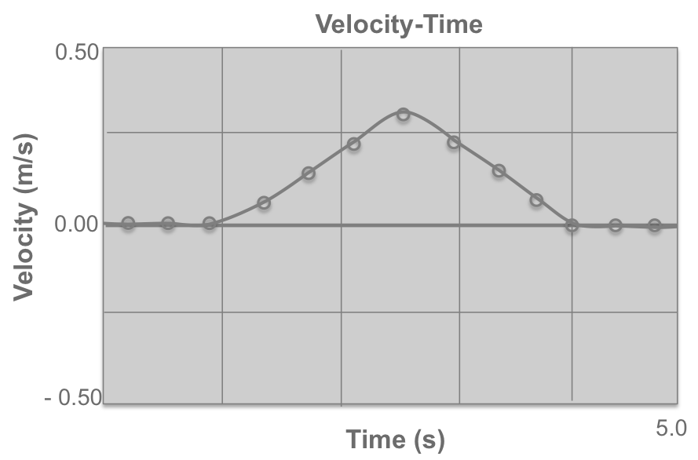
e. 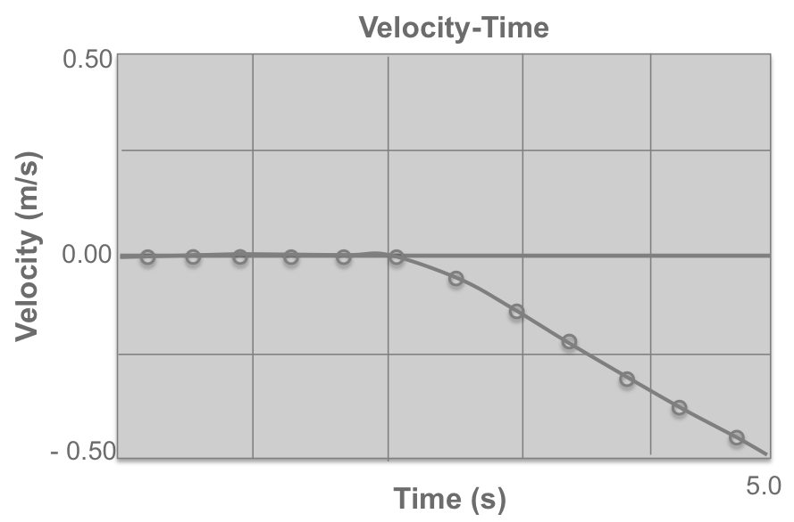 | f. 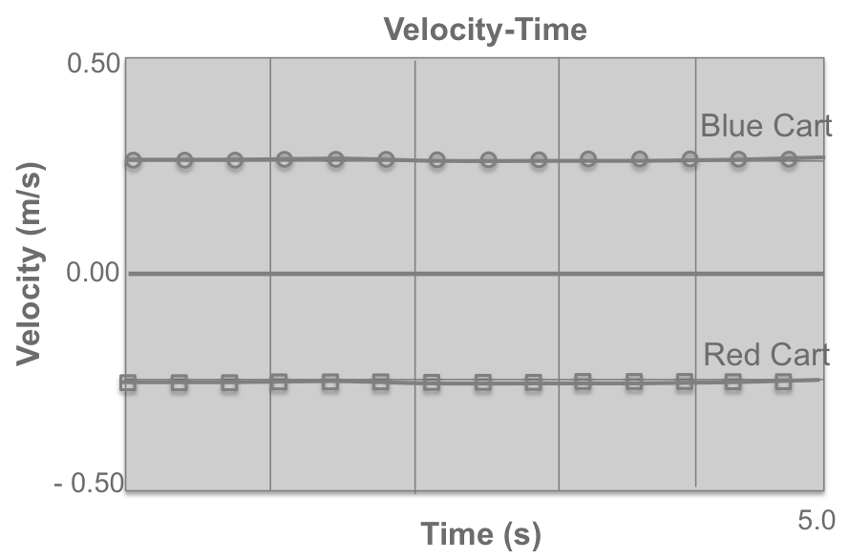
Collecting and Interpreting Evidence:
Experiment #2: What inferences about energy transfer can you make from observations of speed?
Materials:
- Motion track
- Two low friction carts
- Two motion detectors
- Data collection device

Step 1: Place two carts on the track, about 20-30cm apart. Make sure:
- The two ends of the carts facing each other will not stick together with Velcro™.
- There are no magnetic effects between the ends of the carts that face each other.

Step 2: Set up each motion detector on the ends of the track and plug them into the data collection device. This will allow you to graph the motion of both carts at the same time.
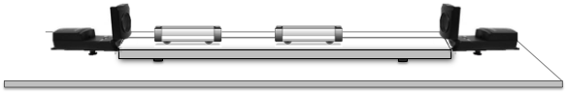
Step 3: Now give one of the carts (we will call this the launched cart) a gentle pull with your hand so that it hits the other cart (we will call this the target cart).
Launched Cart Target Cart
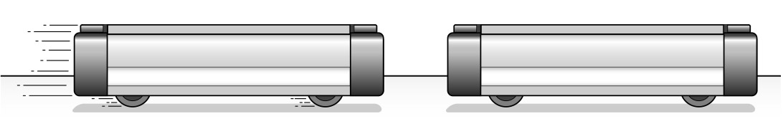
- Draw a velocity-time graph for the target cart.
- Does the energy of the target cart change during the collision? What evidence supports your idea?
- On the same axes as your graph for the target cart, draw a velocity-time graph for the launched cart (starting when it was pushed).
- Does the energy of the launched cart change during the collision? What evidence supports your idea?
- On the two graphs you drew, circle where an energy transfer occurred.

Step 4: Read the Tools of the Trade below about the energy of the launched cart and the target cart and about energy diagrams.
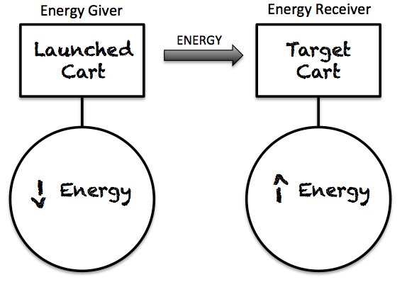
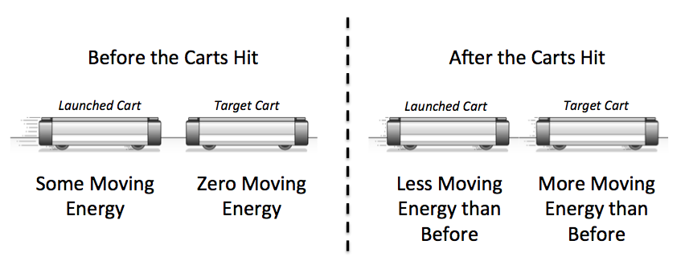
In this class we will use energy diagrams as a way of keeping track of the energy of objects, and as a way of showing the transfer of energy between objects. An energy diagram can be drawn for the collision between the launched cart and the target cart in this activity.
- What inference can you make about when the energy transfer occurred from the Tools of the Trade reading above?
- Based upon the energy diagram, which object was the energy transferred from (giver)? Which object was the energy transferred to (receiver)? What evidence from this experiment supports this transfer of energy?

Collecting and Interpreting Evidence:
Experiment #3: When does energy transfer take place?
Materials:
- Track
- Low-friction cart
- Motion sensor
- Data collection device
- Slow motion videos

 | Pushes and pulls have the same effect on the cart, so it does not matter whether you give the cart a push or a pull to start it moving. Either way, be sure your hand does not get in the way of the sensor. | 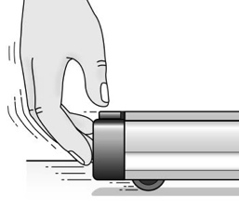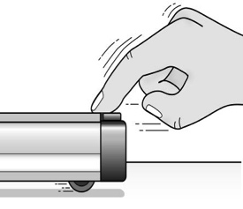  Push Pull

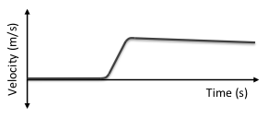
Step 1: The graph on the right shows the velocity of a cart. The cart began stopped (at rest) and was pushed by a hand before traveling at a relatively constant speed.
- Copy this graph into your lab notebook. Predict (by circling) when you think the hand is transferring energy to the cart. What is your reasoning?
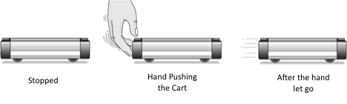
- In a different color, predict (by circling) when you think the hand is in contact with the cart. Describe your reasoning.

Step 2: Your instructor will show you a slow-motion video of a hand giving a quick shove to a cart to start it moving.
- On the graph you drew in the previous question, circle the entire time the hand was in contact with the cart (based on the slow-motion video as evidence).
- Do your observations of the slow motion video make sense to you? Why or why not?
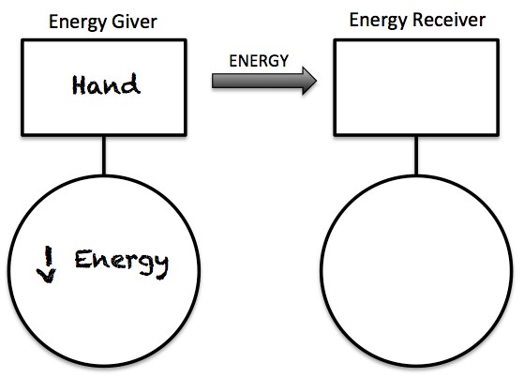
- Based on the slow motion video, once the hand let go of the cart, did the cart continue to increase in speed? If not, describe what did happen to the cart’s speed?
- What inferences can you make from the slow motion video about when energy is being transferred from the hand to the cart?
- Complete the energy diagram (in your laboratory notebook) for the time the hand pushes the cart to speed up.

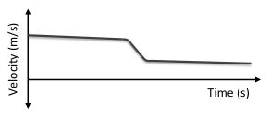
Step 3: The graph on the right shows the velocity of a cart. The cart traveled at a relatively constant speed and was then pushed by a hand in the opposite direction it was moving. The cart did not change direction.
- Copy this graph into your lab notebook. Circle when you think the hand is pushing the cart. Describe your reasoning.
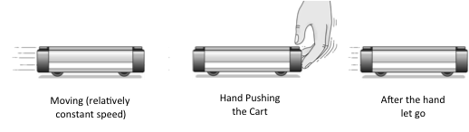

Step 4: Your instructor will show you a slow-motion video of a hand giving a quick push opposite its motion.
- On the graph you drew in the previous question, circle the entire time the hand was in contact with the cart (based on the slow-motion video as evidence).
- Do your observations of the slow motion video make sense to you? Why or why not?

Step 5: The graphs below show the motion for two different carts. Copy the graphs into your lab notebook.
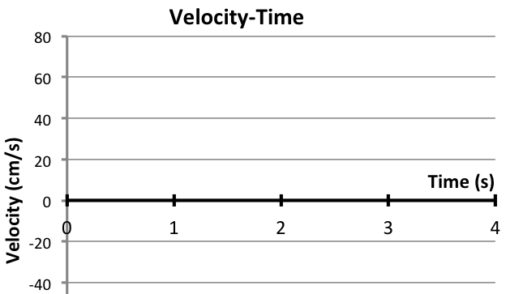

- On each graph, circle when a hand was in contact with the cart.
- Describe how you decided what to circle on the graphs and why.

Step 6: Using a track, low-friction cart, motion sensor, and data collection device, try to produce the four velocity-time graphs below.
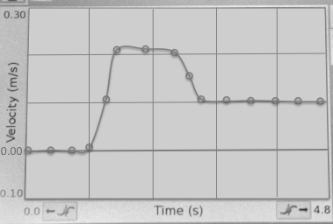 | 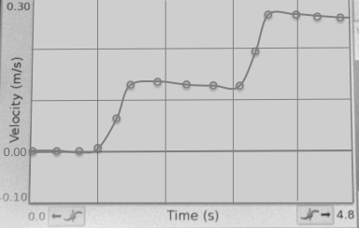
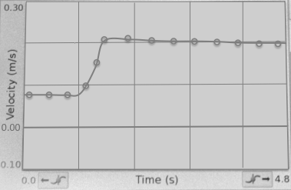 | 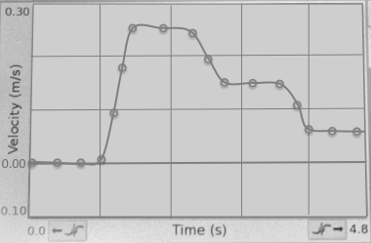

- Draw each of the graphs in your lab notebook and circle when the hand was in contact with the cart.
Summarizing Questions Name: _______________________________
What is needed to change the energy of an object? How can we represent these energy changes?
Learning Target: You will draw conclusions about energy from velocity data and represent energy transfers and changes using diagrams.
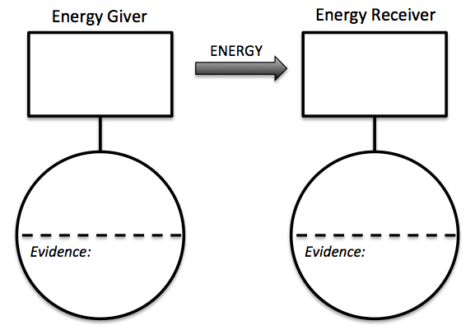
- In a game of pool, the cue ball collides with the eight ball. Draw an energy diagram for the energy transfer that occurs when they are in contact. Include your evidence in the circle.
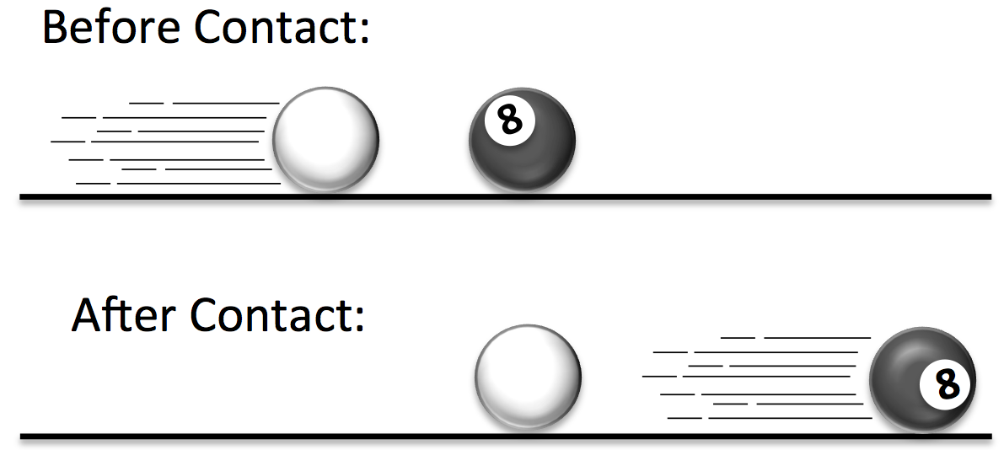

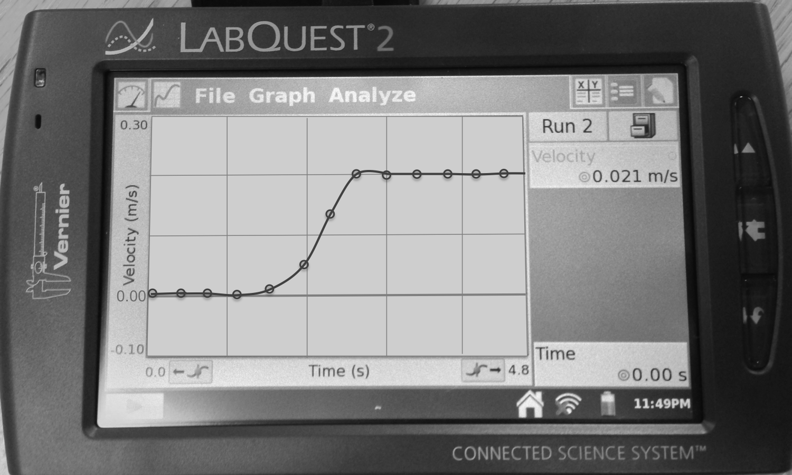
- The graph on the right shows the motion for a cart that was pushed by a hand.
  - On the graph, circle when a hand was in contact with the cart.
  - What evidence from this lab did you use to decide how to circle the graph?

  - Label on the graph where the energy is lowest and where the energy is highest? How do you know?

  - In terms of energy, describe why the speed of the cart will no longer increase once the hand releases the cart.

- 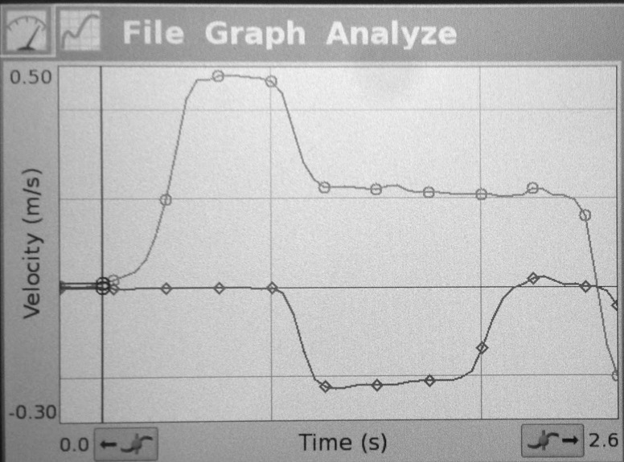Shown on the right are velocity-time graphs for two carts. One cart (cart A) was pushed by a hand and then hit the second cart (Cart B), similar to what you observed in the experiment.
Cart A
Cart B
  - On the graph circle when the hand was in contact with the cart.
  - On the graphs, use a different color to circle when the carts were in contact with each other.
  - Complete the energy daigram below for the energy transfers:
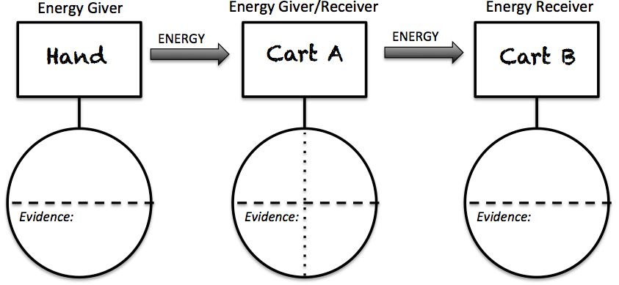
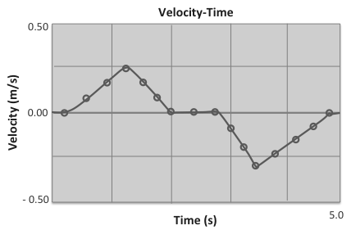
- The graph on the right shows a cart’s velocity. Label all the places when the cart’s energy is increasing and when the cart’s energy is decreasing. Hint: there are at least two of each!

1.3 Scientist Ideas Reading – Part 1
Instructions: Read the Scientist Ideas, paying careful attention to each key idea. When you read, try to think about how the key ideas relate to the evidence you collected in the activity.
Observation and Inference Idea: Inferences are conclusions made from observations.
Energy itself cannot be directly observed. Rather, we must make inferences about energy from our observations. Remember, observations are what you do with your senses—what you see, taste, feel, hear, or smell. An inference is a conclusion that is drawn from observations.
Kinetic Energy Idea: Using observations of an object’s speed, it is possible to make inferences about the object’s motion energy. Scientists call the energy associated with movement kinetic energy, and it can be abbreviated KE.
Kinetic (motion) energy changes as the speed changes. As you saw in this lab, you can infer that an object’s kinetic energy is zero when the speed is zero, and the kinetic energy is increasing when its speed is increasing. The faster an object is moving, the more kinetic energy it has. An object’s direction does not affect its kinetic energy; it is only how fast the object is moving that matters. Therefore, scientists discuss kinetic energy in terms of speed, not velocity.
The velocity-time graph below includes inferences about kinetic energy that can be drawn from the graph. Carefully evaluate the graph to see that it is only the speed (magnitude), not the direction the object is moving, that affects the kinetic energy.
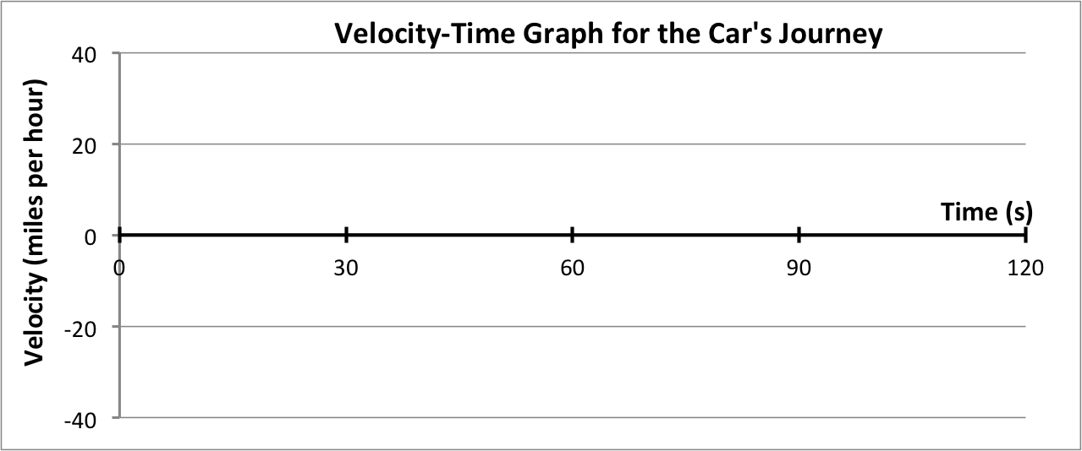
Decreasing KE
Increasing KE
Zero KE
Constant KE
Decreasing KE
Increasing KE

Energy Transfer Idea: Energy can be transferred when two objects are in contact. Speed (and therefore kinetic energy) only changes when there is a push or pull.
From the slow motion video, you observed that in order for an object to change speed, there had to be contact in the form of a push or pull. Therefore, increases and decreases in kinetic energy only occur when there is a push or pull.
This change in speed (and therefore change in energy) is a result of the transfer of energy that happens when the hand is in contact with the cart.
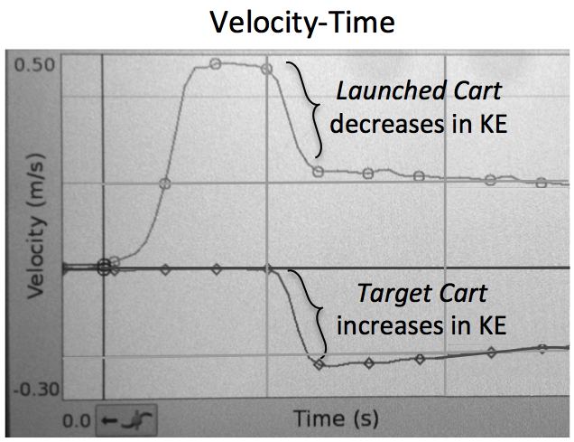
In this activity, you observed the speed of two carts, a launched cart that hit a target cart. In the collision, the launched cart slowed down, while the target cart sped up. From this observation of the change in speed, it is possible to make the inference that energy is transferred from the launched cart to the target cart. This transfer of energy can be represented using an energy diagram.

Energy Diagram Idea: Energy diagrams show transfer of energy.
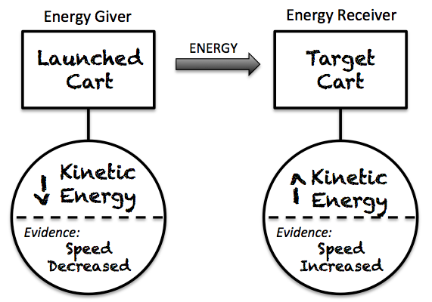
Energy diagrams show the transfer of energy between the carts (or any objects). The cart that initially started with the energy, the launched cart, is called the energy giver because it supplies the energy that is transferred. The target cart is called the energy receiver.
Energy diagrams use arrows to show that the kinetic energy of the launched cart decreased (evidence: decrease in speed), and the kinetic energy of the target cart increased (evidence: increase in speed).
Respond to the following questions individually in your lab notebook:
- What observation would lead you to infer that an object’s energy has changed?
- Summarize the relationship between speed and kinetic energy.
- Does the direction an object is moving affect the kinetic energy? Explain.
- Draw a velocity-time graph for someone giving you a quick push on a skateboard and then letting go. Hint: You began stopped, your speed increased, and then you traveled at a constant speed. Circle and label when your friend was pushing you.
- What evidence suggests that the launched cart had kinetic energy before colliding with the target cart and the target cart did not?
- In an energy transfer, what happens to the energy of the energy giver? What about the energy receiver’s energy?
- Draw an energy diagram for a baseball bat that hits a baseball. Include evidence.

1.3 Scientist Ideas Reading – Part 2
Instructions: Read the Scientist Ideas, paying careful attention to each key idea. When you read, try to think about how the key ideas relate to the evidence you collected in the activity.
Chemical Potential Energy Idea #1: Chemical potential energy is “stored” in our bodies.
It is common to use the idea of energy to describe how you feel. After a good night’s sleep you might get up and feel full of energy. But after a long day you might feel drained of energy. This suggests that people can “store” energy. This is indeed true; the food we eat provides energy to our bodies. Scientists call this chemical potential energy (CPE).
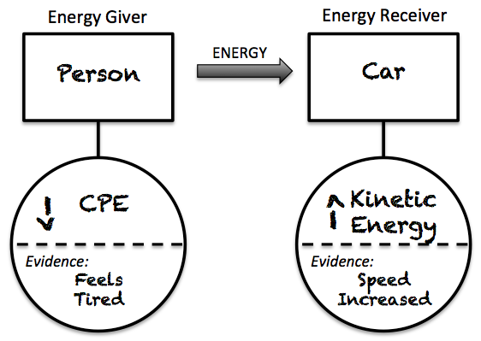
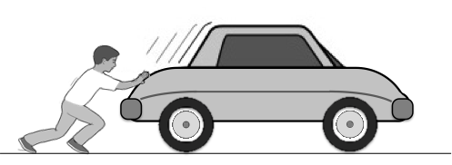
Imagine pushing a car. After pushing the car for a while, you would begin to feel tired. This is an indication that you have transferred your chemical potential energy into the car. In this energy transfer, your chemical potential energy decreased and the car’s kinetic energy increased. An energy diagram can be used to show this energy transfer.
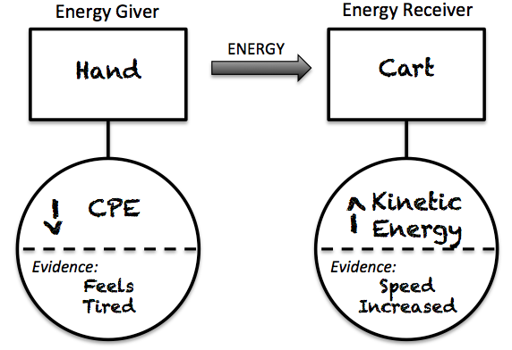
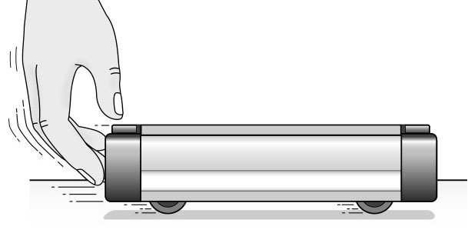
The same type of energy transfer happens when you push the cart with your hand, but on a much smaller scale. Unlike kinetic energy, it is much more challenging to make inferences about chemical potential energy from observations. This is because chemical potential energy has to do with how the atoms in your body are arranged, and atoms are too small for us to observe directly.
Chemical Potential Energy Idea #2: Chemical potential energy comes from food and is used for our bodies to move.
Different foods have different amounts of chemical potential energy depending upon the type of food. Scientists conduct experiments in order to determine how much chemical potential energy is in food; they use a unit of energy called a calorie to express the amount of energy that is available for humans. When you eat food, you can think of the amount of calories as the amount of chemical potential energy that you eat.
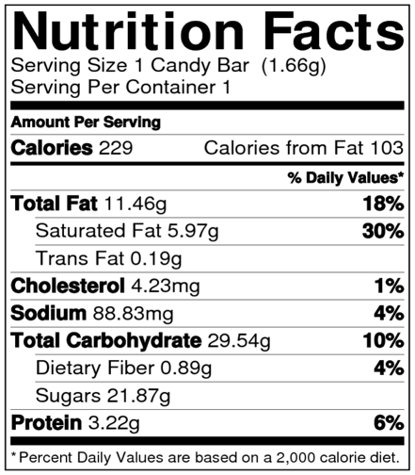
Not all types of chemical potential energy in food turn into usable energy at the same rate. Have you ever noticed that after you eat a candy bar, you will experience a burst of energy before again feeling tired? This is because the chemical energy in candy bars is in the form of small sugar molecules (simple carbohydrates) that quickly release energy. Once you use the energy the candy bar no longer provides you with ‘fuel,’ and you may begin to feel tired. On the other hand, vegetables and whole grain breads have a larger form of sugar called a complex carbohydrate. These take much longer to turn into energy, so they provide you with chemical potential energy for a longer amount of time. The “Total Carbohydrate” shown on a nutrition label indicates the total amount of simple and complex carbohydrates. The amount of simple carbohydrates is indicated by the “Sugars.”
Respond to the following questions individually in your lab notebook:
- Think about a soccer player using her muscles to kick a ball:
  - Energy giver: What or who supplied the energy?
  - Energy decrease: What type of energy changed in the giver?
  - Energy receiver: What or who gained energy?
  - Energy increase: What type of energy changed in the receiver?
- Using your responses to the previous four questions, draw an energy diagram for this energy transfer (from the person to the ball).
- Draw an energy diagram for a person who is pushing her friend on a bicycle.
- What is chemical potential energy? Where does this energy come from?
- How might you notice that you have increased or decreased in chemical potential energy?
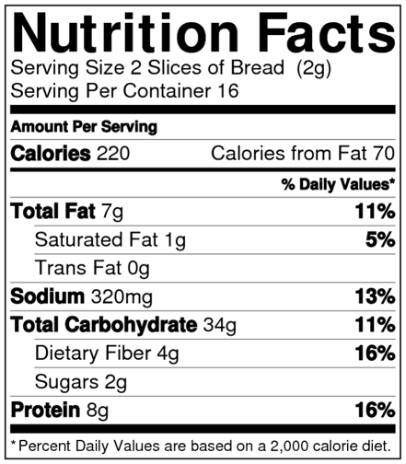
- Evaluate these two nutrition labels.
  - Based upon the calories alone, which provides the greatest amount of chemical energy to your body?
  - Based upon the sugars, which will provide the longest lasting chemical energy?
  - A friend is preparing to play in a full-day baseball tournament. What would you tell him to look for on a nutrition label to ensure that he would have enough chemical potential energy for the whole day?
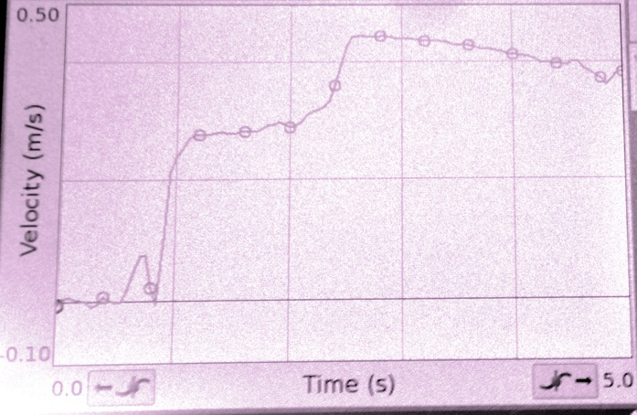
- The graph on the right shows a cart’s velocity. Over the 5 seconds shown, a hand has come into contact with the cart (one or more times). Draw the graph in your notebook and circle when the hand was in contact with the cart.

1.3 Practice Questions
Instructions: Complete the practice problems in your laboratory notebook. Work individually, and then check your responses with your group.
- Think about a cart that is stopped on a table. After being stopped for 5 seconds, the cart is given a quick push by a hand and then the hand releases the cart.
  - Draw two velocity-time graphs of the cart’s motion (one where the cart was pushed away from the sensor and the other where the cart was pushed toward the sensor).
  - On your graphs, label when the cart’s energy is: zero, the highest, changing, and/or constant.
  - What leads you to conclude that the cart’s energy changed?
  - Does the energy of the cart depend on its direction? How do you know?
- What evidence do you need to determine if an object is an energy giver? How is this different than when an object is an energy receiver? Think of an example and draw an energy diagram.
You have observed times when energy is transferred from a giving object to a receiving object. You have also been introduced to two different types of energy that can be associated with things we can observe:
Kinetic Energy: related to the how fast an object is moving.
Chemical Potential Energy: associated with chemical processes in people’s bodies.
- In your laboratory notebook, record the two types of energy we’ve learned about so far. For each type, include the evidence of that energy.
To draw energy diagrams, it is often helpful to ask yourself four questions:
  - Which object supplied energy during this energy transfer? Energy Giver
  - What type(s) of energy changed in the giver? Energy Decrease
  - Which object gained energy during this energy transfer? Energy Giver
  - What type(s) of energy changed in the receiver? Energy Increase
- Answer each of the four questions above for the energy transfers listed below:
  - A soccer player kicks a soccer ball
  - A bowling ball hits a bowling pin
  - A person pushes a car and the car starts moving
  - A dad pushes a baby in a stroller
  - A basketball player throws a freethrow (throws the ball through the air)
- Draw a Giver-Receiver energy diagram for each of the following energy transfers:
  - Energy Transfer #1: A hockey player uses his muscles to swing his stick. (Note this is a transfer between the player and the stick. The puck is not involved – yet!)
  - Energy Transfer #2: After being hit, the puck slides across the ice, slowing down slightly as it moves
  - Energy Transfer #3: A player from the red team is skating across the ice when he bumps into a player from the blue team, who was stationary. The red player stops and the blue player is sent sliding across the ice. (Neither of the players use their muscles to push each other)
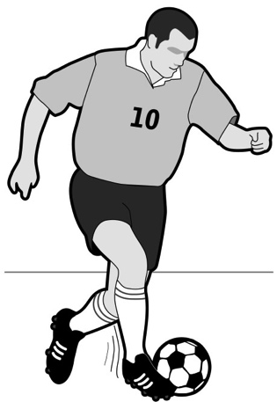
- A soccer player uses her muscles to kick a stationary soccer ball.
  - Draw an energy diagram to show what happens to the energy of the player and the ball during this energy transfer.
  - State the evidence you included.
  - What are the different ways you could observe that the player used her energy?
- Read the explanation about Chain Energy Transfers below.
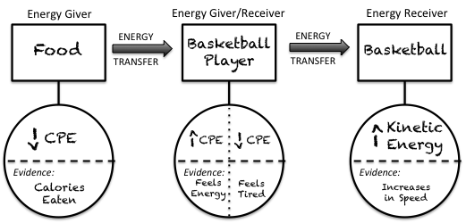
In a previous question you described the energy transfer (and drew an energy diagram representation) for a basketball player who threw a free throw (threw the basketball in the air toward the hoop). But what if you wanted to think about where the basketball player’s chemical potential energy came from? In situations where you need to show more than one energy transfer, you may want to draw chain transfer energy diagram.
The food the player ate was the initial energy giver. The energy in the food is turned into chemical potential energy in the player’s body. This is the energy the player use to throw the basketball.
  - Think of 2 more situations when a chain transfer diagram would be useful.
  - Draw a chain transfer diagram for a person who pushes a cart (the launched cart). The launched cart then hits a target cart.

