Learning Target:
You will analyze and interpret velocity-vs-time graphs to represent speed and direction.

Purpose:
In the previous activity you began to explore the idea of speed and how to represent speed using graphs. When scientists are talking about speed, they often need to also know about the direction that something is traveling. Can you think of examples when it is important to know both the speed and the direction of an object?

How can you represent both the speed and direction of an object?

Initial Ideas:
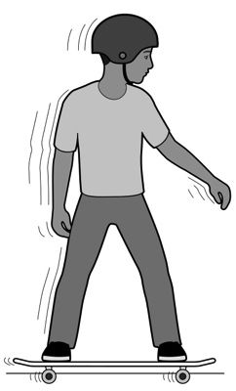
Complete the following questions individually in your lab notebook:
- Think about a skateboarder who is moving very quickly away from a motion sensor. Draw a representation to show that he is moving 9 meters per second away from the sensor.
- Up to this point, we’ve only moved objects away from the motion sensor. What do you think the graph of the skateboarder’s motion would look like if he were to move at 9 meters per second toward the motion sensor?

Share your ideas with your group members.
On a presentation board, record your group’s thoughts about the Initial Ideas.

Collecting and Interpreting Evidence:
Experiment #1: How does a graph show speed and direction?
Materials:
- Tape or post-it notes
- Low-friction cart
- Motion sensor
- Data collection device
- Colored pencils

Step 1: Prepare an area by marking off 2 meters. Set the motion detector at one end.
1m
2m
0m
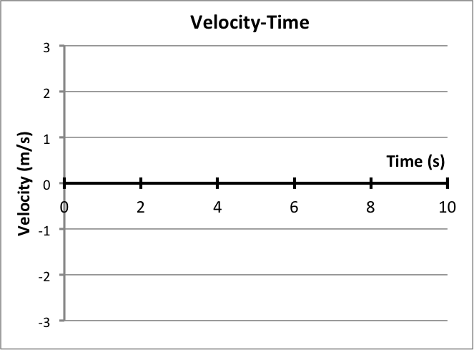
Step 2: Using the motion sensor and the data collection device, collect a velocity-vs.-time graph for the cart’s motion. Push the cart away from the motion sensor. Draw the graph on a set of axes like the one shown on the right.
Velocity vs Time

Step 3: Using the motion sensor and the data collection device, collect a velocity-vs-time graph for the cart’s motion. This time, start the cart on the other end of the track and push it toward the motion sensor. Draw the graph on the same axes as the previous step. On your graphs, label the lines “away” and “toward.”
- Copy the statements below into your lab notebook and fill in the blanks with the appropriate word: above or below
When the cart moved toward the motion sensor, the graph was _____________________ the X-axis.
When the cart moved away from the motion sensor, the graph was _____________________ the X-axis.
- Based upon your observations, describe how a graph can show both speed and direction.
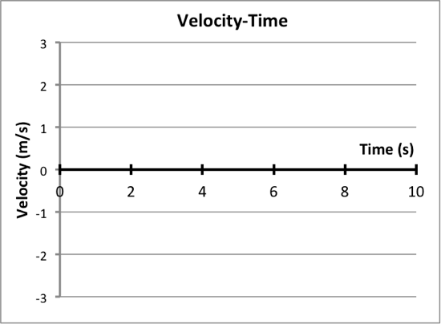
Step 4: Now collect a velocity-vs-time graph for a cart that is pushed away from the sensor and then pushed back toward the sensor 3 times (away, toward, away, toward, away toward).
Velocity vs Time

- On a new set of axes, draw the velocity-vs-time graph.
- On the graph, circle each of the points when the cart changed direction. (Note: You may need to collect data again to watch carefully to see what happens on the graph when the cart turns around.)
- How does the velocity-vs-time graph show something has changed direction?
- Look at the Y axis of your graph (Remember: In this case, the Y axis is the one labeled Velocity). What is the velocity of the cart when it changed direction?

Step 5: For comparison, collect a velocity-vs-time graph for the cart moving away from the motion sensor. Push the cart so that it speeds up and then release the cart so that it slows down.
- On a new set of axes (like the one shown on the right), draw the graph of the cart’s motion. Label the graph:
  - Away: speeding up
  - Away: slowing down

Step 6: Now start the cart at the other end of the track. Collect a velocity-vs-time graph for the cart moving toward the motion sensor. Again, push the cart so that it speeds up and then release the cart so that it slows down.
- On the same set of axes, draw the graph of the cart’s motion. Label the graph:
- Toward: speeding up
- Toward: slowing down
- If you did not observe an object moving but are able to look at a velocity-vs-time graph, how would you know if the object was moving away from or toward the motion sensor?
Collecting and Interpreting Evidence:
Experiment #2: Do we always have to talk about toward and away from the motion sensor?
Materials:
- Computer

Step 1: Go to: http://phet.colorado.edu/en/simulation/moving-man
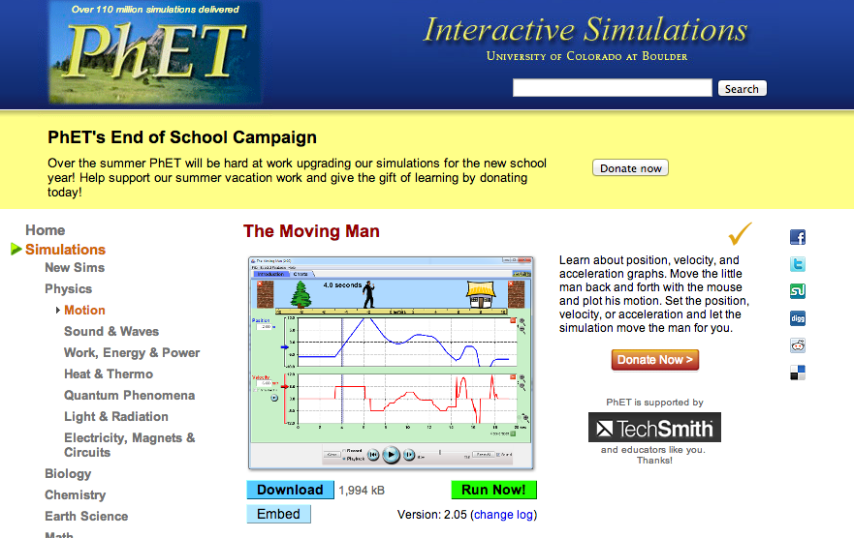
- Click the green button that says Run Now!
- A new window will open. At the top of the window, the tab Introduction will be selected.
- Click on the tab that says Charts.
- Take 5 minutes to experiment with the simulator to get to know its features.
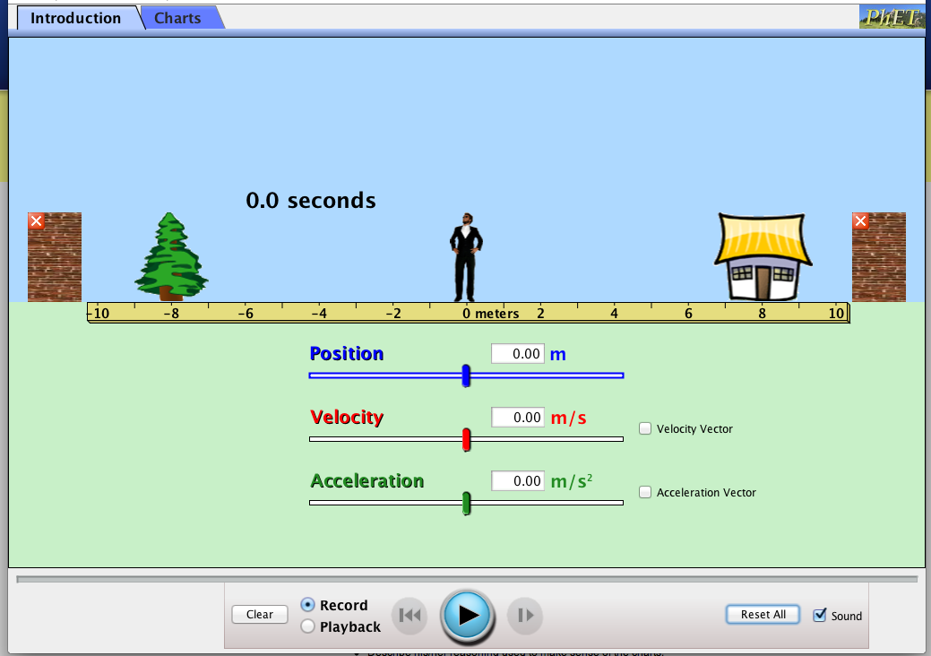
INTRODUCTION WINDOW CHARTS WINDOW

Step 2: For this simulator activity, we will only be working with the Velocity graph. Remove the Position and Acceleration graphs by clicking on the red square minus icon [] on the top right of the each graph.
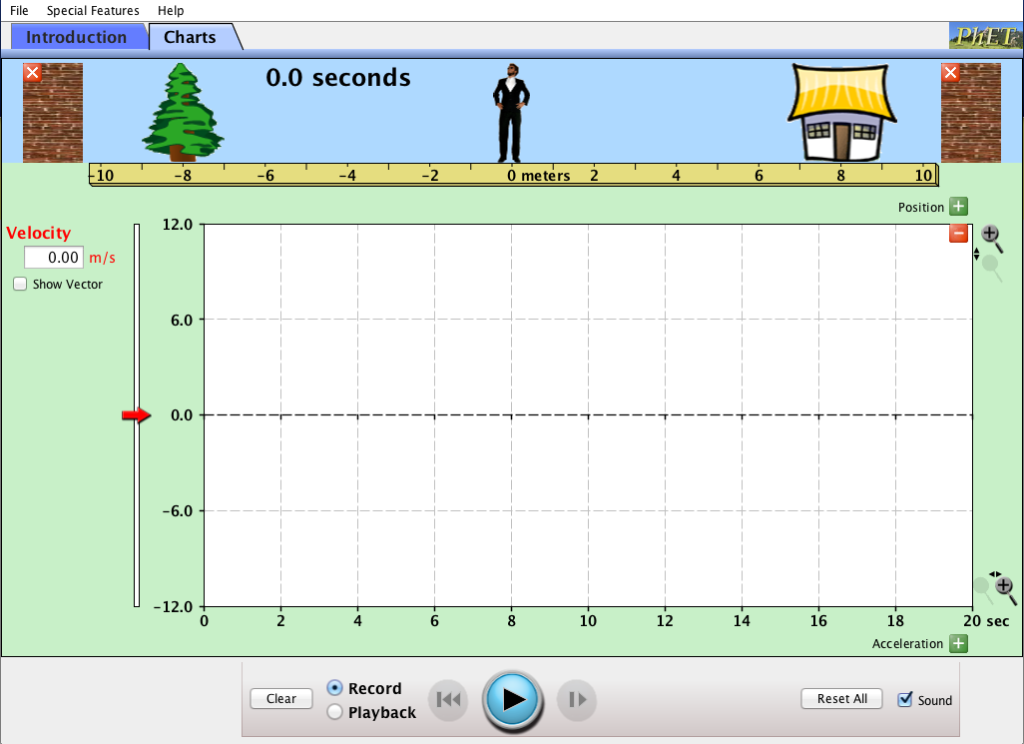
Step 3: Your new window will look like the one shown on the right. Practice collecting velocity-time data in these ways:
- Drag the man with your computer mouse
- Type positive and negative velocity values into the velocity box,
- Move the red arrow slider

- Make a list of 3 to 5 observations from the moving man simulation.

Step 4: Click clear to erase the velocity-time graph. Start the man at the tree and drag him away from the tree and then have him stop at the house.
- Was the graph positive (above the X axis) or negative (below the X axis)?

Step 5: Click clear to erase the velocity-time graph. Start the man at the house and drag him toward the tree.
- Was the velocity positive or negative?
- Where do you think the motion sensor would most likely be located, at the house or the tree?

Summarizing Questions Name: _______________________________
How can you represent both the speed and direction of an object?

Learning Target:
You will analyze and interpret velocity-vs-time graphs to represent speed and direction.
- What information does velocity provide about an object’s motion? How is velocity different from speed? Support your thinking with ideas and observations from the lab.

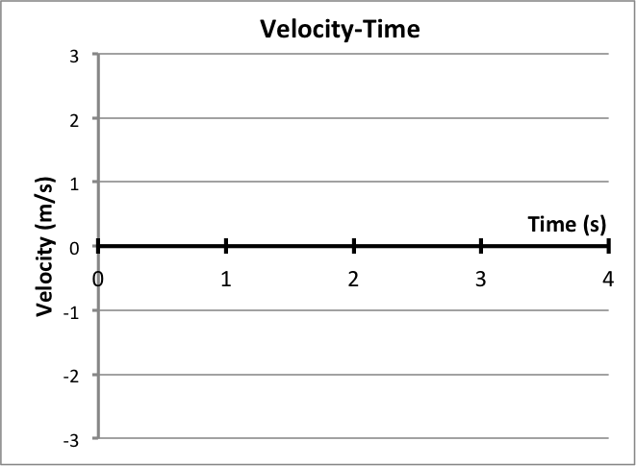
- The velocity-vs-time graphs on the right provide information for two different moving objects (object A is shown by the solid line and object B is shown by the dashed line).
Velocity vs Time

Object A
Object B
- Describe the motion of Object A. Be specific using speeds and directions.

- Describe the motion of Object A. Be specific using speeds and directions.

- On the graphs below, label when the man is speeding up, slowing down, moving at a constant speed, stopped, or changing direction.
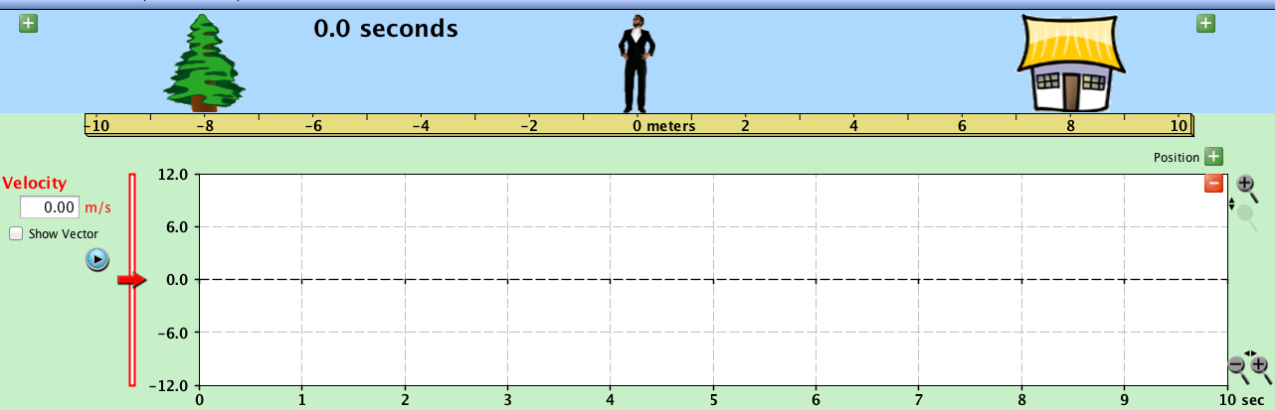

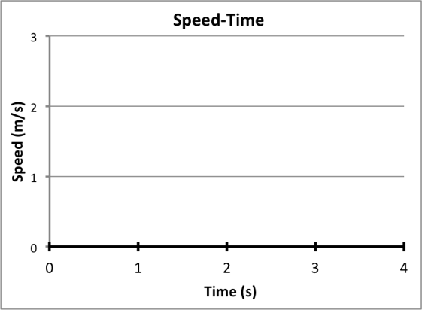
- On the right is a Speed-vs-Time graph for a girl who is taking a walk. Note that this is a SPEED-vs-TIME graph, which means that it does not give information about the girl’s direction.
Velocity vs Time

  - Make a circle on the graph where the girl could have changed directions.
  - Write two different possible stories for this girl’s walk. For each story, also draw a velocity-vs-time graph.
In the first story, the girl is only walking in one direction, away from her house.

In the second story, the girl changes direction.

1.2 Scientist Ideas Reading
Instructions: Read the Scientist Ideas, paying careful attention to each key idea. When you read, try to think about how the key ideas relate to the evidence you collected in the activity.
Speed Idea: Speed is a value (number) that expresses how fast an object is moving. Speed does not provide information about the direction an object is moving.
In the previous activity, you learned about speed. You are probably familiar with speed in terms of cars traveling in miles per hour. In this class, we will mostly use units of meters per second (m/s) to represent speed.
Velocity Idea: Velocity gives information about both the speed and the direction. The speed is provided in the number and the direction the object is traveling is shown by whether the number is positive or negative.

Have you ever watched a football game where a player catches the football and then runs to the wrong end zone? Not only is it important for the player to run fast, but it is important they have an understanding of what direction they are running! Similarly, scientists often need more information than just the speed of an object.
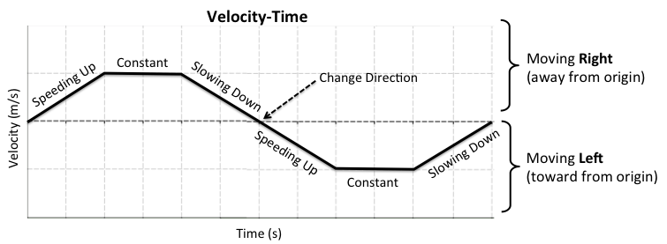
The graph below shows an object that is first moving right. It speeds up, travels at a constant speed and then slows down and changes direction. The direction change is indicated by the graph crossing the X-axis (therefore changing from moving right to moving left). Moving left, the object speeds up, moves at a constant speed, and slows down.
Velocity vs Time

Vector Idea: Scientists use the term vector when a variable gives information about both the size (magnitude) and the direction. Velocity is an example of vector. Vectors are represented by the symbol with an arrow above it ($\vec{v}$).
Scientists represent velocity using a lowercase v with an arrow above it ($\vec{v}$). Whenever you see a symbol with an arrow above it, it means the information about direction is given by whether the number is positive or negative.
Direction of Motion and Sign Idea: Objects moving to the right have a positive velocity and objects moving to the left have a negative velocity.
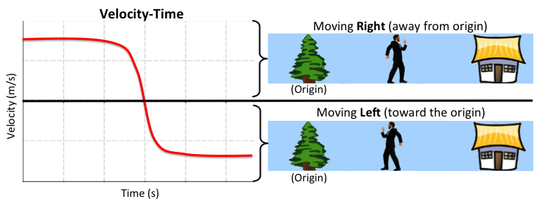
This agreement among scientists is called a convention (rule), and makes their work easier if everyone follows the same rule. So, saying $\vec{v}$ = 5 m/s, actually means “moving at 5 m/s to the right,” and $\vec{v}$ = -3 m/s means “moving at the 3 m/s to the left.”

Respond to the following questions individually in your lab notebook:
- What is the symbol that scientists use to represent velocity?
- Summarize the Vector Idea. In your summary, explain what is meant by the word vector and magnitude.
- According to convention, what direction is an object with a velocity of –10 m/s moving? What direction is an object with a velocity of 20 m/s moving?
- Describe the motion of the object for each of the velocity-vs-time graphs below. Include a description of the time intervals when the object is speeding up, slowing down, moving at a constant speed, or stopped. Also include the direction (right or left) that the object is moving.
a. 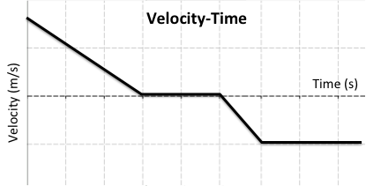 b. 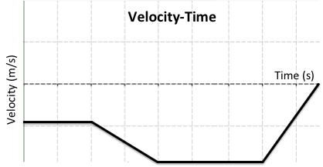
0 1 2 3 4 5 6 7 8
Velocity vs Time

Velocity vs Time

0 1 2 3 4 5 6 7 8

- Draw a velocity-vs-time graph for an object that speeds up to the left, moves at a constant speed for 2 seconds, slows down and changes directions and then speeds up to the right.

